PRESS RELEASE

Anantara Golden Triangle Marks World Elephant Day 2026 with Culture, Conservation and Elephant Research

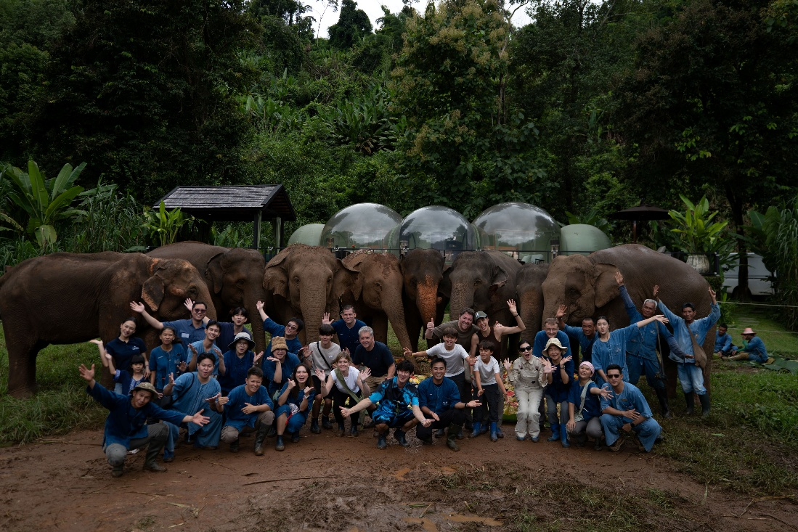
Chiang Rai, Thailand – 13 August 2026 – Anantara Golden Triangle Elephant Camp & Resort, in collaboration with the Golden Triangle Asian Elephant Foundation (GTAEF), marked World Elephant Day on 12 August 2026 with a day of activities bringing together cultural heritage, elephant welfare education and scientific research. Guests, team members and their families took part in a programme designed to deepen understanding of elephants, their caretakers and the conservation work supporting their future.
Observed globally each year on 12 August, World Elephant Day raises awareness of the challenges facing elephants and the importance of their long-term protection and welfare. In Thailand, the occasion also coincides with National Mother’s Day, giving the resort an opportunity to extend the programme to team members and their families through educational activities centred on elephants and conservation.
The morning began at the resort’s Elephant Camp with a Pakham Ceremony, a traditional blessing ritual reflecting the longstanding cultural relationship between elephants, mahouts and elephant-keeping communities. Rooted in the traditions of the Kui community, the ceremony honours ancestral guardian spirits and seeks protection, good health, harmony and prosperity for elephants and their caretakers.
The celebration continued at the Jungle Bubble Lodge, where participants prepared a special 'cake' using fresh fruits, vegetables and other elephant-friendly ingredients. The activity offered guests an opportunity to learn about elephant nutrition, feeding behaviour and welfare before the elephants were presented with a colourful buffet of fresh produce prepared in celebration of World Elephant Day.
“World Elephant Day gives us an important opportunity to bring together culture, learning and conservation in a way that is meaningful for our guests, our team and their families,” said Jean Marc Pougnet, General Manager of Anantara Golden Triangle Elephant Camp & Resort. “Our aim is not simply to bring people closer to elephants, but to encourage a deeper understanding of their needs, the role of their caretakers and the knowledge required to support their long-term welfare. This year’s programme reflects that commitment through activities that connect celebration with education.”
The afternoon placed a particular focus on education and research. Team members and their families met the elephants at Suan Sai Jai before joining live research demonstrations at the Elephant Camp. The sessions explored ongoing projects, behavioural studies and the ways scientific research can contribute to improved elephant care, welfare and conservation. The programme concluded with a discussion led by the elephant research team on current conservation challenges and the future of elephants in Thailand.
“Research is essential because good intentions need to be supported by evidence,” said John Roberts, Group Director of Sustainability & Conservation at Minor Hotels. “By making elephant research accessible through live demonstrations and discussion, we can help people understand how behavioural science and welfare studies translate into better care. At the same time, traditions such as the Pakham Ceremony remind us that elephants are also deeply connected to the cultures and communities that have lived alongside them for generations. World Elephant Day gives us a valuable platform to bring these perspectives together.”
The World Elephant Day programme reflects the long-standing collaboration between Anantara Golden Triangle Elephant Camp & Resort and GTAEF, with conservation education and responsible elephant encounters forming an integral part of the resort’s approach to connecting guests with the natural and cultural landscape of Northern Thailand.
For more information about Anantara Golden Triangle Elephant Camp & Resort, please visit www.anantara.com/en/golden-triangle-chiang-rai. To learn more about the work of the Golden Triangle Asian Elephant Foundation, please visit www.helpingelephants.org.
-Ends-
About Anantara Golden Triangle Elephant Camp & Resort
Anantara Golden Triangle Elephant Camp & Resort is an award-winning 63-key luxury retreat perched on a lush hillside overlooking the meeting point of Thailand, Laos and Myanmar. Set within 160 acres of bamboo forest, just one hour from Chiang Rai International Airport, the resort is home to the Golden Triangle Asian Elephant Foundation and offers unforgettable experiences including ethical elephant encounters, Jungle Bubbles, treetop dining at Canopy, immersive wellness and destination-inspired adventures. Favoured by couples, honeymooners, families and luxury travellers seeking meaningful experiences in nature, the resort combines authentic local culture with world-class hospitality in one of Southeast Asia's most extraordinary destinations. Discover more at anantara.com/golden-triangle-chiang-rai and follow the resort on Facebook and Instagram.

About Anantara Hotels & Resorts
A luxury hospitality brand for modern travellers, Anantara Hotels & Resorts connects guests to genuine places, people and stories in some of the world’s most extraordinary destinations. Each Anantara embraces the surroundings and culture of its destination, creating unforgettable memories for every guest since 2001. From city to sea and desert to jungle, Anantara delivers heartfelt, Thai-inspired hospitality at its over 50 hotels and resorts across Asia, Europe, Africa, the Middle East, and the Indian Ocean.
Anantara Hotels & Resorts is a Minor Hotels brand and recognises its guests through one unified loyalty programme, Minor DISCOVERY, part of GHA DISCOVERY.
Visit anantara.com for more information, and connect with Anantara on Facebook, Instagram, TikTok, X, and YouTube.
About Minor Hotels
Minor Hotels is a global leader in the hospitality industry with more than 640 hotels, resorts and branded residences in operation and committed development across 67 countries. The group crafts innovative and insightful experiences through its hotel brands including Anantara, Elewana Collection, The Wolseley Hotels, Tivoli, Minor Reserve Collection, NH Collection, nhow, Avani, Colbert Collection, NH, Oaks, and iStay, as well as a diverse portfolio of restaurants and bars, travel experiences, and spa and wellness brands. With over four decades of expertise, Minor Hotels builds stronger brands, fosters lasting partnerships, and drives business success by always focusing on what matters most to our guests, team members and partners.
Minor Hotels is a proud member of the Global Hotel Alliance (GHA) and recognises its guests through one unified loyalty programme, Minor DISCOVERY, part of GHA DISCOVERY.
Discover our world at minorhotels.com and connect with Minor Hotels on Facebook, Instagram, LinkedIn, TikTok and YouTube.

For media enquiries, please contact:

Sunny Chawla
Area Director of Public Relations
Anantara Golden Triangle Elephant Camp & Resort |Anantara Siam Bangkok | Anantara Riverside Bangkok | Anantara Lawana Koh Samui | Anantara Bophut Koh Samui | Anantara Rasananda Koh Pha Ngan
M: +66 92 899 9614
E: sunny_ch@minor.com

Supa-arpha Itthikaiwan (Mandy)
Cluster Director of Marketing & Communications
Anantara Chiang Mai Resort | Anantara Golden Triangle Elephant Camp & Resort
M: +66 93 789 3864
E: supaarpha_it@anantara.com

