PRESS RELEASE
Koh Samui villa stays shaped around their guests
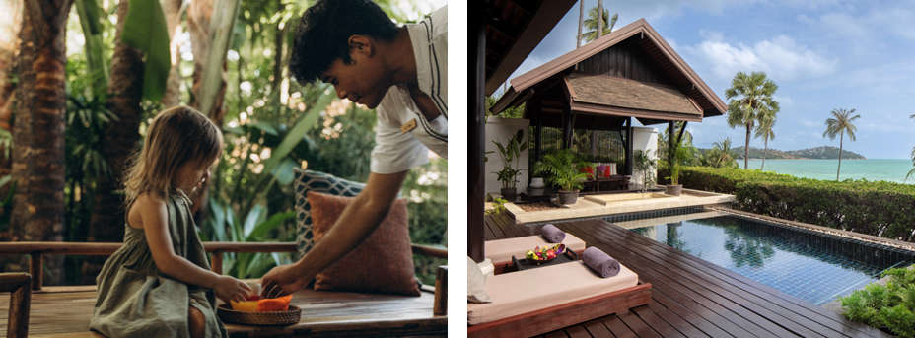
Imagery available here
At Anantara Lawana Koh Samui Resort, slower mornings, private pools, sunset rituals and intuitive service create a more personal way to stay on the island
Koh Samui, Thailand, 15 June 2026 - Luxury villa stays in Koh Samui are no longer defined by space alone. For many travellers seeking private pool villas in Koh Samui, the real value lies in how naturally a stay adapts to them: a slower morning, a private moment by the pool, a table arranged at sunset, or a detail remembered without needing to be repeated.
At Anantara Lawana Koh Samui Resort, Pool Villas and Sea View Pool Villas are designed for this more personal rhythm. Inspired by Koh Samui’s coconut-farming heritage, each villa combines garden courtyards, private pools, outdoor baths and generous indoor-outdoor living with the warmth of intuitive Thai hospitality. The Two Bedroom Oceanfront Residence extends the same villa-led experience with two en-suite bedrooms, generous living and dining spaces, a kitchenette, private pool and expansive oceanfront terrace, designed for families, multi-generational stays and intimate gatherings.


For eligible direct reservations across these villa-led stays, the experience begins quietly, with private check-in setting a more seamless tone. Mornings can unfold at leisure, with breakfast served oceanfront at Ocean Kiss or in-villa until 11:00 am. A complimentary minibar, replenished daily with selected items, adds ease between time by the pool, beach and villa. As the day softens, daily sunset cocktails with tapas-style bites create a simple golden-hour ritual.
Behind these touches is a dedicated Villa Host, a familiar point of contact who helps connect the practical details of a stay with the personal ones. For families, that may mean noticing how a child bonds with the resort team - as in the case of a young guest who named a stuffed monkey doll after the host who gifted it. In another stay, when a child lost a much-loved doll after leaving the resort, a replacement was carefully sent on.
For celebrations, the villa becomes a private setting for shared memories. One family seeking an intimate Christmas away from home enjoyed a private in-villa dinner with festive decorations and traditional touches, while a 60th birthday stay saw gifts and personal cards arranged across several days for invited guests.
These are not extravagant gestures. They are smaller, quieter details that speak to what many luxury travellers increasingly seek: time, privacy, ease and the feeling of being understood.
“Travellers are increasingly looking for stays that feel less scheduled and more personal,” says Frederic Kolde, General Manager of Anantara Lawana Koh Samui Resort. “Across our Pool Villas and Two Bedroom Oceanfront Residence, the value is not only in the private pool or the space, but in the way each day can move around the guest - from breakfast taken at their own pace to sunset drinks thoughtfully arranged, and the stories shaped along the way by our Villa Hosts.”
Located on the northern end of Chaweng Beach, moments from Samui International Airport, Anantara Lawana Koh Samui Resort offers a calmer expression of Koh Samui: close to the island’s energy, yet set within a beachfront landscape of tropical gardens, sea air and intuitive hospitality. For Pool Villa and Residence guests, the result is a stay shaped not simply by where they sleep, but by how they want to feel while they are there.
-Ends-

Note to editors
The Pool Villas and Sea View Pool Villas at Anantara Lawana Koh Samui Resort feature terraces with private pools and salas, outdoor bathtubs, indoor and outdoor showers, generous living spaces, dedicated Villa Host service and design details inspired by Koh Samui’s coconut-farming heritage.
The Two Bedroom Oceanfront Residence extends the same villa-led experience with two en-suite bedrooms, generous living and dining spaces, a kitchenette, private pool and expansive oceanfront terrace, designed for families, multi-generational stays and intimate gatherings. Recognised by Elite Traveler as an Elite Suite, it represents one of the resort’s most elevated private stays.

For eligible reservations made directly with the resort or through anantara.com across these categories, guests enjoy direct-reservation benefits including private check-in, breakfast at Ocean Kiss or in-villa until 11:00 am, a complimentary minibar replenished daily, and access to the daily Sunset Cocktail Hour where complimentary drinks and tapas-style plates are served each evening.

About Anantara Lawana Koh Samui Resort

Set on the northern end of Chaweng Beach, moments from Samui International Airport, Anantara Lawana Koh Samui Resort is a MICHELIN Key beachfront resort rooted in Koh Samui’s Sino-Thai heritage. The resort features 122 rooms, suites, pool villas and residences, with design details inspired by the island’s early Hainanese settlement, songbird traditions, fishermen’s homes and coconut-farming heritage.

Guests can begin the day with oceanfront breakfast at Ocean Kiss, explore sea-facing dining at CAY and Sandal by João Costa, enjoy sunset cocktails at The Singing Bird Lounge, a filming location for The White Lotus Season 3, and dine above the canopy at Tree Tops, Koh Samui’s only treetop dining experience. With Anantara Spa wellbeing, dedicated Villa Host service and tangible sustainability initiatives recognised through Green Growth Platinum membership, the resort offers a refined Koh Samui retreat shaped by place, people and personalised hospitality.

Visit anantara.com/lawana-koh-samui for more information, and connect with Anantara Lawana on Instagram, Facebook, TikTok, and LinkedIn.

About Anantara Hotels & Resorts

A luxury hospitality brand for modern travellers, Anantara Hotels & Resorts connects guests to genuine places, people and stories in some of the world’s most extraordinary destinations. Each Anantara embraces the surroundings and culture of its destination, creating unforgettable memories for every guest since 2001. From city to sea and desert to jungle, Anantara delivers heartfelt, Thai-inspired hospitality at its over 50 hotels and resorts across Asia, Europe, Africa, the Middle East, and the Indian Ocean.

Anantara Hotels & Resorts is a Minor Hotels brand and recognises its guests through one unified loyalty programme, Minor DISCOVERY, part of GHA DISCOVERY.

About Minor Hotels
Minor Hotels is a global leader in the hospitality industry with more than 640 hotels, resorts and branded residences in operation and committed development across 66 countries. The group crafts innovative and insightful experiences through its hotel brands including Anantara, Elewana Collection, The Wolseley Hotels, Tivoli, Minor Reserve Collection, NH Collection, nhow, Avani, Colbert Collection, NH, Oaks, and iStay, as well as a diverse portfolio of restaurants and bars, travel experiences, and spa and wellness brands. With over four decades of expertise, Minor Hotels builds stronger brands, fosters lasting partnerships, and drives business success by always focusing on what matters most to our guests, team members and partners.
Minor Hotels is a proud member of the Global Hotel Alliance (GHA) and recognises its guests through one unified loyalty programme, Minor DISCOVERY, part of GHA DISCOVERY.
Discover our world at minorhotels.com and connect with Minor Hotels on Facebook, Instagram, LinkedIn, TikTok and YouTube.

For media enquiries, please contact:

Name: Brian Anand Soosay
Position: PR & Marketing Manager
Email: bsoosay@anantara.com

