PRESS RELEASE
The Koh Samui restaurant tracing Thailand’s Indian heritage through spice
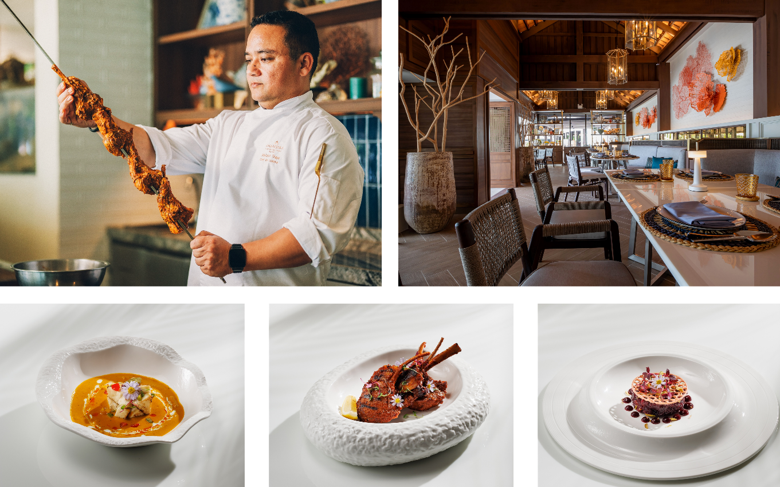

Imagery available here
At CAY, a tribute to Thailand’s Indian heritage is told through the menu: migration and memory expressed in pairings of Thai brightness and Indian depth, shaped by Chef Mahesh Thapa’s 23-year devotion to Indian cooking.
Koh Samui, Thailand, 20 May 2026 - It begins like a story told across a table: a boy carrying cardamom, clove and cumin in paper twists; a girl gathering lemongrass, makrut lime and coconut from a Thai garden. One arrives with spice. The other with herbs. Between them is a shared language of warmth, generosity and food prepared with care.
At CAY, the Thai-Indian restaurant at Anantara Lawana Koh Samui Resort, that imagined meeting becomes a dining experience shaped by memory, migration and craft. The menu pays tribute to the Indian families, traders and cooks who made Thailand their home, bringing spice traditions that found a natural conversation with Thai herbs, coconut-rich curries and the country’s instinctive way of gathering around food.
CAY treats Thai and Indian cuisine as two living traditions in dialogue. Thai coastal ingredients bring brightness and fragrance; Indian spices bring depth, smoke and structure. At the helm is Chef de Cuisine Mahesh Thapa, whose 23 years of Indian cooking guide the experience with discipline and restraint - built around balance rather than heat. His craft begins with patient spice work, careful marination, and the steady command of tandoor fire, with curries made from scratch and warm bread shaped by hand.
The table is designed for contrast and companionship - dishes enjoyed side by side in vibrant pairings. Goy goong alongside pani puri awakens the appetite with freshness and crunch; gaeng puu bai chaplu finds comfort in warm, soft home-made naan; a bright som tum lifts the warmth of tandoor-grilled meats or house-made paneer. To finish, gluay hom thod and coconut ice cream are balanced by the gentle tartness of pineapple phirni, leaving a final note that is both familiar and quietly celebratory.
Set on the northern end of Chaweng Beach, CAY opens to sea views in a setting designed for all-weather dining, combining indoor comfort with an easy island rhythm. Located between Chaweng and Bophut, the restaurant is conveniently accessible from all parts of the island. Open daily from 12.00 pm to 11.00 pm. For reservations, please call +66 77 960 333 or visit anantara.com/en/lawana-koh-samui/restaurants/cay

-Ends-

About Anantara Lawana Koh Samui Resort

Set on the northern end of Chaweng Beach, moments from Samui International Airport, Anantara Lawana Koh Samui Resort is a MICHELIN Key beachfront resort rooted in Koh Samui’s Sino-Thai heritage. The resort features 122 rooms, suites, pool villas and residences, with design details inspired by the island’s early Hainanese settlement, songbird traditions, fishermen’s homes and coconut-farming heritage.

Guests can begin the day with oceanfront breakfast at Ocean Kiss, explore sea-facing dining at CAY and Sandal by João Costa, enjoy sunset cocktails at The Singing Bird Lounge, a filming location for The White Lotus Season 3, and dine above the canopy at Tree Tops, Koh Samui’s only treetop dining experience. With Anantara Spa wellbeing, dedicated Villa Host service and tangible sustainability initiatives recognised through Green Growth Platinum membership, the resort offers a refined Koh Samui retreat shaped by place, people and personalised hospitality.

Visit anantara.com/lawana-koh-samui for more information, and connect with Anantara Lawana on Instagram, Facebook, TikTok, and LinkedIn.

About Anantara Hotels & Resorts

A luxury hospitality brand for modern travellers, Anantara Hotels & Resorts connects guests to genuine places, people and stories in some of the world’s most extraordinary destinations. Each Anantara embraces the surroundings and culture of its destination, creating unforgettable memories for every guest since 2001. From city to sea and desert to jungle, Anantara delivers heartfelt, Thai-inspired hospitality at its over 50 hotels and resorts across Asia, Europe, Africa, the Middle East, and the Indian Ocean.

Anantara Hotels & Resorts is a Minor Hotels brand and recognises its guests through one unified loyalty programme, Minor DISCOVERY, part of GHA DISCOVERY.

For media enquiries, please contact:

Name: Brian Anand Soosay
Position: PR & Marketing Manager
Email: bsoosay@anantara.com

