Anantara Chiang Mai Resort
Press Kit
2026

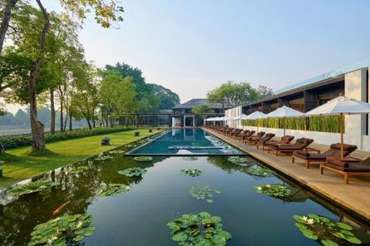

Chiang Mai has long captivated travellers with its distinctive Lanna culture, verdant landscapes and relaxed pace of life. Set on the banks of the Mae Ping River, minutes from the old town and approximately 15 minutes from Chiang Mai International Airport, Anantara Chiang Mai Resort offers a tranquil base in the heart of Northern Thailand’s cultural capital.

The resort occupies the former British Consulate grounds, with the heritage 1921 House forming its historic centrepiece and housing a collection of dining and drinking venues. Contemporary architecture and minimalist, Lanna-inspired interiors complement the property’s riverside setting, while spacious rooms and suites, Anantara Spa and private river cruises provide opportunities to unwind and discover the destination.

From the resort, guests can easily explore Chiang Mai’s ancient temples, traditional markets, creative neighbourhoods and surrounding countryside, returning to the calm of riverside living at the end of the day.

Topline facts

- Management: Minor International PLC
- Ownership: Pacific Hotel Chiangmai Co., Ltd
- General Manager: Tudsaporn Jaiboonchuen
- Architect: Kerry Hill Architects
- Built: 2005
- Opened as Anantara: 2013
- Resort size: 7 Rais/11,200sqm
- Room inventory: 52 rooms, 34 suites and 25 serviced suites
- Starting rate: USD440++ per night including breakfast and an array of culturally immersive experiences.
- Address: 123 - 123/1 Charoen Prathet Road, Changklan, Muang, Chiang Mai 50100, Thailand
- Tel: +66 53 253 333
- Email: chiangmai@anantara.com
- Website: anantara.com/en/chiang-mai
- Instagram: @anantara_chiangmai
- Facebook: @anantarachiangmai
- TikTok: @anantara.chiangmai
- Press kit and photography: https://media.minorhotels.com/en-GLO/assets/232118/

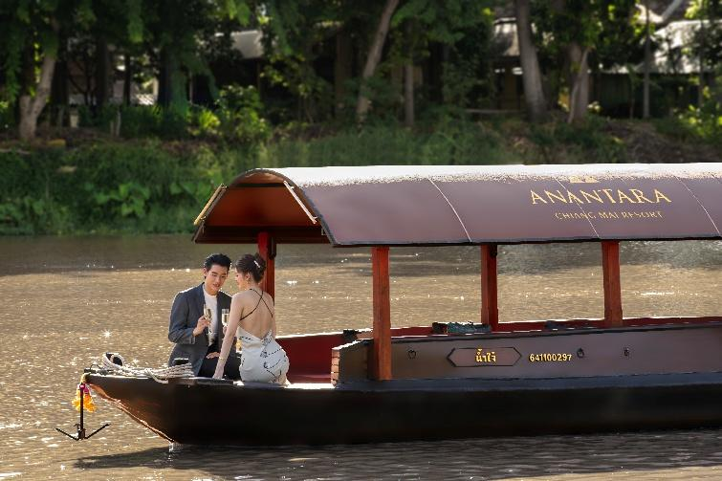

Location and heritage

Widely regarded as Northern Thailand’s cultural capital, Chiang Mai has long captivated visitors with its mountain landscapes, rich traditions and relaxed pace of life. The city’s storied past remains visible in the surviving walls, gates and moat that encircle its historic centre.

Founded by King Mangrai in 1296 as the capital of the Lanna Kingdom, Chiang Mai occupied a strategically important position between the Mae Ping River, surrounding mountain ranges and regional trading routes. The city flourished as a centre of governance, religion, craftsmanship and commerce, with connections extending across present-day Thailand, Myanmar, Laos and southern China.

From the mid-16th century, Chiang Mai came under Burmese influence, a period marked by shifting control and intermittent conflict in the region. Over time, the city experienced significant decline and was eventually left largely deserted before being restored and repopulated under Prince Kawila in 1796. It later developed into an important centre for the teak trade and international exchange, before being gradually integrated into the Kingdom of Siam through administrative reforms in the late 19th century.

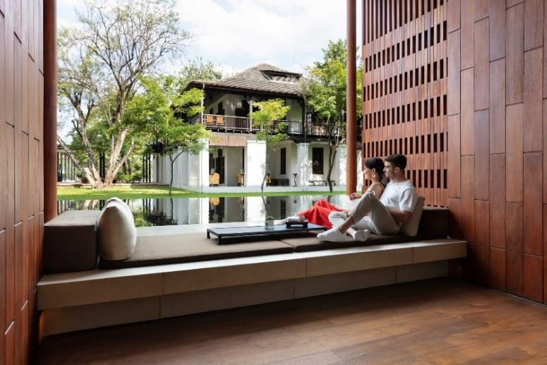

Getting here

Anantara Chiang Mai Resort is located in the city’s most exclusive neighbourhood which winds along the tranquil Mae Ping River. Guests can fly into Chiang Mai International Airport (CNX), an 80-minute hop from capital Bangkok, which also receives domestic flights from Phuket, Hua Hin and Koh Samui in Thailand, and regional flights from South Korea, China, Hong Kong, Japan, Singapore, and Laos, among others.

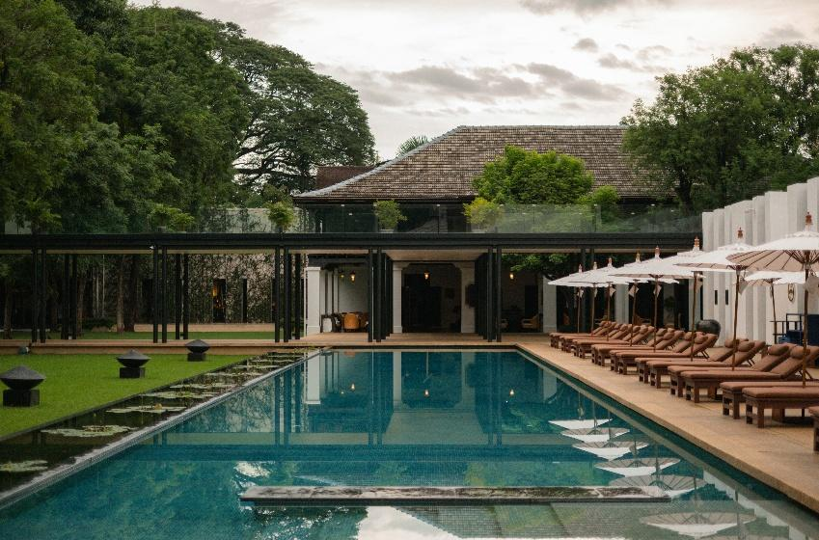

Resort features

- Room inventory: 52 rooms, 34 suites and 25 serviced suites
- Restaurants and bars: 5 restaurants and bars, including Bodhi Terrace, The Service at 1921 House, Brit Bar at 1921 House, The Verandah at 1921 House, and Bubbles rooftop bar
- Swimming pools: 2 pools. A 34-metre pool, which is surrounded by lily ponds and loungers, and overlooks the river at the resort and a 20-metre rooftop pool at Anantara Serviced Suites.
- Babysitting service
- Spa: 225 Sqm spa and wellness facility, including 9 luxurious indoor treatment rooms and couple suites. VIVID Chiang Mai is also located on the same premises offering Vitamin hydrating drip services.
- MICE & Event Space: 1 meeting room over 146 Sqm, seating up to 120 people (theatre)
- Fitness centre
- Limousine service and airport transfers
- Valet service and indoor parking
- 24-hour security
- 24-hour guest services
- Foreign currency exchange
- Laundry and room service

Iconic USPs

- A heritage setting on the former British Consulate grounds
Anantara Chiang Mai Resort is set on the former British Consulate grounds and centred around the heritage 1921 House. Built in 1921 and carefully preserved, the century-old teak residence is now home to The Service at 1921 House and Brit Bar, forming the historic and social heart of the resort.
- A prime riverside location in the heart of Chiang Mai
Set along the banks of the Mae Ping River, the resort offers a tranquil retreat only minutes from Chiang Mai’s old town, the Night Bazaar and the city’s cultural and creative districts. Chiang Mai International Airport is approximately 15 minutes away by car.
- Distinctive architecture by Kerry Hill
Designed by renowned architect Kerry Hill, the resort juxtaposes minimalist contemporary architecture with the historic 1921 House. Clean lines, reflective pools and Lanna-inspired details complement the original teak building, creating a considered dialogue between heritage and modern design.
- Private river journeys from the resort’s pier
Guests can embark on river journeys directly from the resort’s private pier aboard the JAO Ping River Cruise fleet. Its three distinctive vessels include Dibba Yana Chitta, an art boat featuring the work of renowned Thai artist Chalermchai Kositpipat, creator of Wat Rong Khun, or the White Temple.
- Spacious Lanna Suites with tailored privileges
The resort’s Lanna Suites range from 105 to 140 square metres and offer garden, river or direct riverfront settings. Selected suites include personalised arrival services, private transfers and in-suite dining privileges, while the Lanna Pool Suite features a temperature-controlled plunge pool and private cabana.
- A signature sunset cultural ritual
As the sun sets, live khim music and traditional Lanna dance create a graceful evening ritual on the lawn overlooking 1921 House. The performance offers guests an introduction to Northern Thailand’s musical and cultural traditions within the resort’s historic setting.
- Wellness rooted in Northern Thai traditions
Anantara Spa combines contemporary wellbeing with therapies inspired by Northern Thai healing practices. Treatments include Yam Khang, a traditional Lanna technique that uses controlled heat, herbal preparations and rhythmic foot massage to ease muscular tension.
- Lanna culture woven throughout the stay
Northern Thailand’s culture is reflected across the resort through locally crafted amenities, regional art, dining, wellness and curated activities. Guests can discover Chiang Mai through traditional arts and crafts, temple and market visits, cultural walks and river excursions.
- Premium steak and seafood at The Service at 1921 House
Set within the heritage 1921 House, The Service at 1921 House presents premium steak and seafood prepared through a Josper-led grill programme. House dry-aged beef, carefully selected cuts, seafood and an extensive wine list are complemented by The Service Cocktail Book, inspired by the building’s consular history and the world of the British secret service.

Top 5 tips for an unforgettable stay

1. Discover the rich artistry of Thailand through our complimentary daily arts and crafts workshops. Held every afternoon from 3.30 pm to 4.30 pm, these sessions invite you to explore traditional techniques and create your own masterpiece in a serene setting. View the workshop schedule and reserve your place with our Guest Services Team to ensure you do not miss this unique cultural experience.

2. Visit on a weekend. On Saturday evenings, explore Wua Lai Walking Street, renowned for its silverware and handcrafted goods, all set within a lively local atmosphere. On Sundays, do not miss the famous Tha Phae Walking Street, also known as the Sunday Night Market, where you can browse an array of hill tribe products, intricate wood carvings, handicrafts and local delicacies. These vibrant markets offer an authentic taste of Chiang Mai.

3. Embark on a journey aboard JAO Ping River Cruise. One of the most memorable ways to experience Chiang Mai, a river cruise offers a unique perspective on local life along the Mae Ping River, revealing the region's rich heritage, traditional riverside communities and lush scenery. The JAO Ping River Cruise fleet comprises three distinctive vessels: Nam Jai, Nam Jit, and the one-of-a-kind Dibba Yana Chitta ("Heavenly Boat"), designed by renowned Thai artist Chalermchai Kositpipat, creator of Wat Rong Khun (the White Temple) in Chiang Rai.

4. Find the secret door. Here's a hint: visit The Service at 1921 House, where the bookcase is not quite what it seems.

5. Learn Muay Thai from a professional. Our experienced Muay Thai instructor introduces guests of all levels to Thailand's traditional martial art, guiding each session through the fundamentals of this revered national sport.
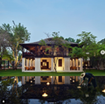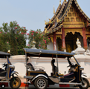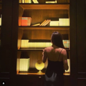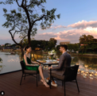
Most photogenic moments

- Discover the secret door at The Service at 1921 House.
- Experience Chiang Mai from a different perspective aboard JAO Ping River Cruise, where the tranquil Mae Ping River reveals the city's heritage and riverside charm.
- Book Designer Dining, an intimate private dining experience for two on a riverside deck beneath the stars.
- Hop aboard a tuk-tuk to explore Chiang Mai's historic landmarks, including Wat Chedi Luang and Chiang Mai Gate.
- Admire the century-old 1921 House, once the British Consulate, where colonial heritage meets contemporary dining.

What’s in a name?

- Derived from the Sanskrit word meaning “without end”, the word “Anantara” embraces the excitement of discovery and the vibrant energy of new horizons.
- Chiang Mai, meaning "New City" in Thai, was named to mark its establishment as the new capital of the Lanna Kingdom in 1296 by King Mengrai. The term "Chiang" means "city" or "fortified town," and "Mai" means "new." King Mengrai founded Chiang Mai as a strategically located and fortified city along the Ping River, replacing the nearby city of Chiang Rai as the capital.
- The Lanna Kingdom gets its name from the Thai words "Lan" (a million) and "Na" (rice fields), meaning "Kingdom of a Million Rice Fields." This name reflects the region's fertile valleys and its historical agricultural abundance, which supported its prosperity.

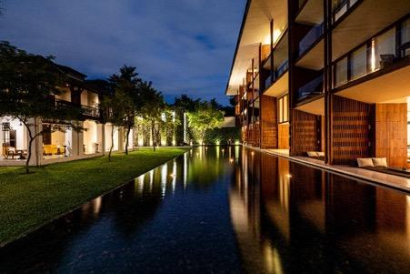

Architecture and design

Just a short tuk-tuk ride from Chiang Mai’s Old Town, Anantara Chiang Mai Resort is a unique urban resort hidden behind a bamboo wall. The surrounding mid-rise buildings and city bustle melt away as soon as guests enter the tranquil grounds, which comprise a series of low-slung modern buildings and green spaces bordered by the Mae Ping River.

The resort was designed by the late Australian architect Kerry Hill, whose clean and understated vision centres around the original 1920s colonial building of the former British Consulate. Masterfully incorporating three key elements—teak, rocks and water—the design creates a harmonious and immersive environment that reflects the region’s natural beauty and cultural heritage.

In a nod to the region’s rich history as a forestry and teak export hub, the resort’s architecture makes extensive use of teak, a material known for its durability and warm, rich tones. From the lobby to the guest rooms and exterior façades, teak is employed throughout to create a sense of luxury and connection to the local heritage.

The timber-lined guest rooms feature private balconies with daybeds, as well as open-plan bathrooms clad in handmade red tiles and terrazzo flooring. These distinctive materials add warmth and character to the contemporary interiors, creating a harmonious blend of modern design and traditional craftsmanship.
Throughout the hotel, water has been used to great effect. Inspired by the neighbouring Mae Ping River, the resort’s incorporation of water features, such as ponds, the swimming pool and the water curtain wall at Bodhi Terrace, creates a soothing ambience and complements the use of teak and rocks. This thoughtful integration of water enhances the overall guest experience, promoting relaxation and wellbeing while reflecting scenes of life along the river.

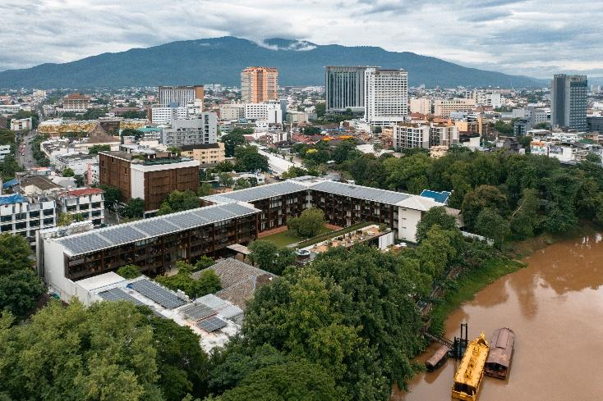
Sustainability credentials
- Green Growth 2050 Platinum Certification. Anantara Chiang Mai Resort has been awarded Green Growth 2050 Platinum Certification, most recently recertified in 2025, recognising the resort’s commitment to responsible tourism, environmental stewardship and sustainable operations.
- Water treatment. Greywater generated through the resort’s daily operations is treated and reused for landscape irrigation, helping to maintain the gardens while reducing freshwater consumption.
- Energy efficiency. The resort’s 573 rooftop solar panels generate approximately 413,956 kWh of clean energy each year, reducing monthly energy costs by around 17% and preventing approximately 196.6 tonnes of CO₂e emissions annually—the equivalent of planting more than 3,200 trees each year.
- Local artisans and apprentices. Through the resort’s Streetwise Insider programme, guests are introduced to local experiences, communities and attractions. The resort also welcomes students from local colleges and universities to participate in apprenticeship programmes. Guests can support community enterprises by purchasing locally made products from initiatives including the Doi Tung Royal Project, Elephant POOPOOPAPER Park and DAO Ethical Gifts, which create employment opportunities for underprivileged communities and hill tribe women.
- Responsible sourcing and local producers. The resort works with farmers, cooperatives and artisan producers across Thailand, with a particular focus on Northern Thailand, to source quality ingredients and support local livelihoods. Free-range chicken is supplied by Sirin Farm in Chiang Rai, where the chickens are fed corn and grains and raised without antibiotics or growth hormones. The resort grows a selection of edible flowers in its own garden for use across its restaurants, complemented by organically grown herbs and edible flowers sourced from Mae Jo, Chiang Mai. Selected cheeses are procured from the Chiang Mai Dairy Cooperative, while handmade organic jams from Wild Nature Artisans, produced using ingredients from growers in Lampang and Chiang Mai, are served at breakfast. At The Service at 1921 House, the culinary team also highlights Thailand’s regional salt-making traditions. Rock salt is sourced from Nan, where salt has been produced from natural saltwater wells for more than 800 years. Salt from Pattani Bay is valued for its mild, mellow flavour, shaped by the brackish waters where fresh water meets the sea.
- Dollars for Deeds. Anantara’s Dollars for Deeds programme gives guests the option to donate USD 1, approximately THB 30, for each night of their stay, with Anantara matching every contribution. Funds raised support the Golden Triangle Asian Elephant Foundation in Chiang Rai, the Mai Khao Marine Turtle Foundation in Phuket and the Princess Sirindhorn Craniofacial Centre at Chulalongkorn Hospital in Bangkok.

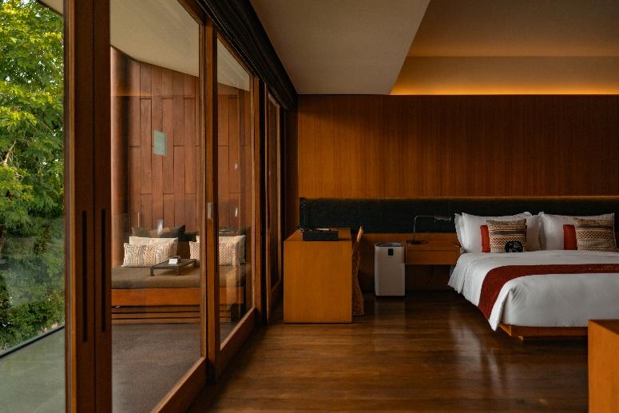

Stays: rooms, suites and serviced suites

The resort’s 86 rooms and suites are housed in a low-rise building wrapped around a garden courtyard. With sleek contemporary design, each boasts a feeling of space and serenity. Suites are exceptionally luxurious, with open living spaces and upgraded amenities. Suite guests enjoy exclusive Lanna privileges, including afternoon refreshments, social hours with cocktails and canapes, laundry service and a late check-out.
Rooms

Rooms start from USD 440++ per night including breakfast, and an array of culturally immersive experiences.
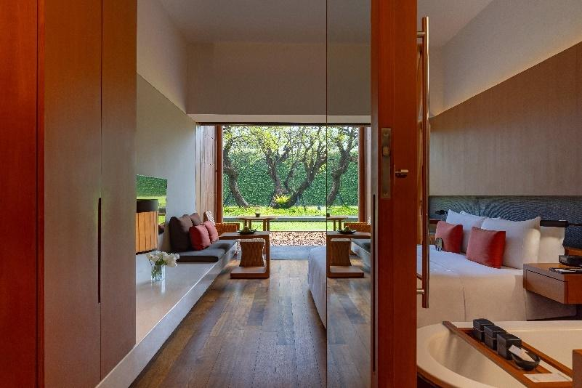
Deluxe Garden View Room

Deluxe Garden View Room
Deluxe rooms bring the tranquillity of the outdoors in, with sleek Zen lines and cool materials. Guests can lounge on their daybed overlooking lush grounds or unwind with in-room yoga or a soak in the tub.
- 50 Sqm
- Maximum 2 adults + 1 infant
- Highlights include a terrace with garden view via floor to ceiling windows, day bed, rain shower and Terrazzo tub, 50” flat screen TV, yoga mat, Nespresso coffee machine, Dyson hair dryer, air purifier and mini bar.

Deluxe River View Room
Make the most of our picturesque five-star hotel in Chiang Mai, with tranquil Mae Ping River views enjoyed from your private balcony. Wake gently as curtains glide open at the touch of a bedside button.
- 50 Sqm
- Maximum 2 adults & 1 infant
- Highlights include a terrace with river view via floor to ceiling windows, day bed, rain shower and Terrazzo tub, 50” flat screen TV, yoga mat, Nespresso coffee machine, Dyson hair dryer, air purifier and mini bar.

Lanna Suites offer generous space, thoughtful amenities and exclusive privileges, including a welcome bottle of wine and Thai sweets, a private cocktail-making experience, a Lanna-inspired gift, savings on dining and spa treatments, complimentary laundry, late check-out and a guided Path of Blessing cultural tour.

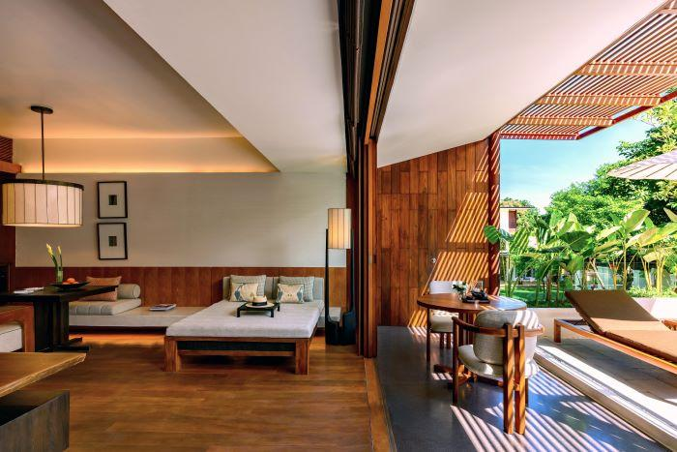
Lanna Garden Terrace Suite

Lanna Suites start from USD 560++ per night, including daily breakfast and a collection of exclusive Lanna privileges designed to enrich every stay. Guests booking directly with the resort are welcomed with a bottle of wine and traditional Thai sweets, enjoy an in-suite cocktail-making experience with a curated minibar set, receive a signature Lanna Traveller gift, and benefit from 20% savings on spa treatments and dining, complimentary laundry service, and late check-out until 2.00 pm (subject to availability). The experience is further enhanced with the Path of Blessing, a guided walking journey to nearby cultural landmarks that celebrates the traditions and heritage of Chiang Mai.

Lanna Garden View Suite
Lanna Garden View Suites at Anantara Chiang Mai Resort are spacious and filled with natural light, featuring open-plan living and dining areas designed for relaxed riverside living. Begin your morning with a freshly brewed espresso on the private balcony overlooking the gardens, or unwind in the evening with a glass of wine chilled to perfection.
- 105 sqm
- Maximum occupancy: 3 adults or 2 adults and 2 children
- Highlights: Private balcony with garden views framed by floor-to-ceiling windows, daybed, separate living and dining areas, rain shower and terrazzo bathtub, 65-inch flat-screen TV, wine chiller, Nespresso coffee machine, minibar, yoga mat, Dyson hair dryer and air purifier.

Lanna River View Suite
Lanna River View Suites invite moments of effortless relaxation, with floor-to-ceiling windows framing serene views of the tranquil Mae Ping River. Savour a freshly brewed espresso on your private balcony by day, then watch the sunset with a chilled bottle of wine as the river drifts quietly by.
- 105 sqm
- Maximum occupancy: 3 adults or 2 adults and 2 children
- Highlights: Private balcony with garden views framed by floor-to-ceiling windows, daybed, separate living and dining areas, rain shower and terrazzo bathtub, 65-inch flat-screen TV, wine chiller, Nespresso coffee machine, minibar, yoga mat, Dyson hair dryer and air purifier.

Lanna Garden Terrace Suite
Our most spacious suite offers an elegant retreat where indoor living flows seamlessly into a private garden terrace, scented by the fragrant Perfume Flower Tree. Contemporary Lanna design, warm teakwood accents and abundant natural light create a tranquil sanctuary for unhurried mornings and peaceful evenings.
- 150 sqm
- Maximum occupancy: 3 adults or 2 adults and 2 children
- Highlights: Private garden terrace, daybed, separate living and dining areas, rain shower and terrazzo bathtub, 65-inch flat-screen TV, wine chiller, Nespresso coffee machine, minibar, yoga mat, Dyson hair dryer and air purifier.

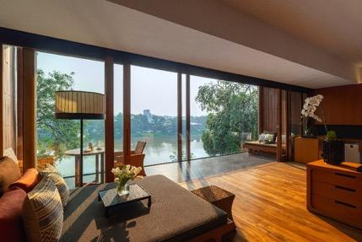
Lanna Riverfront Suite

The Lanna Riverfront Suite starts from USD 730++ per night, including daily breakfast and a collection of exclusive Lanna privileges. Guests booking directly with the resort are welcomed with a bottle of wine and traditional Thai sweets, enjoy an in-suite cocktail-making experience with a curated minibar set, receive a signature Lanna Traveller gift, and benefit from 20% savings on spa treatments and dining, complimentary laundry service, and late check-out until 2.00 pm (subject to availability). The experience is further enhanced with the Path of Blessing, a guided walking journey to nearby cultural landmarks that celebrates the traditions and heritage of Chiang Mai.

Exclusive to the Lanna Riverfront Suite, guests also enjoy a personalised in-suite check-in, a one-time in-suite breakfast during their stay, one complimentary round-trip transfer between the resort and Chiang Mai Old Town or the Nimman area, and a thoughtfully curated farewell gift.

Lanna Riverfront Suite
The resort's three most exclusive suites enjoy a coveted position overlooking the tranquil Mae Ping River, with magnificent views from the bedroom, bathroom, and elegant indoor and outdoor living spaces adorned with Jim Thompson silks. Every stay is thoughtfully elevated with personalised privileges, including in-suite check-in, the option of one in-suite breakfast during the stay, and a collection of exclusive Lanna experiences designed to make each visit truly memorable.
- 105 sqm
- Maximum occupancy: 3 adults or 2 adults and 2 children
- Highlights: Private balcony with river views framed by floor-to-ceiling windows, daybed, separate living and dining areas, rain shower and terrazzo bathtub, 65-inch flat-screen TV, wine chiller, Nespresso coffee machine, minibar, yoga mat, Dyson hair dryer and air purifier.

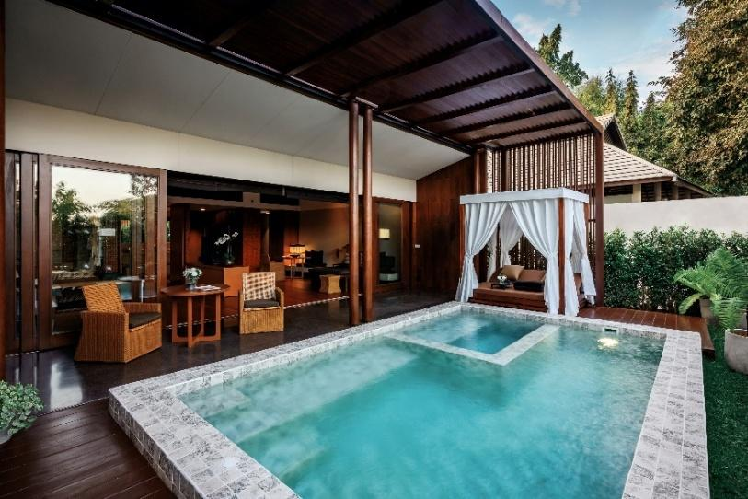
Lanna Pool Suite

The Lanna Pool Suite starts from USD 830++ per night, including daily breakfast and a collection of exclusive Lanna privileges. Guests booking directly with the resort are welcomed with a bottle of wine and traditional Thai sweets, enjoy an in-suite cocktail-making experience with a curated minibar set, receive a signature Lanna Traveller gift, and benefit from 20% savings on spa treatments and dining, complimentary laundry service, and late check-out until 2.00 pm (subject to availability). The experience is further enhanced with the Path of Blessing, a guided walking journey to nearby cultural landmarks that celebrates the traditions and heritage of Chiang Mai.

Exclusive to the Lanna Pool Suite, guests also enjoy a personalised in-suite check-in, one floating breakfast during their stay, one complimentary round-trip transfer between the resort and Chiang Mai Old Town or the Nimman area, and a thoughtfully curated farewell gift.

Lanna Pool Suite
The resort's most exclusive accommodation, the Lanna Pool Suite offers the ultimate in privacy and tranquillity. Hidden amidst lush tropical foliage, this elegant retreat features a temperature-controlled private plunge pool, creating a secluded sanctuary for leisurely days and peaceful evenings.
- 140 sqm
- Maximum occupancy: 3 adults or 2 adults and 2 children
- Highlights: Temperature-controlled private plunge pool with jacuzzi, private cabana and terrace with an outdoor dining table, separate living and dining areas, rain shower and terrazzo bathtub, 65-inch flat-screen TV, wine chiller, Nespresso coffee machine, minibar, yoga mat, Dyson hair dryer and air purifier.

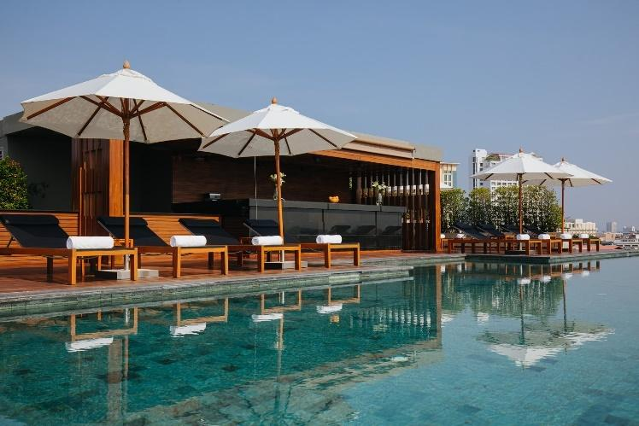
Anantara Chiang Mai Serviced Suites

With only 25 suites spread over seven storeys, Anantara Chiang Mai Serviced Suites offers an exclusive base from which to take in the sights of the Lanna capital. The suites themselves are spacious and fully equipped, ideal for business travellers, families, including those with pets, and long stays. Each consists of ensuite bedrooms, a separate living room, a kitchen and laundry. Guests benefit from complimentary minibar, daily housekeeping, as well as secure parking downstairs and a 24-hour service.
They also enjoy, in additional to the rooftop pool, full access to the facilities of Anantara Chiang Mai Resort, located just across the road and reached via a covered walkway.

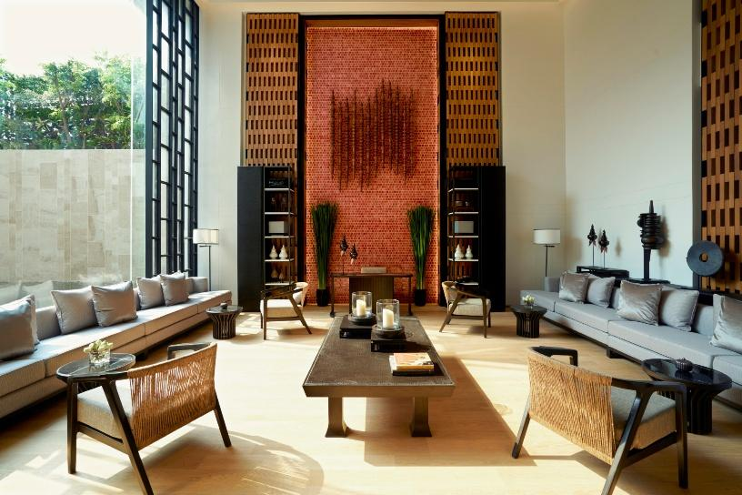
The lobby at Anantara Chiang Ma Serviced Suites

Serviced Suites start from USD 430++ per night, including daily breakfast, exclusive access to a rooftop pool with panoramic city and mountain views, a complimentary minibar, daily housekeeping, secure on-site parking, and personalised 24-hour service.

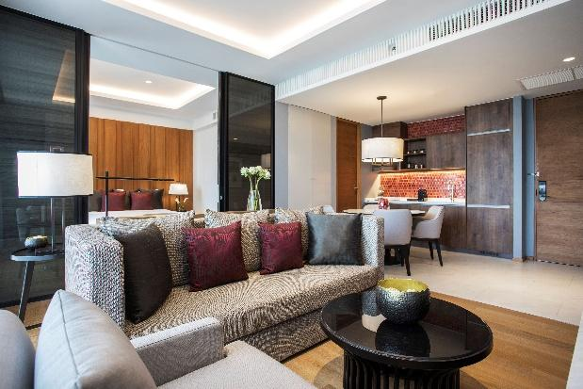
One Bedroom Suite
Guests can enjoy all the comforts of home in the heart of the city at this residence hotel in Chiang Mai.
- 60 Sqm
- Maximum 2 adults
- Highlights include a balcony, living and working spaces, kitchen and dining area, washing machine and dryer, rain shower and Terrazzo tub, complimentary mini bar, 50” flat screen TV, Nespresso coffee machine and mini bar.

Premier One Bedroom Suite
Premier suites enjoy higher-floor views, as well as easy access to the rooftop.
- 60 Sqm
- Maximum 2 adults
- Highlights include a balcony, living and working spaces, kitchen and dining area, washing machine and dryer, rain shower and Terrazzo tub, complimentary mini bar, 50” flat screen TV, Nespresso coffee machine and mini bar.

Two Bedroom Suite
Guests can enjoy all the comforts of home in the heart of the city at this residence hotel in Chiang Mai. Two ensuite bedrooms open onto a shared living and dining room, and cooking and laundry facilities make travelling with children a breeze.
- 90 Sqm
- Maximum 4 adults
- Highlights include a balcony, living and working spaces, kitchen and dining area, washing machine and dryer, rain shower and Terrazzo tub, complimentary mini bar, 50” flat screen TV, Nespresso coffee machine and mini bar.

Premier Two Bedroom Suite
Premier suites enjoy higher-floor views, as well as easy access to the rooftop. Contemporary design is spiced with Thai accents and materials, bathed in natural light through floor-to-ceiling windows.
- 90 Sqm
- Maximum 4 adults
- Highlights include a balcony, living and working spaces, kitchen and dining area, washing machine and dryer, rain shower and Terrazzo tub, complimentary mini bar, 50” flat screen TV, Nespresso coffee machine and mini bar.

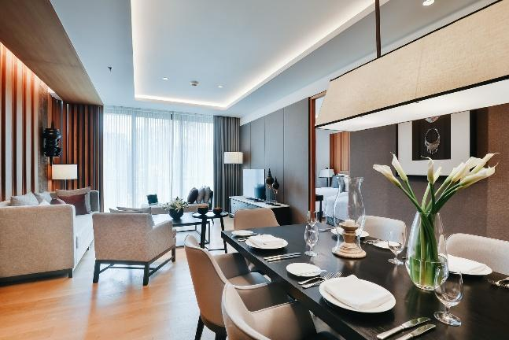
Three Bedroom Suite
This expansive suite is ideal for entertaining while in the city. Three ensuite bedrooms open onto an elegant living and dining room, where guests can host dinner parties at these residences in Chiang Mai with a personal chef and waiters for the evening.
- 160 Sqm
- Maximum 6 adults
- Highlights include a balcony, living and working spaces, kitchen and dining area, washing machine and dryer, rain shower and Terrazzo tub, complimentary mini bar, 50” flat screen TV, Nespresso coffee machine and mini bar.

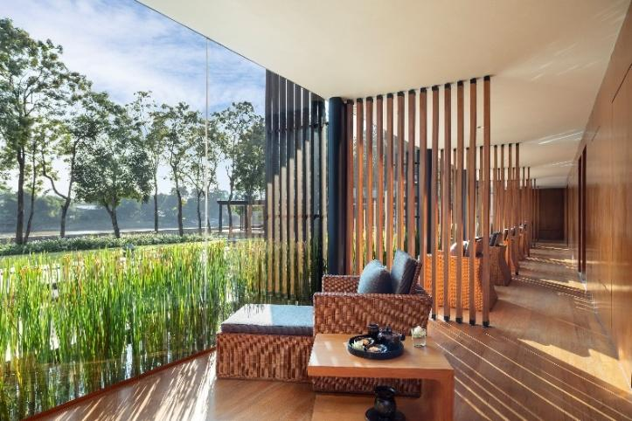

Spa and wellness

A world of wellbeing awaits at the award-winning Anantara Spa. Discover time-honoured signature treatments designed to restore body and mind, experience traditional Lanna healing led by highly trained and certified specialists, or rejuvenate with advanced IV hydration therapies.

- Four individual treatment rooms, each featuring a steam shower and terrazzo bathtub
- Four couples' treatment rooms with an herbal steam room, aromatic sauna and terrazzo bathtub
- Fully equipped fitness centre
- Yoga, Yoga Fly and Pilates
- Tai Chi
- Muay Thai
- Manicure and pedicure lounge
- Indoor relaxation lounge overlooking the resort's riverside pool
- IV Hydrating Drip
- Open daily from 10.00 am to 10.00 pm

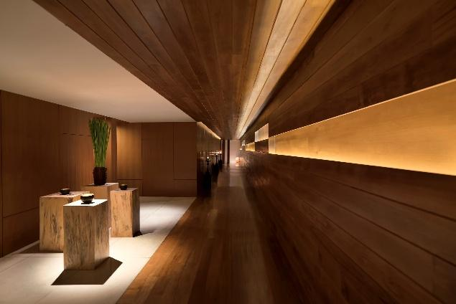
Signature experiences

Lanna Ritual (90 minutes)
From USD130++ per person
The Lanna Ritual at Anantara Chiang Mai Resort is a special wellness and spiritual experience designed to immerse guests in the traditional customs and beliefs of the Lanna culture. It combines elements of traditional healing, spiritual cleansing, and mindfulness, inspired by rituals once practiced in the Lanna Kingdom. This ritual provides a unique way for guests to connect with the local heritage in a peaceful and reflective setting.

Signature Yajoo Massage (60/90 minutes)
From USD 110++/USD 130++ per person
The unique yajoo treatment utilises the healing power of local herb plai to ease tension and to induce deep relaxation. A fragrant herbal poultice is pressed along the body to ease pain and inflammation, followed by a plai oil massage. The experience ends with a gentle scalp massage and tok sen rhythmic tapping on the back.

Tok Sen Therapy (60/90 minutes)
From USD 110++/USD 130++ per person
Rhythmic tapping with a small mallet and wedge made of tamarind wood stimulates the energy points and meridian lines of the body. Deep vibration is combined with manual pressure and passive stretching to transform the body’s energy and mind.

Yam Khang Fire Therapy (60 minutes)
From USD 116++ per person
A sacred art, and as such is a rare and prized treatment. The therapist dips her foot in medicated oil, heats it on an iron ‘khang’ over fire, then massages the body with her foot, relieving pain and releasing blocked energy.

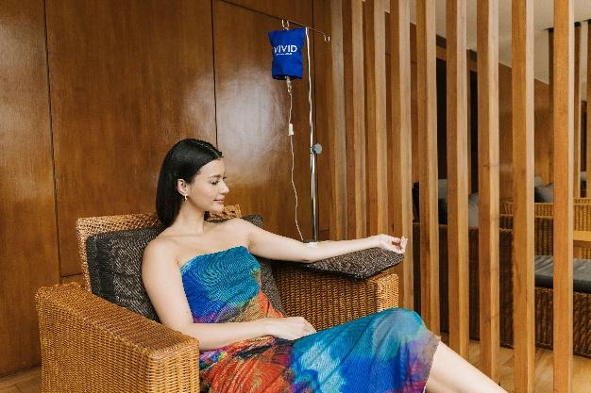

Energy booster invigorate + refresh (15 minutes)
From USD 56++ per person
VIVID by Verita Health is an IV drip bar, anti-ageing and aesthetics hub rolled into one. Located in the heart of the city at Anantara Chiang Mai Resort, VIVID is staffed by a professional team of clinicians who tailor treatments for each patient. Guests can experience an instant boost to their energy levels, as well as improved mental focus and cognitive function with a high dose of Vitamin B12, taurine and alpha lipoic acid. Especially effective as a recovery therapy after a stressful period, this detoxifying treatment is recommended to those who want to be at peak mental and physical performance.

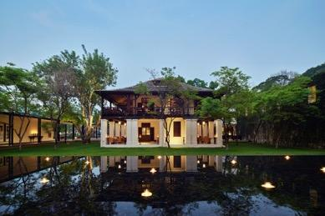

Food & beverage

Anantara Chiang Mai Resort's collection of restaurants and bars showcases exceptional cuisine in distinctive settings, from the historic former British Consulate to the tranquil banks of the Mae Ping River. Whether savouring premium steaks and seafood, indulging in a leisurely afternoon tea or raising a handcrafted cocktail at sunset, every experience is thoughtfully curated to celebrate the flavours, heritage and charm of Chiang Mai.

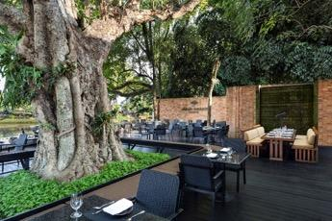

Bodhi Terrace
North to South Thai
Breakfast: 06:30 am – 10:30 am | Lunch: 12:00 pm – 2:30 pm | Dinner: 5:30 pm – 10:30 pm
Bodhi Terrace celebrates the diverse regional cuisines of Thailand, enriched by the country's long-standing cultural exchanges with its Southeast Asian neighbours. Discover the bold spices and vibrant flavours of the South, influenced by Malay and Hokkien traditions, alongside the fragrant curries and distinctive specialities of Northern Thailand, including beloved Chiang Mai classics.

Must try dishes:
- Khao Soi River Prawn or Wagyu Beef
- Yum Bai Cha
- Moo Hong
- Pad Thai Chaiya
- Pad Kraprao Wagyu
- Seafood Khantoke (seasonal)

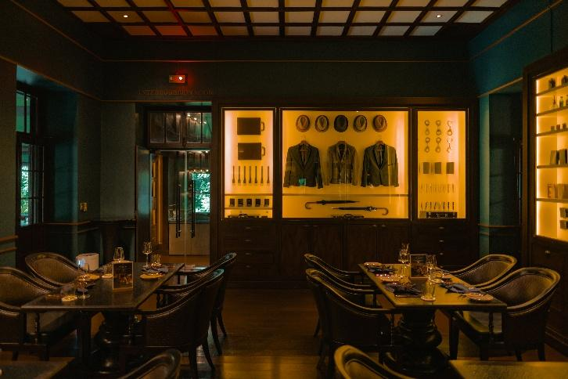

The Service at 1921 House
Contemporary steakhouse and grill
Daily: 12:00 pm – 10:30 pm
Housed within the resort's magnificent century-old former British Consulate, The Service at 1921 House is Chiang Mai's signature contemporary steakhouse and grill. Prime cuts, premium seafood and the restaurant's own in-house dry-aged beef are expertly prepared over a Josper charcoal oven, delivering exceptional flavour with a distinctive smoky finish. Guests can also explore The Service Cocktail Book, where signature cocktails inspired by the world of Her Majesty's Secret Service sit alongside timeless Classic Empire Cockails, complemented by an extensive wine collection.

Must try dishes:
- Royal Oscietra Caviar
- The Service Grand Platter
- Beef Tartare
- Tournedos Rossini
- Mayura Wagyu A4, Australia
- Arigaton Port Belly Ribs
- Tasmanian Half Rack of Lamb
- Whole Andaman Mullet
- Charcoal-Roasted Leek (v)
- Our Eton Mess
- The Service Chocolate Caviar
- 1921 House Crumble

Must try cocktails:
- Operation Nightingale
- Black Gold
- Black Lens
- Red Seal
- Vesper Martini
- White Lady

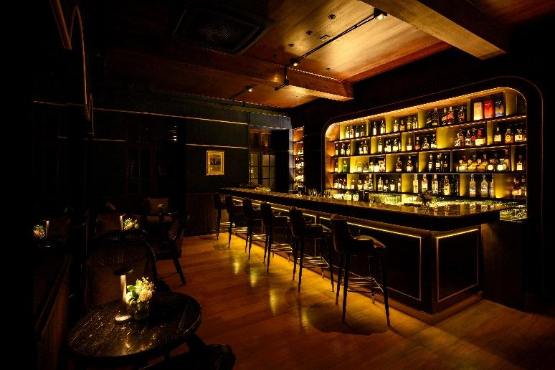

Brit Bar at 1921 House
Old World drinks and conversations
Daily: 12:00 pm – 12:00 am
Step into the timeless elegance of Brit Bar at 1921 House, where a classic bar, leather-upholstered armchairs and vintage prints evoke the charm of a traditional British members' club. Signature cocktails inspired by iconic decades—from the glamour of the Roaring Twenties to the vibrant spirit of the Retro Sixties and the bold indulgence of the Decadent Eighties—are served alongside British-inspired comfort dishes, premium oysters and sharing plates, creating the perfect setting for leisurely conversations and evening aperitifs.

Must try bites and cocktails:
- Spiced Calamari
- Wagyu Sliders
- 1921 Prawn Cocktail
- The roaring 20’s
- The retro 60’s: Ankle biter style
- The decadent 80’s: gnarly style

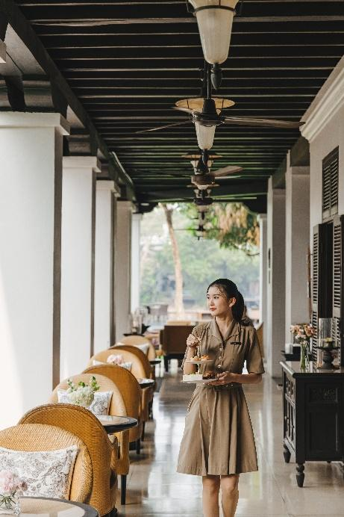

The Verandah at 1921 House
Casual bites accompanied by a river breeze
Daily: 12:00 pm – 12:00 am
The ground floor of the resort’s century-old teak mansion enjoys cool breezes from the river during the day. Guests are invited to taste their way through a light lunch followed by the famous afternoon tea

Must try experience and dishes:
- The seasonal afternoon tea
- Local Heritage Tomato Salad
- Angus Steak & Stout Pie
- Pulled Pork Sandwich
- Beer-Battered Cod

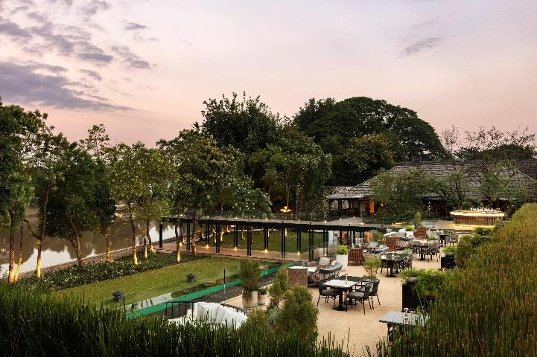

Bubbles
Rooftop Bar
Daily: 5:00 pm –10:00 pm
Chiang Mai’s Rooftop Cocktail Bar enjoys a magical setting overlooking the Ping River. A table for two awaits at the end of the glass walkway at river’s edge, perfect for a romantic proposal or anniversary, and only available with advanced reservation.

Must try cocktails:
- Garnet Crown
- Mea-Kha-Nhing
- Pink Tournaline
- Tiger’s Eye

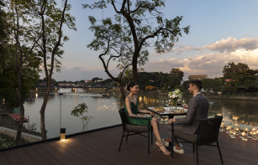

Designer Dining
Starting from USD 100++ per person
Guests can choose to dine in a pavilion on the waterfront law or at the end of the glass walkway at river’s edge. Designer Dining by Anantara brings cuisine and romance to once-in-a-lifetime settings. The menu is crafted in collaboration with guests’ personal chef and each experience includes a discreet butler service and carefully paired wines.

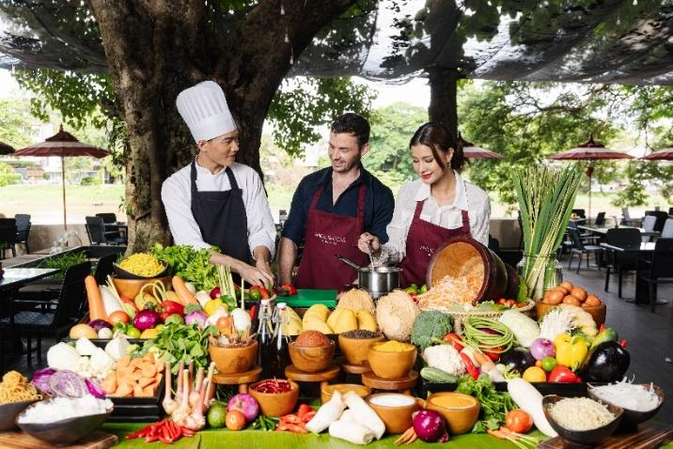

Signature in-resort experiences

Afternoon Tea at the Verandah at 1921 House
Daily: 2:00 pm – 5:00 pm
Starting from USD 40++ per person

Nestled amidst the shade of the resort’s century-old teak mansion, that once served as the British consulate, guests can partake in the very British ritual of Afternoon Tea. Guests will begin their afternoon tea experience with savoury bites including cucumber and cream cheese tartlet, and black truffle arancini, as well as delicate finger sandwiches featuring coronation chicken and spiced mango, and smoked salmon with chive and roe on brioche. Sweet treats will follow including black sesame and mango crème choux, and of course traditional scones with a Thai twist.

Spice Spoons Thai cooking class
Daily: 10:00 am -11:30 am
Starting from USD 95++per person, with minimum two persons per booking
Discover the secrets behind your favourite Thai recipes in a step-by-step class that begins with a guided visit to the local market. Together with our chef, explore the colourful stalls brimming with fresh, fragrant produce, sampling local snacks along the way. Back at the resort, roll up your sleeves to prepare your chosen dishes, then savour your creations over a delightful lunch.
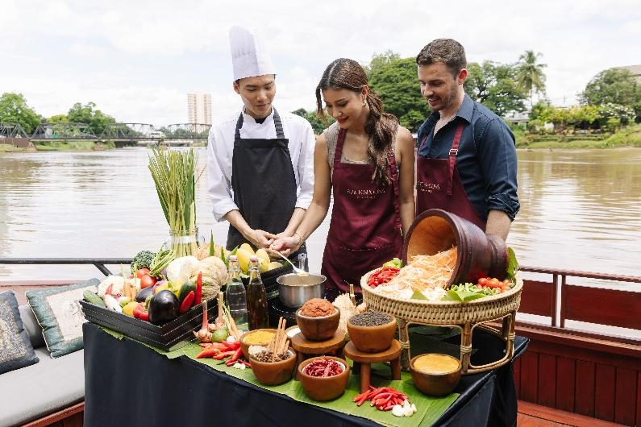

Spice Spoons Thai cooking class on cruise
Starting from USD 117++ per person, with minimum two persons per booking
Embark on a culinary journey like no other aboard Nam Jit, our elegant teak pontoon. Enjoy your cooking class as you drift down the tranquil Mae Ping River, combining authentic flavours with an unforgettable setting.

Tung flag making
Every Monday: 3:30 pm
Complimentary for guests
The Tung flag (or Tung) is a traditional decorative banner commonly used in the Lanna culture of northern Thailand. These flags are notable for their vibrant colours and intricate designs, often carrying significant cultural, spiritual, and ceremonial meanings.

Floral art
Every Tuesday: 3:30 pm
Complimentary for guests
Floral art in the context of Lanna culture and Thai traditions encompasses a variety of practices involving flowers, which are integral to religious ceremonies, festivals, and everyday life. This art form reflects the deep appreciation for nature, beauty, and spirituality in Thai culture, particularly in the northern region of Thailand

Mocktail making
Every Wednesday: 3:30 pm
Complimentary for guests
Guests are invited to prefect the art of creating non-alcoholic beverages using local ingredients and herbs.

Soap carving
Every Thursday: 3:30 pm
Complimentary for guests
Soap carving in the context of Lanna culture refers to the traditional art of carving glycerin soap into intricate designs, often inspired by the rich cultural heritage of northern Thailand. This craft is not only a form of artistic expression but also a way to celebrate the unique aesthetics and symbols found within Lanna culture such as flowers and nature motifs.

Sketching masterclass
Every Friday: 3:30 pm
Complimentary for guests
This workshop is designed to support artists of all levels improve their sketching skills through structured guidance, techniques, and personalized feedback.

Herbal compress making
Every Saturday: 3:30 pm
Complimentary for guests
Herbal compress making is a traditional practice in Lanna culture, particularly in northern Thailand, where the use of herbal compresses has been integrated into wellness and healing rituals. These compresses are typically made from a combination of local herbs such as lemongrass and tumeric and other natural ingredients such as rice, which are wrapped in fabric and steamed or heated before being applied to the body.

Fruit carving
Every Sunday: 3:30 pm
Complimentary for guests
This intricate craft involves sculpting fruits and vegetables such as watermelon, papaya and pineapple into elaborate designs, often used for decoration, celebration, and presentation in culinary contexts. Fruit carving reflects the region's artistic heritage and is deeply rooted in Thai culture, showcasing the creativity and skill of artisans.


Tok Sen

Tok Sen therapy workshop
Every Monday: From 10:30 am - 11:00 am
Complimentary for guests
Learn the Thai wisdom of Tok Sen, rhythmic tapping with a small mallet and wedge made of tamarind wood stimulates the energy points and meridian lines of the body

Aerial Yoga
Every Monday, Tuesday and Wednesday: From 4:00 pm – 5:00 pm
Group sessions start from USD 23 per person
Guests can take an Aerial Yoga class and restore their inner harmony and body flexibility.

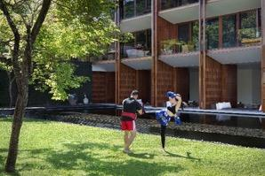

Thai Boxing
Every Thursday, Saturday and Sunday: From 4:00 pm – 5:00 pm
Group sessions start from USD 23 per person
Guests can discover Thailand’s national sport, the traditional martial art of Thai Boxing of Muay Thai with a professional coach.

Core and lower body workout
Every Wednesday and Sunday: From 1:00 pm – 2:00 pm
Complimentary for guests
Strengthen your core and lower body with this invigorating workout, designed to tone muscles and improve balance. Perfect for all fitness levels, this complimentary session is exclusive to our in-house guests, offering a dynamic mix of exercises to energise your day. Join us and embrace a healthier, stronger you.

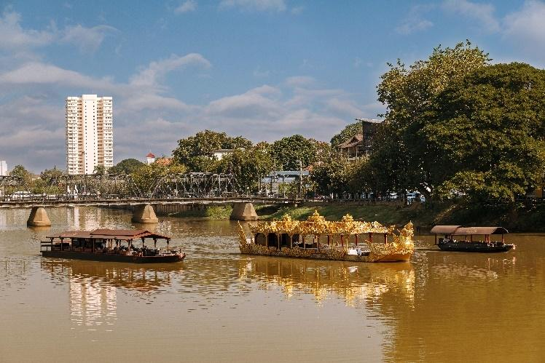
Nam Jit, Dibba Yana Chitta and Nam Jai

Signature cultural experiences

JAO ping river cruise
- Morning voyage: 9:00 am – 10:30 am: Including adventure to nearby Wat Ket Karam, making merit at the temple – Nam Jai
- Afternoon tea cruise: 2:00 pm – 3:30 pm: Including the very English ritual of afternoon tea – Nam Jit or Nam Jai
- Sunset cruise: 6:00 pm – 8:00 pm: A choice of a free-flow drinks and canapes, or a four-course dinner of royal Thai cuisine – Nam Jit
Cruises start from USD 70++ per person including canapes and free-flowing beverages or a four-course dinner (food only) – Dibba Yana Chitta

Located right on the banks of the river, and with a private pier, Anantara Chiang Mai is the starting off point for wondrous cruises through the city. Guests can journey in style aboard three types of boats; Nam Jai, the teak scorpion-tail barge, which drifts under iconic bridges, past small temples and into lush green. Or the Nam Jit, the resort’s teak rice barge, which sails along the Mae Ping River, passing some of the city's most iconic bridges, small temples, and lush greenery. The latest addition to JAO Ping River Cruise fleet is Dibba Yana Chitta, a floating masterpiece designed by a renowned Thailand’s artist, Chalermchai Kositpipat.

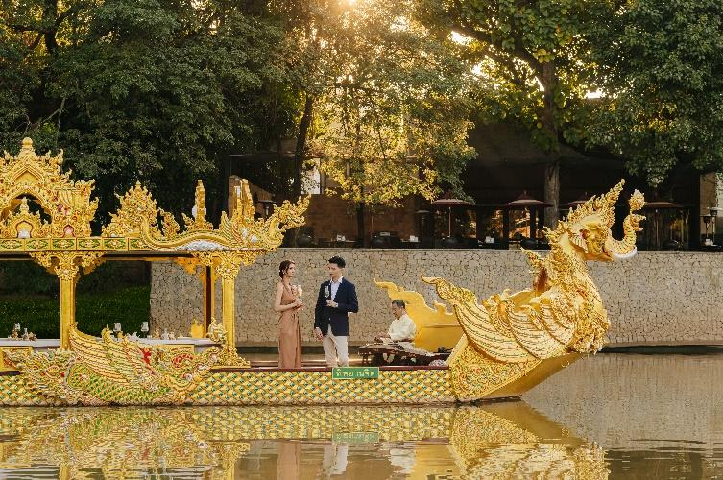
Dibba Yana Chitta

JAO ping river cruise- Dibba Yana Chitta
- Dinner cruise: 5:30 pm – 8:00 pm: Including seven course of royal Thai cuisine, by a renowned guest chef with a MICHELIN star and Thai costume on loan.
Dinner is priced at USD 200++ per person, with an additional USD 60++ for wine pairing.

Described as one of northern Thailand’s most spectacular vessels, Dibba Yana Chitta or ‘Heavenly Boat’ is designed by acclaimed Thai Artist, Ajarn Chalermchai Kositpipat, known worldwide for his famous ‘White Temple’ in Chiang Rai. The boat’s design depicts the journey from this world to the next and the vessel’s figurehead has been hand-carved into a mythical creature, symbolising the transport of humans along the river to heaven. Highly exclusive, with only 18 seats, guests on board can indulge in the finest Thai dining experience. Each season, a new tasting menu is to be curated by the kingdom’s top Michelin-starred chefs, with the inaugural menu by Chef Piyachart Phudtawong (nicknamed Boy) of Saneh Jaan restaurant in Bangkok.

Streetwise Insider
Daily: 9:00 am – 1:00 pm / 9:00 am – 3:30 pm (Half day/Full day)
From USD 87++ / USD 116++ per person, minimum 2 persons per booking
Guests are invited to discover the best introduction to the old city of Chiang Mai and experience the charm of the local people with the Streetwise Insider Tour. The day begins with an exploration of the city's historic gates and corners with a friendly tuk-tuk driver and a professional tour guide. A quick stop for local breakfast, before guests continue to explore iconic sites of the region including Chedi Luang and Pan Tao Temples. The days ends with some time at the lively Warorot Market, and the charming Ton Lam Yai Market, as well as a local coffee shop.



Fun fly paramotor
Daily: 5:30 am – 8:00 am
From USD 170++ per person, 20-minute flight (Transfer not included)
Fun Fly Paramotor in Chiang Mai offers an exhilarating experience for adventure seekers and flying enthusiasts. Paramotoring, also known as powered paragliding, invites individuals to fly with a lightweight motor attached to a paraglider, providing a unique and accessible way to explore the stunning mountains, valleys, and scenic landscapes surrounding Chiang Mai.

Wat Phra That Doi Suthep: a spiritual gem of Chiang Mai
Daily: 9:00 am – 5:00 pm
30-minute drive
As the locals say, a trip to Chiang Mai isn't complete without experiencing the majesty of Wat Phra That Doi Suthep. Dating back to the early 19th Buddhist century, Wat Phra That Doi Suthep stands as the most significant temple in Chiang Mai. Located on the top of Suthep Mountain, the temple's beauty is undeniable, marked by the impressive seven-headed serpent statues flanking the staircase. As you ascend, prepare to be awestruck by the Chiang Saen-style golden pagoda and the exquisite Lanna architecture that surrounds it. The panoramic view of Chiang Mai from this vantage point is simply phenomenal.

Tha Phae Gate
Daily 24/7
20-minute walk
Tha Phae Gate is an ancient landmark in Chiang Mai, part of the historic wall that surrounds the city's moat. Situated on the eastern side of the wall, this gate was originally built as one of the main entry points into the old walled city of Chiang Mai. Entering the city through Tha Phae Gate allows guests to explore the entire old city, leading them to the starting point of the Sunday Night Bazaar as well as several nearby temples and attractions that line the wall.

Tha Phae Walking Street (Sunday Night Market)
Every Sunday, 5:00 pm – 10:00 pm
20-minute walk
Tha Phae Walking Street, also known as the Sunday Night Market, is a vibrant pedestrian market that takes place every Sunday. It offers a wide variety of items that appeal to both locals and tourists, including hill tribe products, wood carvings, and handicrafts. The market extends along Ratchadamnoen Road, branching out at the intersection leading to Wat Phra Singh.

Wat Chedi Luang
Daily: 5:00 am – 10:00 pm
15-minute drive
Wat Chedi Luang, a historic 14th-century temple in Chiang Mai, is celebrated for its massive chedi (pagoda), which originally stood 98 metres tall and 54 metres wide. Completed in 1481 during King Mengrai’s reign, the chedi was partially destroyed by an earthquake in 1545 and later restored. The temple is a fine example of Lanna architecture, featuring a striking Naga staircase and an ornate ordination hall. The City Pillar Shrine or Sao Inthakin, housed within the temple, was erected in 1296 by King Mengrai. Each year, an annual celebration known as ‘Sao Inthakin’ honours the city pillar, typically occurring in May or June.

Bo Sang Umbrella Village
Daily: 9:00 am – 5:00 pm
40-minute drive
Situated in the San Kamphaeng district, guests will find renowned skilled artisans who meticulously craft traditional Thai umbrellas. Here, they can witness the intricate process of making these stunning pieces, from hand-painting delicate designs to the careful assembly of bamboo and cotton. Visitors can even try their hand at creating their own umbrell.

Wat Sri Suphan Community
Daily: 9:00 am – 5:00 pm
10-minute drive or 20-minute walk
This community is celebrated for its exquisite silver craftsmanship. Guests can watch skilled artisans transform raw silver into intricate jewellery and decorative items, showcasing traditional techniques passed down through generations. The dazzling silver pieces reflect not only the artistry of the makers but also the cultural significance embedded in each creation.

Wat Ket Community
Daily: 9:00 am – 5:00 pm
15-minute drive
Along the banks of the serene Ping River, Wat Ket Community is a melting pot of cultures, shaped by Chinese traders, Western missionaries, and local residents. This vibrant area showcases a diverse architectural heritage that tells the story of its rich past. At the heart of the community stands Wat Ket Karam, an important historical site that once served as a bustling boat landing for trade routes from Bangkok to Chiang Mai.

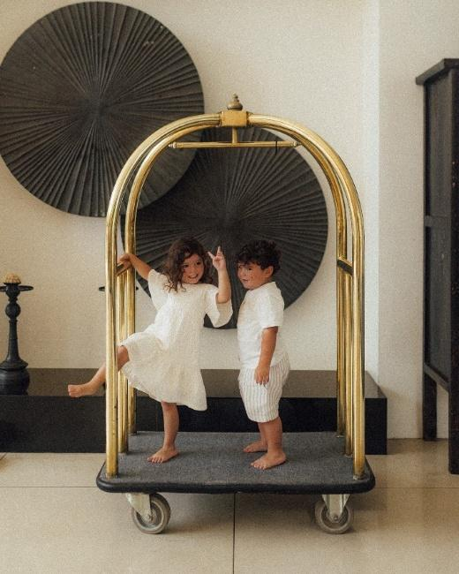

For Families
Children are welcome, and under-4s stay free if they share parents' bedding. Extra beds for 4–11-year-olds cost USD 42++ a night (including breakfast), and USD 83++ a night for over-11s. Babysitters can be booked on request, and a children’s menu can be found across all restaurants.

Babysitting service
From USD 12 per hour for 1 child, USD 18 per hour for 2 children
Adults can enjoy some me time, knowing their children are in safe hands. The resort offers professional nanny services by accredited, first-aid trained childcare experts.

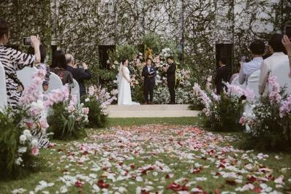
Weddings, meetings and events
Meetings and events
Starting from USD 56++ per person for a full-day meeting
Just a 15-minute drive from Chiang Mai International Airport, Anantara Chiang Mai Resort offers an exceptional setting for corporate gatherings, conferences and incentive events. Guests can host productive meetings in the resort’s dedicated function room, equipped with video conferencing facilities and comprehensive audiovisual technology. Delegates can enjoy coffee breaks or lunch on the peaceful riverside deck or the charming veranda of the heritage house.
Venues and capacities
- Function Room: 146 sqm | up to 120 guests
- Riverside Lawn: up to 120 guests
- The Service at 1921 House: up to 100 guests
- Bodhi Terrace: up to 120 guests
- Bubbles Rooftop Bar: up to 80 guests

Weddings
Starting from USD 5,475++
Couples can celebrate their special day with a traditional Thai ceremony set against the backdrop of a century-old heritage house, or exchange vows on a rooftop terrace overlooking the Mae Ping River. Among Chiang Mai’s most sought-after wedding venues, the resort’s riverside deck and lawn provide an elegant setting for intimate celebrations, sophisticated soirées and grand wedding banquets.

From bespoke ceremonies to personalised receptions, every wedding at Anantara Chiang Mai Resort is thoughtfully curated to create a memorable celebration reflecting each couple’s unique story.

Guests With Disabilities
Rooms on the ground floor can accommodate guests with mobility limitation.

Awards and recognitions
2026
• #1 Upcountry Hotels in Thailand, Travel + Leisure Luxury Awards Asia Pacific 2026
• #5 Best Hotel Pools in Thailand, Travel + Leisure Luxury Awards Asia Pacific 2026
• Best Spotlight 2026, Tatler Thailand
• Triple Crown 2026, Condé Nast Traveller
• Traveler Choice Awards 2026, TripAdvisor (JAO Ping River Cruise)
-----

Media contact
Ms. Supa-arpha Itthikaiwan (Mandy)
Cluster Director of Marketing & Communications
Anantara Chiang Mai Resort | Anantara Golden Triangle Elephant Camp & Resort
E: supaarpha_it@anantara.com
T: +66 (0) 53 333 337

