
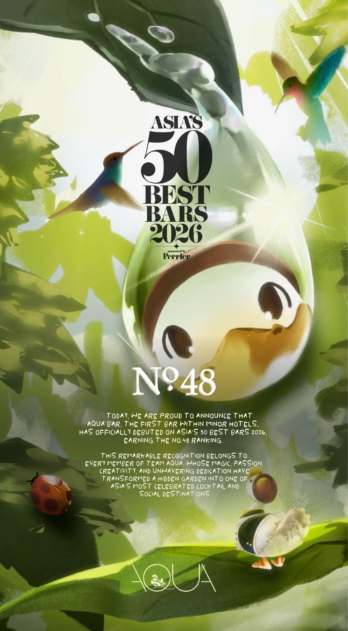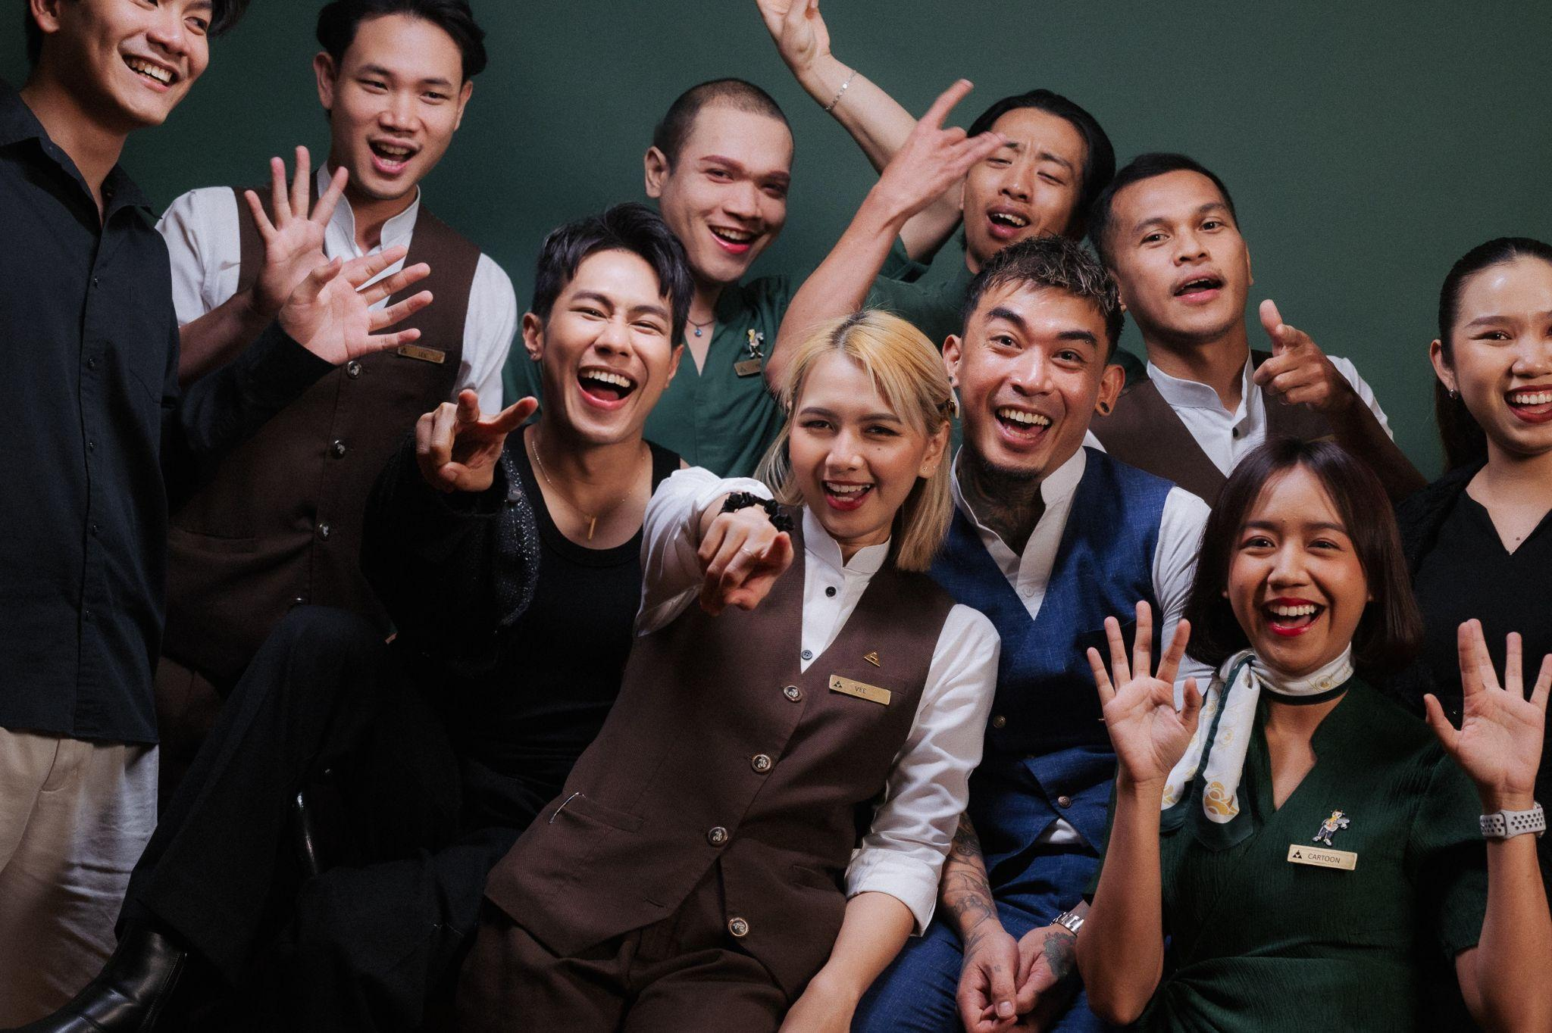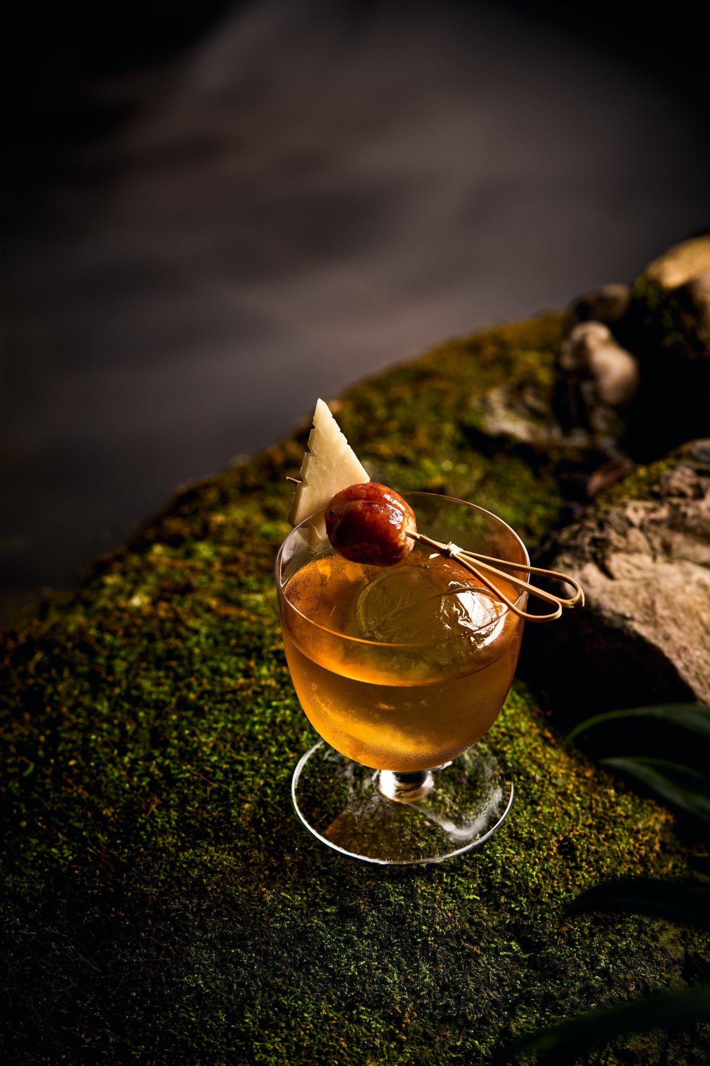
AQUA Bar at Anantara Siam Bangkok Debuts on Asia's 50 Best Bars 2026
Bangkok's cocktail garden earns regional recognition with a reimagined menu built around storytelling and its resident duck
Link to the Images HERE
BANGKOK, 29 July – AQUA Bar at Anantara Siam Bangkok Hotel has been named a new entrant on Asia's 50 Best Bars 2026, announced on 28 July at Wynn Palace, Macau. The recognition lands the bar at No. 48 on the region's most closely watched list, and comes on the back of AQUA's reimagined identity and cocktail programme, set within Parichart Court, the hotel's courtyard garden in the heart of Ratchaprasong.

Asia's 50 Best Bars described AQUA as a square driftwood bar set inside a genuine escape from one of Bangkok's busier districts, ringed by trickling fountains and hanging greenery. By day, that's exactly what it delivers: quiet, shade and distance from the traffic outside the hotel walls. After dark, resident DJs take the same courtyard somewhere livelier, the calm giving way to something with more edge without losing the garden underneath it.
At the centre of the bar's reinvention is Quill the Duck, a character built as a nod to the ducks that once wandered Parichart Court's ponds. Quill now fronts the new cocktail programme, Potions of the Garden, developed by Beverage Manager Ryan Dela Vega around a drinks list the judging panel singled out for its playful narrative and its confident use of heat, spice and umami.

The menu runs from daylight into midnight with clear intent. Dewdrop Whisper opens gently, Roku gin and elderflower served in duck-footed glassware made specifically for the drink. Pomelo's Embrace turns local and savoury, pairing Phraya Gold Rum with ruby pomelo and a hit of fiery Esan sausage. Later in the evening, Off the Duck's Back layers Palo Santo-infused gin with matcha and crispy duck skin, and Quill's Midnight Spell closes the night on tequila and mezcal, served with spiced golden street corn elote. Asia's 50 Best Bars called the pairing of technical mixology with warm hospitality the reason guests stay for one more.

Being named among Asia's finest bars marks a defining moment for AQUA Bar, reinforcing its place as one of Bangkok's more distinctive cocktail addresses. Whether discovering AQUA for the first time or returning for the new menu, guests are invited into a courtyard built around slowing down and staying a little longer.

"Every drink on this menu started as a small idea, a memory, an ingredient, or sometimes just a texture I couldn't stop thinking about. Every detail matters, from the story behind each cocktail to the way it's served. This recognition means so much to all of us because it reflects the passion, creativity, and care we put into every guest experience."— Ryan Dela Vega, Beverage Manager, AQUA Bar at Anantara Siam Bangkok Hotel

AQUA Bar is open nightly from 12.00 pm to 00:30 am, located on the ground floor of Anantara Siam Bangkok Hotel, 155 Rajadamri Road, Bangkok, Thailand.

- Ends -

About AQUA Bar
For more than 20 years, AQUA has established itself as an institution, favoured as an elegant escape in the heart of bustling Ratchaprasong. And now, after extensive renovations, the hidden oasis warmly welcomes you back. Clink crystal glasses of artfully crafted classic cocktails beside the signature koi pond. Unwind to New Orleans Jazz and R ‘n’ B amid the verdant fronds. Whether a special occasion or intimate rendezvous, AQUA is the setting in which to be seen.
https://www.aquabangkok.com/
_____________________________________________________________________________________________
For media inquiries, please contact: For media inquiries, please contact:
Sunny Chawla (Sunny) Natchuda Noppisarnwong (Bambi)
Area Director of Public Relations Public Relations Executive - International Tel: 02-126-8866 ext.1511 Tel: 02-126-8866 ext.1532
Email: sunny_ch@minor.com Email: natchuda_no@anantara.com

