LEADERSHIP BIO
Natruthai Petsuwan – Executive Chef

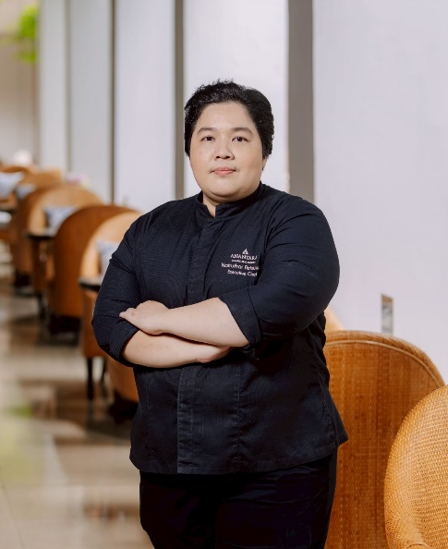

Chiang Mai, Thailand – Known to guests as Chef Sai, Natruthai Petsuwan is Executive Chef of Anantara Chiang Mai Resort, a contemporary luxury riverside resort set on the former British Consulate grounds beside the Mae Ping River.

She joined Anantara Chiang Mai Resort as Executive Sous Chef in 2022 and was promoted to Executive Chef in 2025, reflecting her culinary leadership and continued progression within the company. She brings international experience spanning Thailand, China and the Middle East, following culinary roles with Shangri-La, Marriott, Fairmont and Sheraton. A graduate of Dusit Thani College in Bangkok, Chef Sai joined Anantara in 2016 and later supported the openings of Avani resorts in Lanta, Samui and Krabi before moving to Chiang Mai.

Her culinary philosophy combines fresh ingredients, established techniques and a strong sense of regional identity. Across Bodhi Terrace, The Service at 1921 House, Spice Spoons Thai cooking classes and the resort’s JAO Ping river cruise fleet, she brings together Northern Thai flavours, the cuisine of her native southern Thailand and contemporary international dining. For interview requests relating to Natruthai Petsuwan or the culinary offerings at Anantara Chiang Mai Resort, please contact natruthai_pe@anantara.com.

…Ends…

Editor’s notes

About Anantara Chiang Mai Resort
Anantara Chiang Mai Resort is a contemporary riverside retreat on the former British Consulate grounds in central Chiang Mai. The resort comprises 52 rooms and 34 suites, with 25 one-, two- and three-bedroom serviced suites linked across the road. Kerry Hill’s low-rise design surrounds a garden courtyard and centres on the century-old 1921 House, now home to dining and social spaces. Guests can explore Lanna culture and the city’s old quarter, depart on daily cruises from the private pier, dine beside the Mae Ping River, and access Anantara Spa, a 34-metre riverfront pool and event spaces for up to 120 guests. Chiang Mai International Airport is approximately 15 minutes away.

About Anantara Hotels & Resorts
A luxury hospitality brand for modern travellers, Anantara Hotels & Resorts connects guests to genuine places, people and stories in some of the world’s most extraordinary destinations. Each Anantara embraces the surroundings and culture of its destination, creating unforgettable memories for every guest since 2001. From city to sea and desert to jungle, Anantara delivers heartfelt, Thai-inspired hospitality at its over 50 hotels and resorts across Asia, Europe, Africa, the Middle East and the Indian Ocean.

Anantara Hotels & Resorts is a Minor Hotels brand and recognises its guests through one unified loyalty programme, Minor DISCOVERY, part of GHA DISCOVERY.

Visit anantara.com for more information, and connect with Anantara on Facebook, Instagram, TikTok, X and YouTube.

About Minor Hotels
Minor Hotels is a global leader in the hospitality industry with more than 640 hotels, resorts and branded residences in operation and committed development across 66 countries. The group crafts innovative and insightful experiences through its hotel brands including Anantara, Elewana Collection, The Wolseley Hotels, Tivoli, Minor Reserve Collection, NH Collection, nhow, Avani, Colbert Collection, NH, Oaks, and iStay, as well as a diverse portfolio of restaurants and bars, travel experiences, and spa and wellness brands. With over four decades of expertise, Minor Hotels builds stronger brands, fosters lasting partnerships, and drives business success by always focusing on what matters most to our guests, team members and partners.

Minor Hotels is a proud member of the Global Hotel Alliance (GHA) and recognises its guests through one unified loyalty programme, Minor DISCOVERY, part of GHA DISCOVERY.

Discover our world at minorhotels.com and connect with Minor Hotels on Facebook, Instagram, LinkedIn, TikTok and YouTube.

-----
Media contact
Supa-arpha Itthikaiwan (Mandy)
Cluster Director of Marketing & Communications
Anantara Chiang Mai Resort | Anantara Golden Triangle Elephant Camp & Resort
T: +66 (0) 53 253 333
E: supaarpha_it@anantara.com

