Anantara Golden Triangle Elephant Camp & Resort
Press Kit
2026

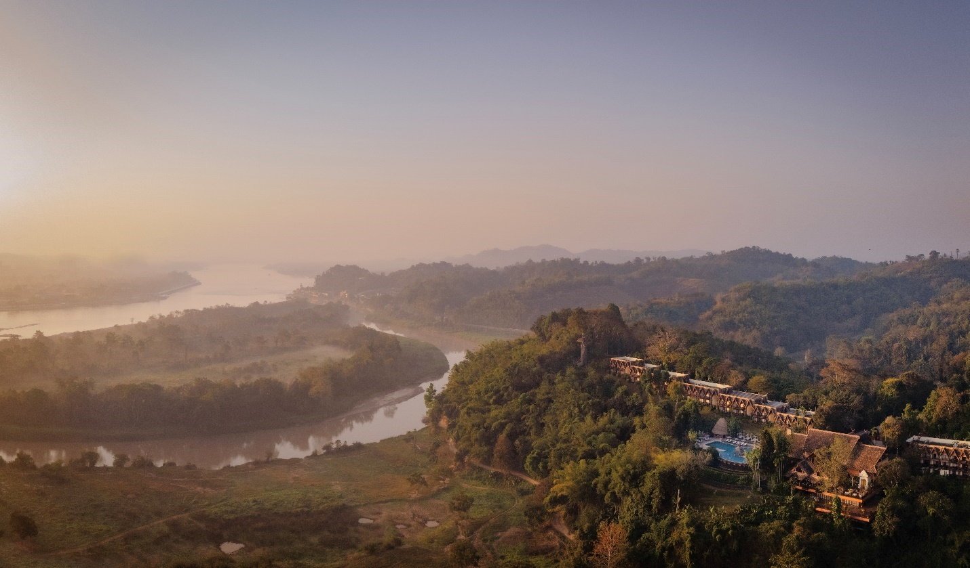

Anantara Golden Triangle Elephant Camp & Resort is a luxury resort nestled in the serene hills of Northern Thailand, where the borders of Thailand, Laos, and Myanmar meet. Surrounded by a 160-acre bamboo forest and gardens meticulously landscaped by Bill Bensley, this stunning retreat offers unparalleled views of the lush jungle and the mighty Mekong River. Known for its commitment to sustainable tourism and wildlife conservation, the resort is home to the Golden Triangle Asian Elephant Foundation's 20 rescued elephants, which provides sanctuary while offering guests the opportunity to engage in ethical, educational and immersive experiences with these gentle giants. Guests at Anantara Golden Triangle can enjoy world-class amenities, including luxurious suites, fine dining with flavours inspired by local and international cuisines, a rejuvenating spa, and an infinity pool overlooking the sweeping landscape. The Golden Triangle Luxury Explorer Package also includes unique cultural and adventure excursions, such as guided jungle walks, excursions into local villages, and cooking classes. Anantara Golden Triangle is more than just a destination; it's an invitation to reconnect with nature, explore new cultures, and find inner peace in the heart of Southeast Asia.

Topline Facts
- Management: Minor Hotels
- Ownership: Minor Hotels
- General Manager: Jean Marc Pougnet
- Architect: Mon Tri (Full name: Mom Luang Tridhosyuth Devakul)- a descendant of the Thai royal family (King Rama IV).
- Interior designer: John D. Lightbody
- Landscape designer: Bill Bensley
- Built: 1989 as the Baan Boran. Translated literally this means “Ancient House” or “House of Antiques” based on the array of genuine antique carvings found throughout the property
- Opened (as Anantara): 1st October 2003
- Room inventory: 63 Rooms, Suites and Tents
- Starting rate: Suites start from USD1,600 per night, including breakfast, lunch and dinner, and one experience per night.
- Address: 229 Moo 1, Chiang Saen, Chiang Rai 57150, Thailand
- Tel: +66 53 784 084
- Email: goldentriangle@anantara.com
- Website: anantara.com/golden-triangle-chiang-rai
- Instagram: @anantara_goldentriangle
- Facebook: @AnantaraGoldenTriangleElephantCamp&Resort
- TikTok: @anantaragoldentriangle
- Press kit and photography: https://media.minorhotels.com/en-GLO/assets/232125/

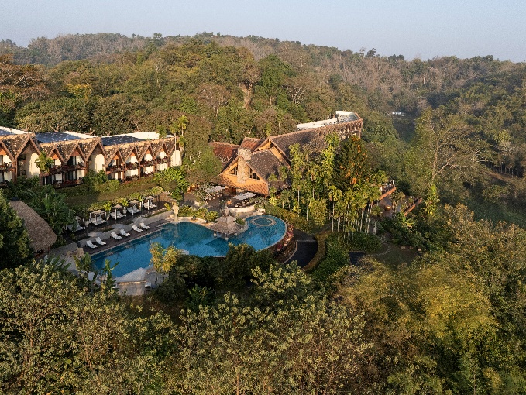

Location

Located at the crossroads of Thailand, Laos, and Myanmar, the Golden Triangle was once an infamous global hub for opium production. Over time, it has shed its dark legacy and evolved into one of the most captivating destinations in Southeast Asia. Nowadays, the Golden Triangle stands as a symbol of transformation, where centuries-old traditions, vibrant ethnic communities, and raw natural beauty intertwine to create an unforgettable journey. The region is characterised by several mountain ranges and offers more seasonal variation than other parts of central and southern Thailand. Native to the region are the hill tribe people, who inhabit the high mountain regions of northwestern Thailand, including the Akha, Yao, Lahu, Lisu, Hmong and Karen people. The resort itself is one hour away from Chiang Rai International Airport (CEI) and Chiang Rai City at the centre of the Golden Triangle.

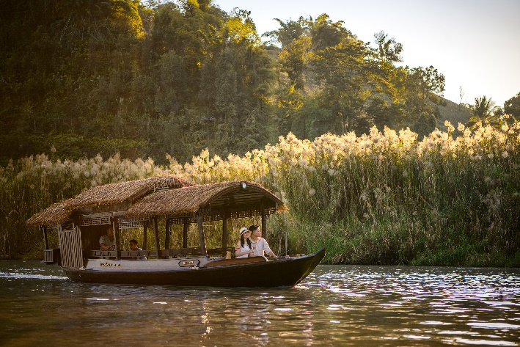

Getting here

A scenic one-hour drive from Chiang Rai Airport (60kms), guests are invited to avail three types of transfer to the resort: traditional longtail boat, car or helicopter.

The resort’s signature Explorer’s Arrival includes a private car from Chiang Rai Airport to the historic riverside town of Chiang Saen, just 15 km south of the resort. A traditional longtail boat or Nakara Boat, a beautifully restored Eiam Chun teak vessel, then guides guests up the mighty Mekong River to where Thailand, Laos and Myanmar converge, and the Golden Triangle begins. The boat pulls up at the resort’s private jetty on the banks of the Ruak River, complete with a welcome committee of elephants. The Explorer’s Arrival takes approximately two hours, starting from Chiang Rai Airport and concluding at the hotel lobby.

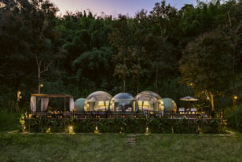

Resort features

- Rooms: 63 rooms, suites and luxurious tents span two wings of the resort, which is nestled amidst 160 acres of ancient jungle
- Restaurants and bars: 4 restaurants and bars, including Samsarn, Canopy, Sala Mae Nam, and Elephant Bar and Opium Terrace
- Swimming pools: 30 metre infinity pool overlooking three countries and the elephant plains
- Award-winning elephant camp and conservation programme
- All-inclusive stays with daily experiences
- Spa: Award-winning spa and wellness facility, including 5 luxurious indoor treatment rooms and couple suites, as well as an outdoor spa pavilion in the rice paddies
- Activities: Nature walks, Sky Bike, jogging tracks, mountain bikes and birdwatching in 160 acres of gardens and bamboo forest
- Fitness centre: Including tennis courts, and outdoor Muay Thai boxing ring
- Laundry service
- MICE & Event Space: 2 meeting rooms, seating up to 144 people
- 24-hour Fitness Centre
- 24-hour Reception
- 24-hour Concierge
- 24-hour In-Room Dining

Iconic USP’s

- Anantara Golden Triangle is a permanent sanctuary for 17 elephants and their mahouts. All have been rescued from illegal logging camps, elephant shows, and a life of begging on the streets. All experiences with the elephants focus on respect and education, from walking with elephants to showering them under the warm sun, Anantara camp works with The Golden Triangle Asian Elephant Foundation (GTAEF) to provide a true place of refuge.
- Each elephant has their own mahout (elephant caretaker). The elephants live with a village of Mahouts and their families, who are trained in all aspects of elephant husbandry. Despite the 4000-year-old tradition of handling elephants, the mahout is a dying profession. While unethical elephant camps should undoubtedly be closed, there is little consideration for what happens to the elephants and their mahouts afterward. The mahout and elephant have their own dialect of commands which, once the elephant is acquainted with their own mahout, they don’t even need to use. The elephants develop such a close relationship with their mahout, they come to treat them like next of kin. Anantara Golden Triangle Elephant Camp & Resort takes providing for their mahouts as seriously as the rehabilitation of their elephants. The mahouts live on-site and receive three meals a day. The GTAEF also supports the mahouts’ families, providing an education to their children in the nearby villages where they live.
- The resort offers a truly sustainable experience. From the complete elimination of single-use plastic to a reliance on solar power, the resort is also home to its own farm, complete with herb and vegetable gardens, grey Oyster mushroom farm, bee hives, and free-range chickens.
- Guests can enjoy coffee using the world’s rarest and most expensive beans. Named Black Ivory coffee, the drink is produced using a fascinating method in which raw Thai Arabica are enjoyed by elephants, allowing the beans to undergo a natural fermentation process in the elephant’s dung. After being hand-picked and processed, the brew is elegantly prepared tableside, delivering a fresh and flavorful taste.
- Guests can enjoy breakfast perched 52 metres in the treetops. Elevated high above the lush grasslands, the unparalleled Canopy experience invites diners to soak in the commanding 360-degree views of the Golden Triangle while enjoying a sumptuous breakfast, lunch or dinner. Devised to replicate the shape of indigenous beehives, the open-sided capsule draws on natural materials and soft, earthy hues, cocooning diners in the lap of luxury.
- Every room comes complete with a variety of locally sourced amenities. This includes teas from Sawanabondin (meaning ‘heaven on earth’), a locally produced sustainable tea brand from Chiang Rai, chocolates from Kad Kakao in Northern Thailand, homemade elephant shaped butter cookies, crispy mushrooms in collaboration with Doi Tung, and a Praewa cloth bag, traditionally used by hilltribes in the Lanna region.
- Guests can opt for an explorer’s arrival experience. Instead of arriving by car, guests can navigate down one of the world’s largest rivers in a traditional longtail boat before being welcomed on the banks of the resort by a herd of elephants.
- A special welcome ritual is performed for every guest on arrival. Set to the beat of a traditional klong sabatchai drum used for ceremonial purposes and to motivate Lanna soldiers in battle, guests are greeted with Nam Khao, a welcome drink crafted from cooked rice water, pandan leaves and seared Phulae pineapple, along with a pineapple tart.
- Every guest receives a bracelet of Job Tears. Upon arrival, all guests are given a bracelet of Job Tears (a rice seed) handcrafted by Akha hill tribe artisans. Traditionally the Akha people and the Karen people who live in the mountainous regions around the Thai-Myanmar border grow several varieties of the plant and use the beads to ornament various handicraft. The seed colour varies depending on the time of year.
- Guests can sleep in a Jungle Bubble Lodge. Complete with a cloud-like four-poster bed and plunge pool, the bubble offers guests the chance to spend an unforgettable night observing majestic elephants in their natural habitat from the comfort of an air-conditioned, fully furnished, transparent Jungle Bubble.

Top 5 tips for an unforgettable stay

- Download the Anantara app. This invites guests to tailor their stay in advance or from the comfort of their room or jungle bubble. The app turns guests’ smartphone into a room key and allows them to seamlessly make reservations, arrange a last-minute laundry pick-up or even order a turndown at the click of a button.
- Ask for the secret recipe. Each room comes complete with a delivery of the resort’s infamous elephant-shaped butter cookies. If requested, the resort’s pastry team will provide a hand-written recipe card before departure.
- Iyara Yindee – Elephant cake making class. Mark a special moment in the most heart-warming way—by creating a personalised gourmet cake for our gentle giants. This joyful, hands-on experience invites you to connect with our beloved elephants while crafting sweet memories that will stay with you long after your journey ends.
- Make a reservation for Samsarn in advance. Deeply inspired by the cultures of the Golden Triangle, Samsarn presents a contemporary interpretation of regional cuisine, weaving together the vibrant spices of Thailand, the aromatic herbs of Laos, and the bold flavours of Myanmar. Each dish celebrates local ingredients and time-honoured traditions, thoughtfully reimagined with modern techniques to create an immersive dining journey that reflects the spirit and diversity of this storied region.
- Discover the region in a Royal Enfield Sidecar. Offering an exhilarating ride through Thailand’s lush northern jungles, guests can book a private driver to whisk them off on an unforgettable journey past elephant pastures, ancient Lanna sites, and remote border regions.

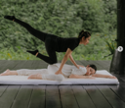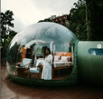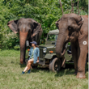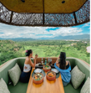

Most photogenic moments

- Feel the thrill of the open road on our Royal Enfield Sidecar tour. Adventure awaits at every turn, with the Golden Triangle’s stunning landscapes unfolding before you.
- Wake up to misty mornings, sunshine beaming through a blanket of fog in your private jungle bubble.
- Beat the heat and dive into an afternoon swim at the infinity pool, overlooking the lush Chiang Saen jungle and Golden Triangle
- Soar above the Golden Triangle and immerse in a breathtaking view from the Canopy. Look ahead to see Myanmar and turn right to catch a glimpse of Laos.
- Under the large tree providing you shade, prepare to experience a serene afternoon "elephant picnic," with sublime views of nature and a gourmet hamper served in a pinto box.

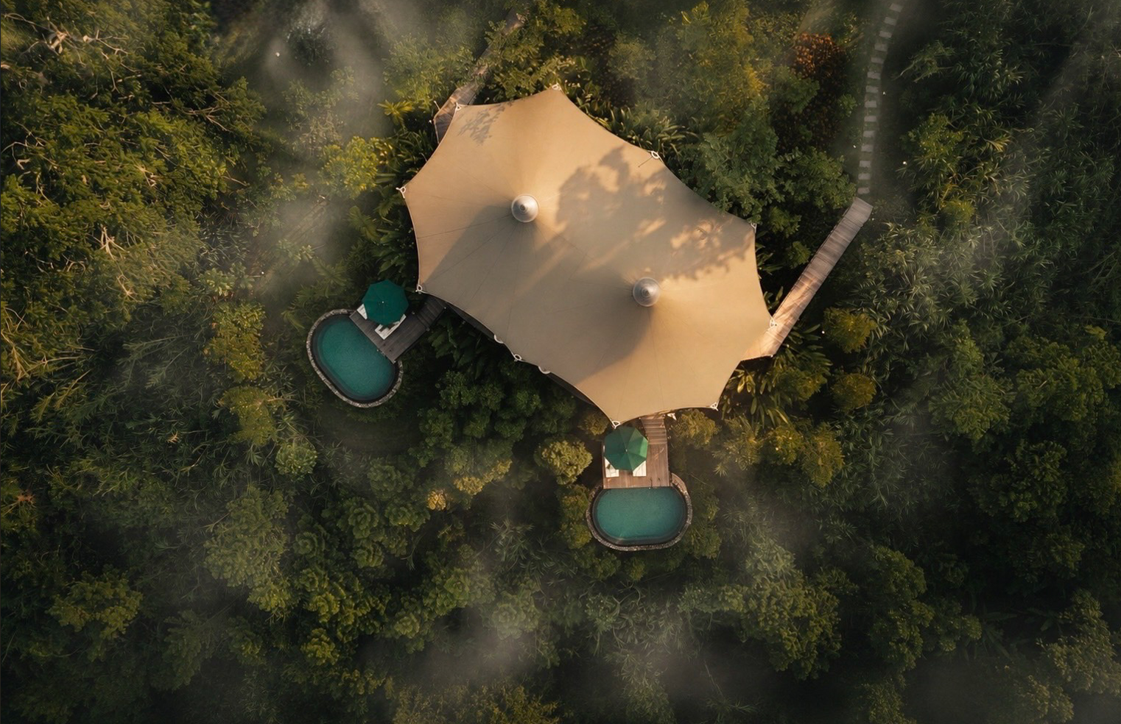

What’s in a name?

- Derived from the Sanskrit word meaning “without end”, the word “Anantara” embraces the excitement of discovery and the vibrant energy of new horizons.
- The name of the region comes from its history. The Golden Triangle was once the global capital of opium production and the hub of the international opium trade. The lucrative substance was literally “worth its weight in gold” as a kilo of opium could be traded for a kilo of gold. The English name of The Golden Triangle comes from the meeting of Laos, Myanmar and Thailand, but to the locals it's Sop Ruak, since this is where the Mekong meets the Ruak River.

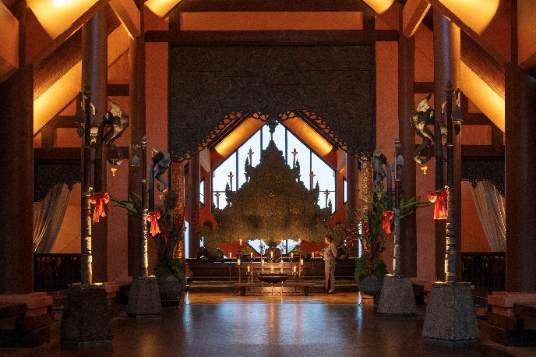

Architecture and design

Originally designed by Mom Luang Tridosyuth Devalux (Mom Tri), a renowned Thai architect and a member of the Thai Royal Family, Mom Tri’s influence brought a deep respect for Thai culture and traditional design across all of the resort’s design touchpoints. Inspired by Northern Thailand Lanna and hill tribe cultures, teak wood can be seen throughout, as well as hand-woven hill tribe patterned fabrics, traditional artwork and Thai daybeds. The buildings and common areas also sport an earthy terra cotta orange colour. In a nod to the region’s past as an opium area, affixed on each rooftop is a carved teak wood decoration of poppy plants, and a huge poppy motif adorns the swimming pool floor.

Interior designer John D. Lightbody describes the aesthetic as "a contemporary interpretation of classic Thai." He was responsible for the careful selection of textures, colors, and furnishings that align with traditional Thai and Lanna styles. Renowned landscape architect Bill Bensley also contributed to the landscape design of the resort, enhancing the integration of the natural environment with the resort’s public spaces.

Guests enter the resort via a courtyard adorned by a pair of copper umbrellas created in the 13th-century Lanna style before being greeted by a 19th century Buddha; a Shan-style statue from the original architect’s collection. This statue was moved to storage during renovations in 2003 until staff heard mournful weeping from the area, believed to come from Buddha crying out against his disrespectful treatment and neglect. It was first moved to the hilltop before occupying its current spot in the lobby.

Standing at the resort's lobby entrance, the Sattapan is a striking two-metre-high, three-metre-wide screen inspired by the traditional Lanna ceremonial candle stand found in Northern Thai Buddhist temples. Adorned with intricately engraved naga (serpent) motifs, it symbolises protection, wisdom and respect for the land. As a contemporary interpretation of a sacred cultural icon, the Sattapan offers guests a meaningful introduction to the rich heritage and spiritual traditions of Northern Thailand from the moment they arrive.

The curated accommodations across the resort are thoughtfully designed to reflect the beauty of the natural surroundings and the cultural heritage of the region. Each room and suite creates a true sense of place, featuring teak wood floors, hill tribe fabrics, and authentic handicrafts. All guest accommodations have private balconies with mosquito net-covered seating and room for outdoor dining. Sliding louvered doors can separate the bath from the sleeping area. The floors are recycled teakwood, and the fabrics are from Jim Thompson, in homage to the American-born Thai businessman who turned Thai silk making into a major industry selling worldwide and became an authority on Thai art.

The Mekong Explorer Suites pay homage to the intrepid travellers who charted the Mekong River centuries ago, fusing the rich traditions of the Lanna Kingdom with refined colonial influences. Dark wood panelling and intricate elephant motifs evoke the essence of Asian heritage, while vintage chests, embellished with antique brass hardware and leather straps, add a touch of old-world glamour. Each suite is named after a specific locale and adorned with captivating artworks that reflect its distinctive character. Step onto your private balcony and welcome a new day by taking in breathtaking views of mist weaving through the rolling green hills.

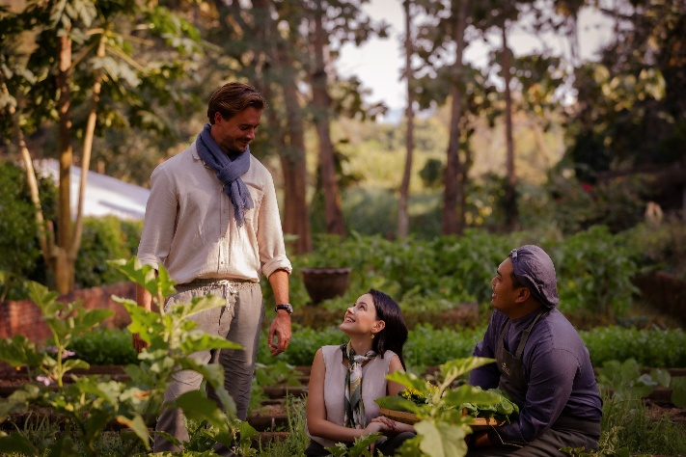

Sustainability credentials

At Anantara, we are committed to preserving the world's most beautiful destinations. With hotels and resorts across Asia, the Indian Ocean, the Middle East, Europe and Africa, we encounter diverse cultures and ecologies. Wherever we go, we aim to preserve and nurture our host communities and environments and operate in a way that is beneficial to the people who live there, and sustainable for generations of residents and travellers still to come.

Responsible operations

Suan Sai Jai's Organic Garden and farm
Guests are invited to take a leisurely stroll through the resort’s lush on-site organic herb and vegetable garden, which supplies the kitchens with everything from seasonal vegetables to organic honey, homegrown mushrooms and free-range eggs. The garden and farm also play host to many events throughout the year, including garden bar takeovers with Chiang Saen and Chiang Mai local talents.

- A family of 35 chickens, produce 40,000 Baht worth of free-range organic eggs for the resort each year. Laying 620 eggs monthly, they provide close to 25% of the resort’s monthly consumption.
- The resort’s 10 operational bee hives are home to tens of thousands of bees and produce 20Kg of honey for the resort per hive every year. This is more than 100% of the property’s honey needs.
- The farm produces 68Kg of seasonal produce every month, including mint, coriander, eggplant, cabbage, long beans, betel leaves, mushrooms, avocado, lychee, jackfruit, lime and hydroponic salad.
- The farm’s mushroom growing facility creates 155Kg of mushrooms every year of the Oyster variety.

Local farms and suppliers
We have partnered with local farmers to introduce a range of fresh and seasonal ingredients to our menus which are responsibly sourced.
- Additional eggs (when needed) are purchased from the nearby Sunflower Farm, which is owned by the Friends of Thai Daughters nonprofit organization and rears cage-free chickens. Friends of Thai Daughters provides education, safe shelter and emotional support to girls at risk of being trafficked in Northern Thailand.
- The resort’s tea is procured from Sawanbondin in Chiang Rai, a family-owned business who produce organic, hand-picked teas.
- Fairtrade Doi Chang Coffee is served throughout the resort, a community-led foundation, that provides healthcare, education and development for the Doi Chang community and surrounding area.
- All cheese is procured from the Chiang Rai and Chiang Mai Dairy Cooperative.
- Organic jams are served at breakfast, from the Chiang Rai Wild Nature Artisans which are hand made by local growers in the Northern mountains.
- Samsarn’s rock salt is procured from Nan province which has been creating salt in the area’s natural saltwater wells for over 800-years.

Waste management

Biogas digester
In 2023, the resort introduced an on-site bio-digester that transforms food scraps and organic waste into gas that fuels our team members canteen, as well as producing fertilizer to use in in Suan Sai Jai's Organic Garden and farm. This technology approximately creates 2,030 Baht worth of fertiliser and created 191kg/4,835 B gas.

Solar panels
There are 357 solar panels installed on the roof of the resort, which generate 190,000 kWh of energy for the resort every year. This allows us to meet up to 35% of the hotels’ and Mahout village’s electricity needs over the course of the year. This also prevents 83,000kg of CO2e from entering the atmosphere.

Single use plastics
We have removed all single-use plastics from the resort including straws, water bottles, takeaway food packaging, in-room amenities and room keys. All guests and team members are also provided a reusable water canteen.

Conservation & animal welfare

Weekly garbage walks and Ruak River clean-up
Mahouts and team members do weekly garbage walks of the elephant camp and grasslands and regularly do a Ruak River clean-up.

Dollars for Deeds
Anantara’s Dollars for Deeds programme gives guests the option to donate one dollar (THB 30) per night of their stay, with Anantara matching each guest’s contribution. The funds raised are donated to three worthwhile foundations: the Golden Triangle Asian Elephant Foundation (GTAEF) in Chiang Rai, the Mai Khao Turtle Foundation in Phuket and the Princess Sirindhorn Craniofacial Centre at Chulalongkorn Hospital in Bangkok.

Elephant camp
Tucked into 160 acres of ancient jungle, Anantara Golden Triangle is a permanent sanctuary for 16 elephants, all rescued from illegal logging camps, elephant shows, and a life of begging on the streets. The resort’s partnership with the Golden Triangle Asian Elephant Foundation is dedicated to rehabilitating these animals while educating guests on the importance of wildlife conservation. The foundation’s work includes providing medical care for elephants, promoting sustainable tourism, and supporting nearby communities through education and employment. Setting a golden standard for ethical tourism, the onsite Elephant Camp offers an opportunity to connect with rescued animals in a humble and respectful manner.
- To date over 40 elephants have been rescued from Thailand’s city streets, of which 16 now live in the jungle environment of Anantara’s Elephant Camp
- We provide 24/7 care for elephants with our dedicated veterinary and animal care teams of 27 colleagues with expert knowledge and experience – including Mahouts, Vets, Doctors and camp managers.
- All elephants are located next to a Mahout Village, which houses and provides for the Mahout as well as their entire family. There are also two full-time English Teachers in the mahouts’ home village of Ban Ta Klang, and three wild elephant conservation projects.

Communities

Indigenous wellness
The resort offers a vast array of unique indigenous wellness experiences that cannot be found anywhere else in Thailand. These include
- Yam Khang, or Thai Fire Barefoot Massage: A sacred ritual performed by a select few healers. Practitioners dip their feet in herbal oil before heating them on an iron plough blade over an open fire and then proceeding to massage various parts of the body using only their feet. The treatment effectively relieves deep muscle, joint, and bone discomfort while boosting a natural flow of energy.
- The Ya-Pao detoxification therapy: This aligns the elements of wind, water, and fire within the body, promoting blood circulation and supporting the lymphatic and digestive systems. As thick herbal paste is applied to the abdomen, the heat gently warms the skin and alleviates tension.
- A Bamboo Massage: Inspired by ancient diverse cultural heritage, this unique massage incorporates healing traditions and stimulates the circulation.
- Mindfulness meditation with a monk: Under the guidance of a revered authentic Buddhist monk, at the nearby temple, “Wat Phra Dhat Sam Mum Mueng” top of mountain in Golden Triangle.

Local artists
Since late 2022, the resort has forged a meaningful collaboration with five talented local artists from Chiang Rai, seamlessly integrating their artworks into the guest experience.
- In 2023 alone, this initiative resulted in the sale of 20 paintings.
- Beyond sales, local artists generously donated four frames to GTAEF, contributing an additional THB 175,000 to the foundation last year.
- To engage guests and the community, we organized two well-received "Art Expedition" events in December 2023 and February 2024. These showcased the artists' works in a prominent resort location, providing a unique opportunity for interaction.
- Recognizing the value of local artistry, Anantara Golden Triangle enlisted the same artists for key renovation projects, enhancing our lobby pillars, team member entrance walkway, Baan Dhalia's door, and antique wooden panels at the bell counter.

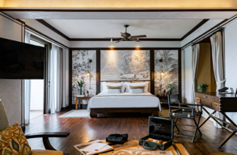

Stays: Rooms, Suites and Jungle Bubbles

Perched on a hilltop and designed in royal Thai Lanna style are 63 rooms, suites and tents featuring a spacious balcony with a built-in sofa overlooking the misty hills of Thailand, Myanmar and Laos. Interiors showcase the elegance of Thai culture with crisp Thai silks, textiles and teakwood furniture complemented by a host of modern amenities, such as a romantic terrazzo bathtub for two featuring retractable doors that can be opened for a soak with a view of the breath-taking surrounds.

Rooms

Rates: The Golden Triangle Luxury Explorer Package with room starts from $1,600 per night including return luxury airport transfers, full board dining, inclusive of breakfast, lunch and dinner, as well as in-room dining, unlimited non-alcoholic beverages, in-room minibar and admission to the Hall of Opium Museum. Every guest also receives one unforgettable activity for every night stayed including an elephant experience, Spice Spoons cooking class, a 60-minute spa treatment or a 60-minute private yoga or Pilates class.

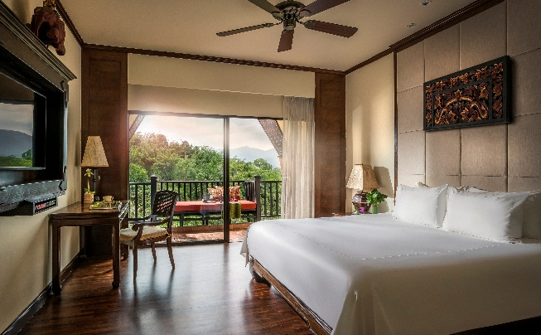
Deluxe Three Country View Room
Offering breathtaking vistas of the mist rising off the hills of Thailand, Laos and Myanmar, lustrous teak floors and rich Thai silks accent all 40 Deluxe Three Country View Rooms. Each room incorporates many local design features to complement the dramatic vistas outside while modern comforts like a flatscreen TV, espresso machine and speaker ensure maximum comfort.
- 32 Sqm
- Maximum 2 adults & 1 child/3 adults
- Highlights include a balcony with jungle views, cantilevered Thai daybed, Terrazzo soaking tub, Nespresso coffee machine, complimentary mini bar, flat screen TV, and locally sourced amenities including teas from Sawanabondin, homemade elephant shaped butter cookies, and a Praewa cloth bag, traditionally used by hilltribes in the Lanna region.

Suites

The new Mekong Explorer Suites pay homage to the intrepid explorers who charted the Mekong River centuries ago, blending the rich traditions of Lanna with elegant colonial influences. Dark wood panelling and intricate elephant motifs evoke the essence of Asian heritage, while vintage travel trunks, adorned with antique brass hardware and leather straps, bring a touch of Western charm. Each suite is thoughtfully named after distinct regions along the Mekong River, with captivating artworks that grace the walls above each headboard, reflecting the unique character of these historical locales.

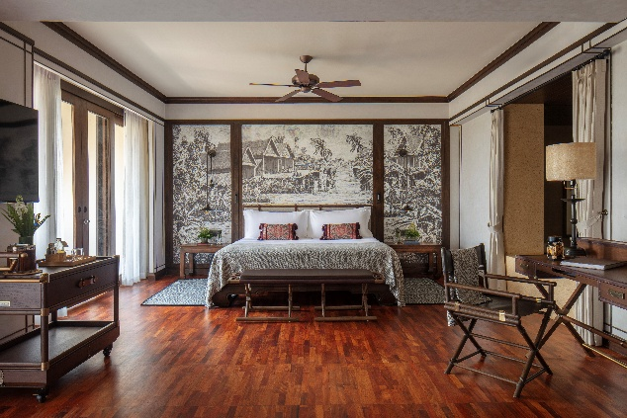

Mekong Explorer Suite
Inspired by the intrepid explorers who navigated the Mekong River, these suites blend Thai Lanna elements with colonial influences. Dark wood panelling and subtle elephant imagery evoke Asian traditions, while large travel trunks embellished with antique brass hardware and leather straps add a western touch. Each suite is named after distinct regions along the Mekong River, with their identities reflected in artworks that adorn the walls above each headboard.
- 64 Sqm
- Maximum 3 adults & 1 child
- Highlights include a balcony with jungle views, cantilevered Thai daybed, living area, rain shower, Terrazzo soaking tub, Nespresso coffee machine, complimentary mini bar, binoculars, flat screen TV, and locally sourced amenities including teas from Sawanabondin, homemade elephant shaped butter cookies, and a Praewa cloth bag, traditionally used by hilltribes in the Lanna region.
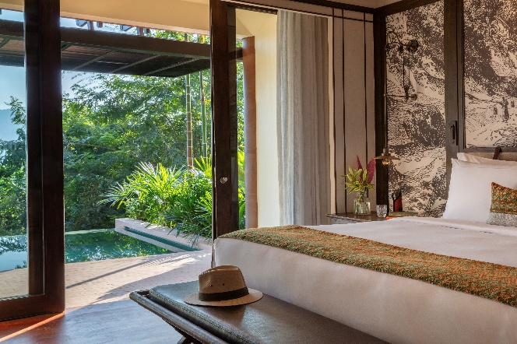

Mekong Explorer Pool Suite
Discover elevated luxury in the Mekong Explorer Pool Suite, where a private pool overlooks the breathtaking meeting point of three countries. Bask on the sunlit terrace surrounded by lush landscapes and mountain views, with the gentle flow of the Mekong River setting a serene ambience. Inside, elegant furnishings, modern amenities, and a spacious layout provide the perfect retreat for couples seeking comfort, privacy, and relaxation.

- 64 Sqm
- Maximum 3 adults & 1 child
- Highlights include a private pool on the balcony with jungle views, cantilevered Thai daybed, living area, rain shower, Terrazzo soaking tub, Nespresso coffee machine, complimentary mini bar, binoculars, flat screen TV, and locally sourced amenities including teas from Sawanabondin, homemade elephant shaped butter cookies, and a Praewa cloth bag, traditionally used by hilltribes in the Lanna region.

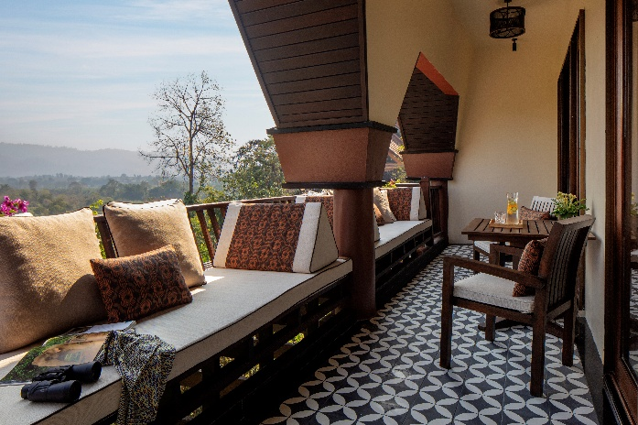

Mekong Explorer Family Suite
Designed for families, the Mekong Explorer Family Pool Suite blends Thai Lanna charm with subtle colonial touches. Enjoy a private pool overlooking the Golden Triangle, along with spacious living and sleeping areas for everyone’s comfort. Travel-inspired décor adds a sense of place, creating a luxurious yet family-friendly retreat.

- 96 Sqm
- Maximum 6 adults & 1 child
- Highlights include a balcony with jungle views, cantilevered Thai daybed, living area, rain shower, Terrazzo soaking tub, Nespresso coffee machine, complimentary mini bar, binoculars, flat screen TV, and locally sourced amenities including teas from Sawanabondin, homemade elephant shaped butter cookies, and a Praewa cloth bag, traditionally used by hilltribes in the Lanna region.

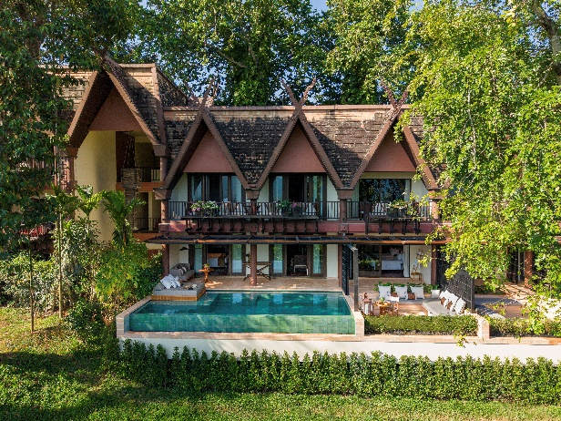

Mekong Explorer Family Pool Suite
Designed for families, the Mekong Explorer Family Pool Suite combines Thai Lanna charm with subtle colonial touches. A private pool overlooks the Golden Triangle and the Mekong River, offering the perfect setting for quality time together. Spacious living and sleeping areas ensure comfort for all, while travel-inspired décor reflects the region’s storied waterways. Blending luxury with family-friendly features, this suite is an ideal backdrop for lasting memories in a truly unique destination.

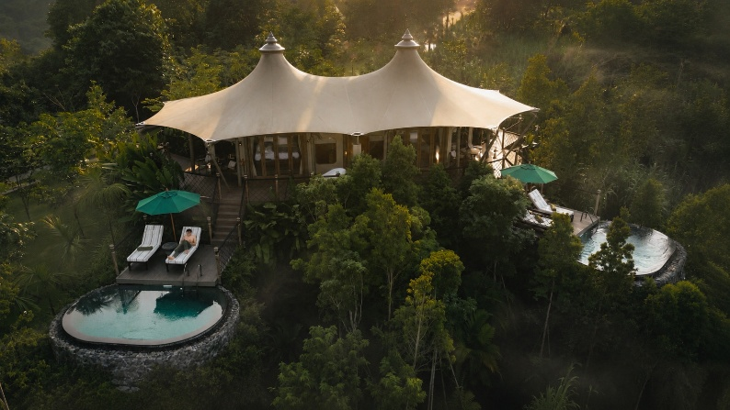

Tent

Anantara Golden Triangle Elephant Camp & Resort proudly unveils its newest luxury accommodation in 2025, The Mekong Explorer Tent. Positioned as one of Thailand’s most unique and luxurious stays, this exceptional hillside retreat offers unrivaled panoramic views of Northern Thailand’s breathtaking landscapes, serving as a serene haven for stargazers, nature enthusiasts, and intrepid explorers alike.

The Mekong Explorer Tent starts from $3,800++ per night, including an Explorer’s Arrival, a Sky Bike adventure, full-board gourmet dining, unlimited non-alcoholic beverages, a fully stocked minibar, and access to the Hall of Opium Museum. Additionally, each night’s stay includes a choice of unforgettable activities. For more information and the best available rates

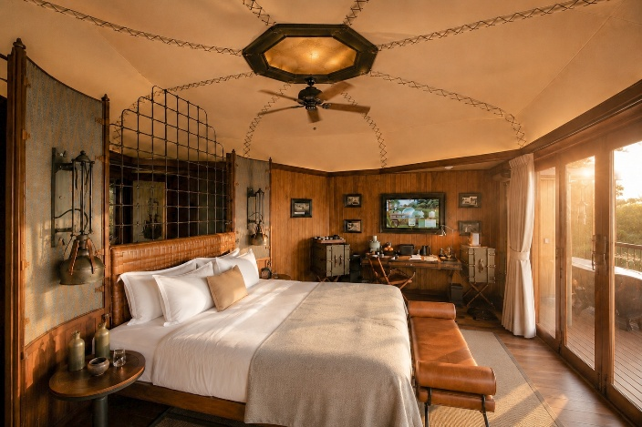

The Mekong Explorer Tent
The two-bedroom luxury retreat is thoughtfully designed with explorers in mind, featuring a tasteful mix of leather, wood, and accents of Jim Thompson fabrics that exude timeless elegance. Handcrafted furniture and locally sourced amenities immerse guests in the region’s rich culture, including locally made, sustainable teas from Sawanabondin, chocolates from Kad Kakao in Northern Thailand, homemade elephant shaped butter cookies, crispy mushrooms in collaboration with DoiTung, and a Praewa cloth bag, traditionally used by hilltribes in the Lanna region. Each spacious bedroom boasts an en-suite bathroom and oversized king-size beds for unparalleled comfort. Outside, two private terraces each feature a 5m x 3m infinity pool and an outdoor bathtub, offering a serene soak amidst nature.
- 2 King Bedrooms 52 sqm with a 22 sqm private balcony, totaling 75 sqm per unit.
- 2 x oversized king-size beds
- 2 x bathrooms
- Outdoor bathtub on the deck for a serene soak amidst nature
- Private swimming pool measuring L4.8m x W3.15m.
- Maximum 4 adults & 2 children
- Highlights include a an expansive terrace and sofa area, plunge pool, outdoor bath tub, Nespresso coffee machine, complimentary mini bar, binoculars, flat screen TV, and locally sourced amenities including teas from Sawanabondin, homemade elephant shaped butter cookies, and a Praewa cloth bag, traditionally used by hilltribes in the Lanna region.

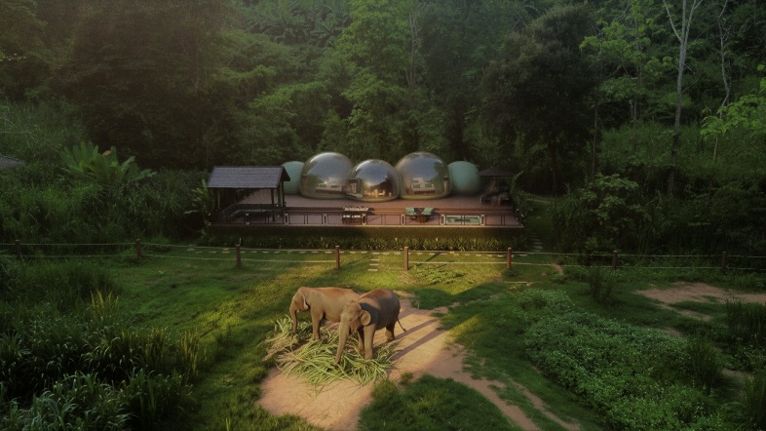

Jungle Bubble

Guests can add an unforgettable addition to their stay with a night in a Jungle Bubble. Secluded in its own pocket of jungle-fringed luxury, this off-the-grid accommodation offers a safari-style experience that begins at sunset. Guests are taken from the lodge to the bubbles in the valley before dinner. There, they are served a Thai or western dinner on the deck overlooking two elephants. After spending the night in the bubble, guests can enjoy coffee and tea on the deck before returning to the lodge to continue their day.

Guests spending the night in the Jungle Bubble Lodge can also participate in unique optional elephant experiences, including waking up in the early morning mist and joining the elephants on their morning walk through the jungle to the banks of the Ruak River, where the frolics and fun of a river bath demonstrate just how cheeky these graceful animals can be. Other options include inviting the resort’s elephant specialist to join the group on the deck for sunset cocktails prepared by a personal butler and learn about the plight and the future of elephants in Thailand. Guests can also enjoy a tutored Yoga session on the deck early in the morning while the cast of gentle giants look on, followed by a wholesome breakfast to start the day revitalised.

The Jungle Bubble experience start from $1,000 per night, including climate-controlled Jungle Bubble, and sunset dinner hamper for two.

Two-Bedroom Jungle Bubble Lodge experience start from $1,600 per night, including climate-controlled Jungle Bubbles, private chef, butler service and sunset dinner experience for four.

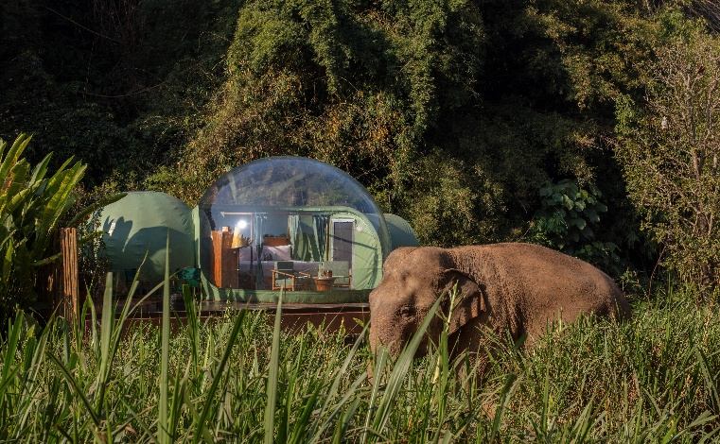
One-Bedroom Jungle Bubble
Perched on a raised wooden deck, the lodge comes complete with one bedroom, a nontransparent en-suite shower and vanity, and outdoor deck. Every experience includes a private dinner hamper beneath the stars as elephants roam free in their natural habitat, right outside the bubble dome.
- 1 x King Bed
- Transparent 4.5-diameter bedroom and living space
- 30m2 terrace
- Maximum 2 adults or 1 adult & 1 children
- Highlights include a climate-controlled Jungle Bubble, terrace, King size four poster bed, outdoor lounge table, Nespresso coffee machine, complimentary mini bar, 24-hour in-room dining service, bathrobes and slippers, crisp white bed linen, feather pillows, hair dryer, vanity and make up mirror.

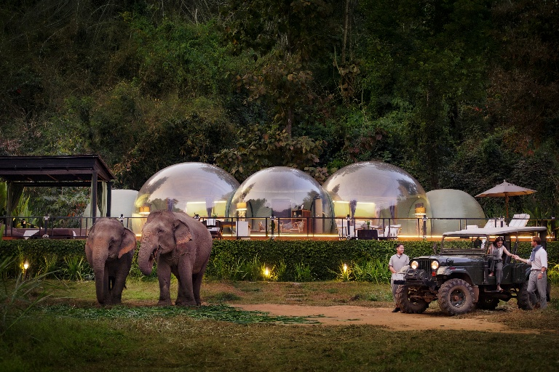

Two-Bedroom Jungle Bubble Lodge
Perched on a raised wooden deck, the lodge comes complete with two separate bedrooms, a connecting lounge, a sprawling outdoor terrace and a private plunge pool. With personalized butler service and a dedicated chef, every experience includes a private dinner beneath the stars as elephants roam free in their natural habitat, right outside the bubble dome.
- 2 x King Bed
- 150 square metres of indoors and outdoors living space (80 square metres terrace)
- Transparent 4.5-diameter bedroom and living space
- Maximum 3 adults & 1 child or 2 adults & 2 children
- Highlights include a climate-controlled two-bedroom Jungle Bubble, terrace with plunge pool, two King size four poster beds, outdoor lounge table, Nespresso coffee machine, complimentary mini bar, 24-hour in-room dining service, bathrobes and slippers, crisp white bed linen, feather pillows, hair dryer, vanity and make up mirror.

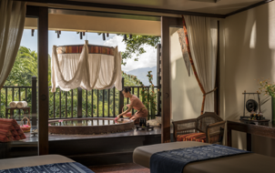

Spa and Wellness

Offering a lesson in hedonism, the resort’s spa is an invitation to unwind in one of the terrazzo and teakwood suites elevated high above the lush jungles of Thailand, Laos and Myanmar. Rooted in time-proven Thai wellness practices and revered natural wisdom, the menu highlights include indigenous therapies that harness the soothing power of burning flames to detoxify the body and restore spiritual equilibrium.

- Over 3,000 sqm of spa and wellness facilities
- 5 luxurious indoor treatment rooms and couple suites
- A wellness room for yoga and Pilates
- Spa by Nature outdoor pavilion in the rice paddies
- Fitness centre featuring the latest Technogym equipment
- Tennis courts
- Outdoor Muay Thai boxing ring
- 10am-10pm

Signature Experiences

Spa by Nature (90 minutes)
From $190 per person
This signature massage is enjoyed outdoors surrounded by rice fields, followed by an organic breakfast prepared by a personal chef, with elephants trumpeting in the distance to welcome in the new day.

Yam Khang (120 minutes)
From $180 per person
Yam Khang, or Thai Fire Barefoot Massage, is a sacred ritual performed by a select few healers. Practitioners dip their feet in herbal oil before heating them on an iron plough blade over an open fire and then proceeding to massage various parts of the body using only their feet. The treatment effectively relieves deep muscle, joint, and bone discomfort while boosting a natural flow of energy.

Ya Pao (120 minutes)
From $180 per person
The Ya-Pao detoxification therapy aligns the elements of wind, water, and fire within the body, promoting blood circulation and supporting the lymphatic and digestive systems. As thick herbal paste is applied to the abdomen, the heat gently warms the skin and alleviates tension.

Poo Loey Massage (120 minutes)
Experience the powerful remedial qualities of a northern Thai herb which is still revered by Thailand’s traditional healers for its ability to treat stiff, tense and aching muscles and joints, and also relieve fatigue.

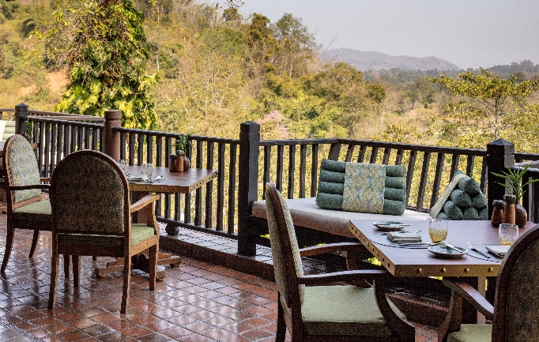
Food and Beverage

Sala Mae Nam
Asian and International
Breakfast: 6.30 am – 10.30 am/Lunch: 11.30 am – 2.30 pm/Dinner: 6.00 pm – 10.30 pm
A stunning double-storey pavilion, Sala Mae Nam serves elaborate dishes from dawn to dusk. The breakfast buffet is a glorious affair, featuring live cooking stations and an impressive selection of local and international favorites. Lunch and dinner highlight northern Thai cuisine, street food delicacies from across the kingdom, and fresh, organic ingredients sourced directly from the resort’s own garden.

Must try dishes:
- Lanna collection - Chiang Rai spicy pork sausage, crispy pork crackling, steamed organic vegetables, local green vegetable chilli dip, pork and tomato chilli dip
- Larb Moo Khua – Chiang Rai minced pork salad, local fresh vegetables, herbs
- Honey roasted DoiTung pumpkin - Local wild arugula, pumpkin seeds, dried cranberries, tahini soy

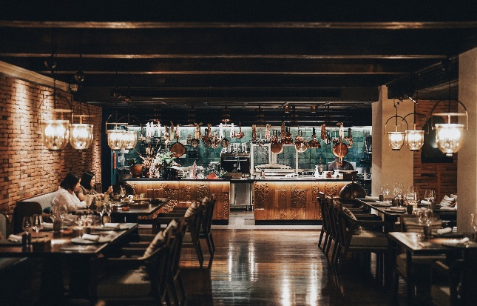

Samsarn
Thai, Laotian and Burmese refined dining
Dinner: 6.00 pm – 10.30 pm
Cocooned by jungle and with views across the Mekong River, the Golden Triangle’s newest culinary jewel, Samsarn takes diners on an odyssey of discovery, at one of the world’s most fascinating culinary crossroads. With two female Thai chefs at the helm, the rich and diverse flavours of the Golden Triangle's three regions; Thailand, Laos and Burma come to life on the plate. Heavily inspired by local Lanna culture, Chefs Wiraparat Pratumma and Parinda Boonrangsee take diners on an exquisite journey, where dishes embrace the vibrant spices of Thai cuisine, Laos's aromatic herbs, and Myanmar's bold flavours, all reimagined with contemporary flair.

Must try experiences:
- The chef’s seven course Mekong Odyssey menu invites diners to traverse the Mekong River, whilst honouring the diverse culinary heritage of each region that surrounds it.

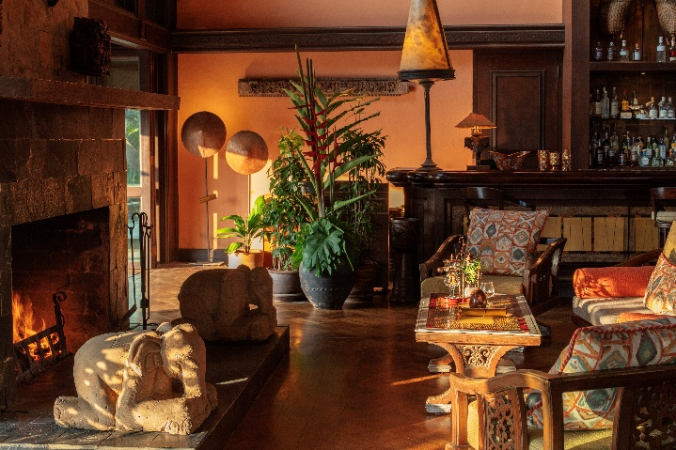

Elephant Bar and Opium Terrace
Cocktails and bites
Daily: 10.00 am – 12.00 am
Fitted out in dark teak and a sophisticated upholstery palette, the Elephant Bar and Opium Terrace channels the refined aesthetics of a classic hunting lodge. Plush, low-slung chairs and gently spinning ceiling fans create an inviting ambiance, perfect for embracing the moment after a long day of exploration. The Elephant Bar’s menu includes signature cocktails using local fruits, herbs and spirits with names reflecting the region, such as Ai-Ya Ra (King of Thai Elephant), Golden Triangle, AGT Jungle and Drastic Opium. The bar also offers a selection of local craft beers from Chiang Mai and Full Moon brewers.

Must try bites, cocktails and experiences:
- Salmon Poke, Spicy Sausage Burger, Thai Summer Rolls
- Cocktails: Ai-Ya Ra, Mekong Explorer Brew, Jungle Breeze, Tea Garden and Silk Road
- Elephant dung coffee from the Black Ivory Coffee Company- With a 2023 approximate allocation of 225 kg (495 LBS), Black Ivory Coffee is the world's rarest coffee.

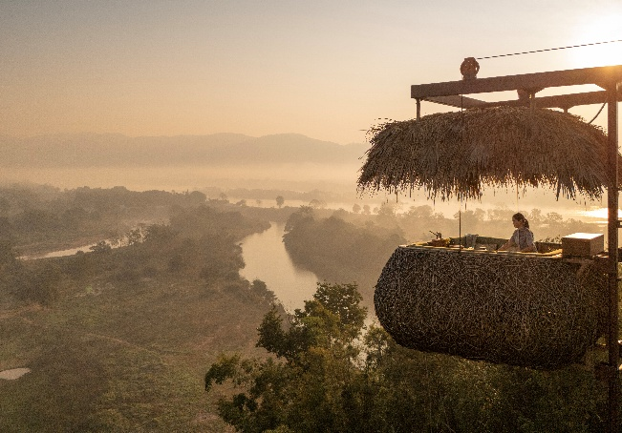

Canopy Tree Top Dining
Breakfast: 7.00 am – 10.30 am/Lunch: 11.00 am – 2.30 pm/Sunset dinner: 5.30 pm – 9.00 pm
Starting from $350 for two, including Culinary Adventure, Mekong Discovery or Jungle Explorer set menu, and $405 for two for Gourmet Odyssey Menu. Every experience also includes a Hilltop Spirit House blessing ritual, private chef, Canopy View leather map, binoculars, sunblock cream, and an Explorer hat.

Elevated 52 meters above the lush grasslands, Canopy presents an exciting new way to dine. This unparalleled experience allows guests to soak in the commanding 360-degree views of the Golden Triangle while enjoying a sumptuous meal. Devised to replicate the shape of indigenous beehives, the open-sided capsule draws on natural materials and soft, earthy hues, cocooning diners in the lap of luxury. Soft touches include a hand-painted leather map and binoculars for elephant viewing. Guests will enjoy the chirping of birds and the occasional elephant trumpeting as they enjoy a sumptuous breakfast, lunch or dinner experience.

The Canopy features three all-day tasting menus curated by Executive Chef Jino and team, and elegantly served in traditional, eco-friendly pinto containers. In the lobby, guests will find a terrarium menu display used to spur intrigue and interest in the experience.
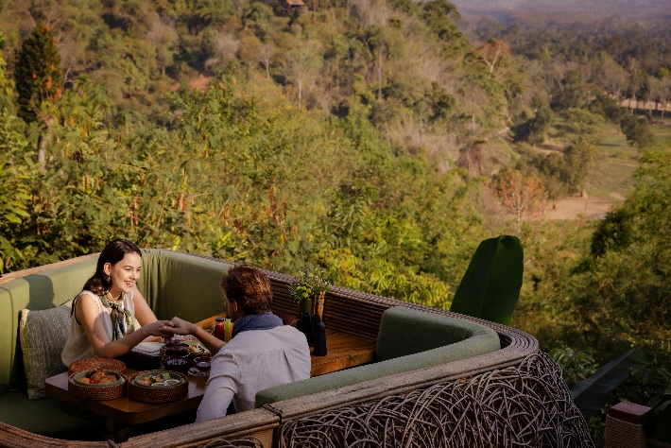

- The Mekong Discovery highlights the region’s culinary roots through elaborate dishes such as Laotian riverweed paired with spicy yellowfin tuna larb, and curried Chiang Rai pork served on roasted rice toast.
- The Gourmet Odyssey marries local and Italian flavours with creamy burrata, seared king scallops, shaved white truffle and decadent black caviar, complemented by an array of desserts ranging from kaffir lime financiers to rose and pumpkin mousse.
- The Culinary Adventure blends traditional gastronomy with creative interpretations. Highlights include slow-cooked Wagyu short ribs, Phuket lobster wraps with ripe avocado, and baked figs served with crème brûlée.
- The Jungle Explorer presents an imaginative selection of international flavours for vegetarian diners, including Chiang Saen oyster mushroom salad, teriyaki tofu, beetroot hummus and eggplant unagi-style nigiri.

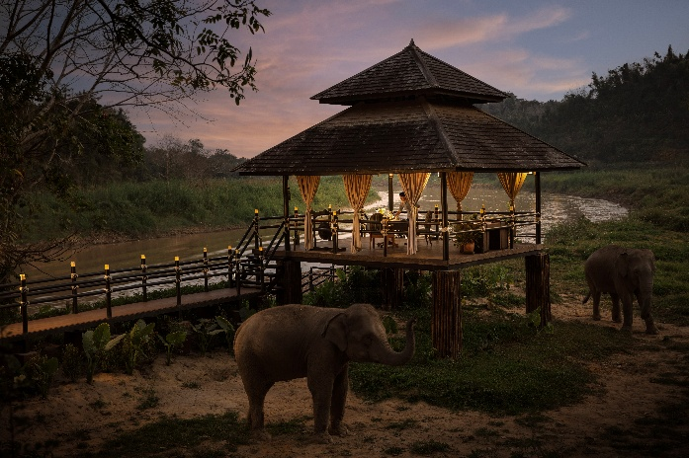

Designer Dining
Starting from $525, including dinner for two with a private chef, service team and symbolic lantern release at the end of the meal.

- Rice Paddy Sala: Located in a traditional sala beside the rice paddies, diners look upon the illuminated Lanna hotel above.
- Riverside Camp Sala: Located in the rustic surrounds of a sala at the Baby Elephant Camp, gentle giants provide wonderful dining companions.
- Guests have the choice of three menus that can be customised to their tastes and preferences: Thai, Northern Thai or Western. Thai and Northern Thai are served family-style, Western is plated. Guests start their evening with a drink and greeting from the elephants before having their private chef introduces the menu. In cooler months, guests can sit by the fire and release lanterns after their meal. After dinner, guests will find elephant-shaped chocolates awaiting them in their rooms to cap off the evening.

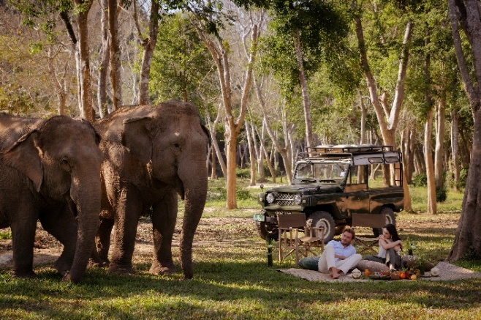

Elephant Picnic
Starting from $190 per person including a gourmet hamper and champagne
Guests are taken to a quiet, secluded area of the property, under a large tree providing shade to watch the elephants in the grass plain over a private picnic.

Mekong Night
Starting from $50 per person including dinner.
A signature themed dinner held three times per month, guests are invited to the resort’s Garden Terrace where they can enjoy an Explorer’s Cocktail and canapés, before settling in for a barbeque buffet, accompanied by local performances. Performances feature folk art highlighting the culture of the hill tribe people of the surrounding areas by introducing guests to ancient stories through the Kai Lai Dance, Dance of the Great Mountain and Gingala and Toh Dance.

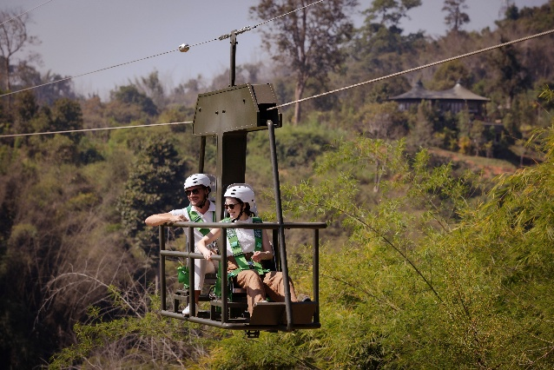
Signature in-resort experiences

Sky Bike
Starting from $85 per person
Designed for adventure seekers, this unique activity invites intrepid explorers to pedal through the treetops, offering breathtaking views of the Golden Triangle’s lush forest, the mighty Mekong River, and the region’s diverse wildlife. Located just a short walk from the resort, the exhilarating journey invites adventurers to embark on a tandem Sky Bike, which glides smoothly between two stations via a 950-foot zipline cable, reaching heights of 130 feet above a lush 160-acre bamboo forest. The innovative and silent bicycle system is suspended high above the forest floor and accommodates two riders at a time, with one person powering the journey by pedaling. The entire journey, from one station to the next and back, takes approximately 20 minutes, depending on the rider’s chosen pace. Suitable for both adults and children (10 years+), the experience offers a safe and exhilarating way to glide over this spectacular natural landscape, providing an intimate and unforgettable perspective of the forest below.

As intrepid explorers traverse the canopy, they will enjoy breathtaking panoramic views of Northern Thailand’s iconic Golden Triangle, where Thailand, Laos, and Myanmar converge, as well as the Mekong River and the Golden Triangle Asian Elephant Foundation’s 20 rescued elephants roaming below. The surrounding ecosystem is also teeming with wildlife, including wild boars, gibbons, and deer, along with a diverse array of bird species such as hornbills, barbets, and sunbirds—a true paradise for keen-eyed nature enthusiasts.

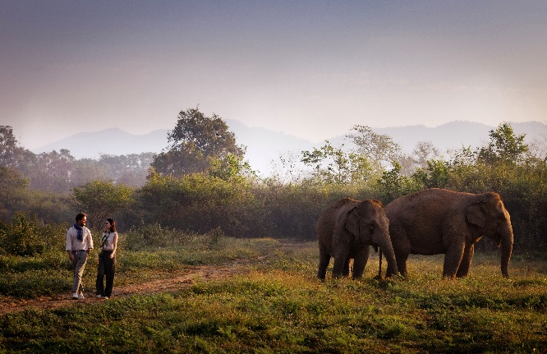

Walking with Giants
Starting from $190 per person including traditional Mahout suit, wellingtons, and Golden Triangle Asian Elephant Foundation guide
The signature Walking with Giants program invites visitors to get closer to those majestic creatures while fostering a firsthand knowledge of the conservation efforts essential to their survival. Attired in a blue traditional Mahout suit and wellingtons, courtesy of the resort, guests can join the elephant friendship groups on their daily exercise.

Walking from the Elephant Camp out to the grasslands or forest, depending on the season, unveils river and wild nature scenery. Falling in pace with the slow, steady rhythm, guests can observe the elephants’ social interaction in their native habitat. The fun of either a river bath or mud playtime demonstrates just how cheeky these graceful animals can be. Guests can help to prepare snacks for the elephants, as well as activities for their behavioural enrichment. Meandering back to the camp, the expert explains about elephant biology and behaviour, and reveals fascinating facts and insights about the past, present and hopeful future for all of Thailand’s elephants.

E.L.E. - Elephant Learning Experience
Starting from $170 per person including traditional Mahout suit, wellingtons, and Golden Triangle Asian Elephant Foundation guide
Guests are invite to observe the behaviour and playful interaction of the Golden Triangle Asian Elephant Foundation’s rescued elephants.

Elephant Guardian Experience
Starting from $190 per person traditional Mahout suit, wellingtons, and Golden Triangle Asian Elephant Foundation guide
Led by a veterinary team member from the Golden Triangle Asian Elephant Foundation, the educational programme introduces guests to the elephant camp, caring for the elephants and the customs of mahouts (caretakers). Guests will get their hands dirty making snack balls of banana, rice, meal, long beans and rock salt. Each elephant typically participates in the activity two to three times per week on a rotation.

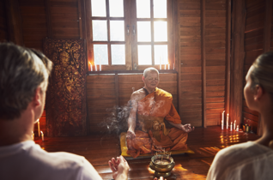

Monk-led meditation
Price on application
Guests can find their inner peace as well as tranquillity meditating under the guidance of a revered authentic Buddhist monk, with morning sessions held at the nearby temple, “Wat Phra Dhat Sam Mum Mueng” top of mountain in Golden Triangle.

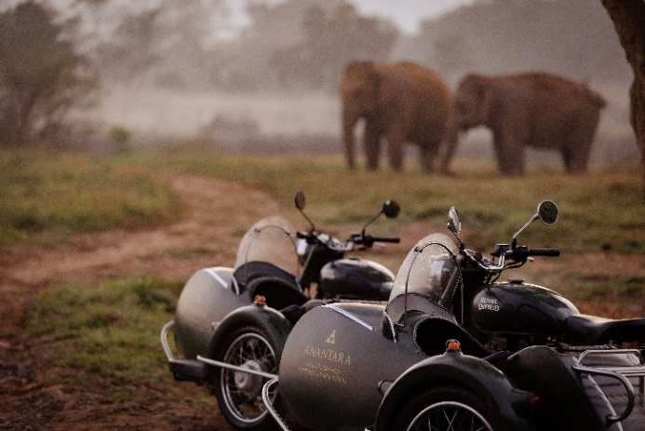

Royal Enfield Classic 500
Starting from $100 per person including motorbike and guide
Guests at Anantara Golden Triangle Elephant Camp & Resort have the unique opportunity to reserve a Royal Enfield sidecar with a driver for excursions outside the resort. The only hotel in Thailand that offers guests this unique transport, this mobility is the ideal way to take in the Golden Triangle that unfolds across 650,000 square metres of Northern Thailand’s jungle.

First produced in 1901, Royal Enfield is the oldest motorcycle brand in the world still in production and its old school, post-war design built around a reliable workhorse ensures passage through most terrains. Beyond the borders of the luxury resort, the motorcycle tour of the Golden Triangle explores the unique character and traditions of Thailand on its border with Myanmar and includes a guided visit to the Giant Golden Buddha in nearby Chiang Sean; sacred temples built in the eighth, twelfth and fourteenth centuries; a local market; and ancient Lanna experiences. Additional stops include, Doi Tung, the highest point of the Doi Nang Non mountain range along Thailand’s border with Myanmar, Wat Phra That Doi Tung that dates to the tenth century and has a stupa that is reputed to contain Buddha's collarbone, as well as the Doi Tung Royal Villa that was the final residence of Thailand’s Royal Grandmother, the mother of the late His Majesty King Bhumibol Adulyadej the Great.

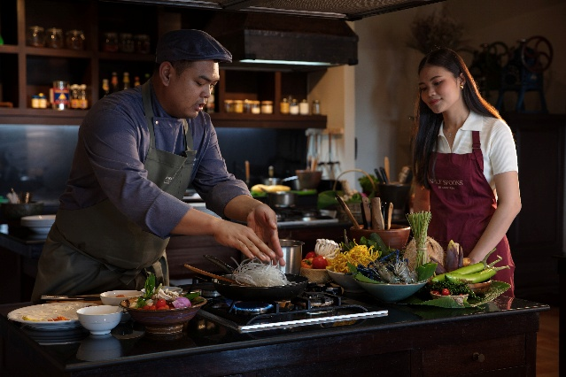

Spice Spoons cooking class
From 1:00 pm daily (A 24-hour advance booking is required)
Starting from $80 per person, including recipe cards, apron and certificate
Guests can join Chef’s cooking class, which focuses on hyper-local flavours and locally sourced ingredients. Starting with a visit to the local Chiang Saen fresh market, keen culinary enthusiasts explore stalls filled with fresh produce, aromatic herbs, and spices essential to Thai cooking. Guides explain the ingredients unique to Thai cuisine and assist in selecting items based on personal preferences. Guests are encouraged to negotiate prices and immerse themselves in the local habits, while learning the Thai names of the most popular ingredients. The market visit is followed by coffee and a simple breakfast of sticky rice, omelette and soup at a local village house, allowing guests to see how locals live. Back at the property, guests and chef stop at the sustainable garden to pick in-season produce for their dishes before preparing their meal of an appetiser, soup, main and dessert in a step-by-step class in the professional Spice Spoons cooking school kitchen or rice paddy sala during cooler months.

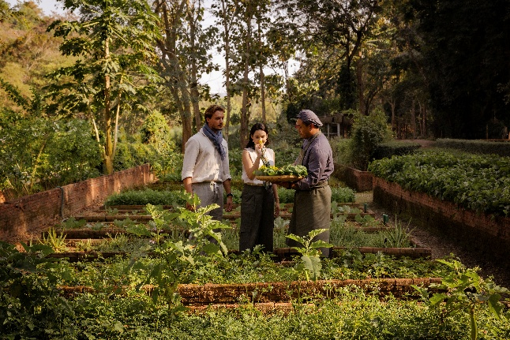

Suan Sai Jai's Organic Garden and farm visit
Daily
Complimentary for guests
Guests are invited to take a leisurely stroll through the resort’s lush on-site organic herb and vegetable garden, which supplies the kitchens with everything from seasonal vegetables to organic honey, homegrown mushrooms and free-range eggs. The garden and farm also play host to many events throughout the year, including garden bar takeovers with Chiang Saen and Chiang Mai local talents.

Mixology in the garden
From 1:00 pm daily (A 24-hour advance booking is required)
Starting from $80 per person, including recipe cards, apron and certificate
Guests can experience an evening of elegance and botanical bliss with the resort’s exclusive cocktail classes, held in the garden. Guests are invited to handpick fresh herbs for their beverages before learning the art of mixology from the resort’s skilled bartenders. The class includes the creation of three signature cocktails or mocktails from timeless classics to innovative blends.

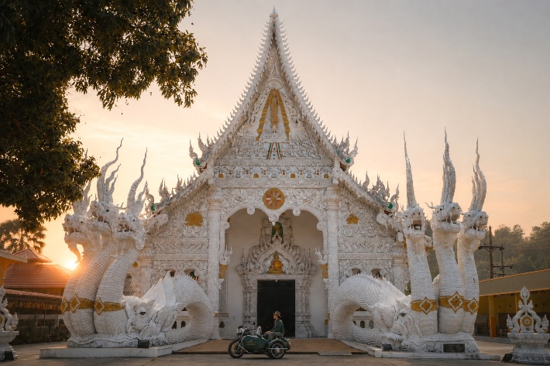

Signature cultural experiences

Mekong River Boat Trip
Daily
Price on application
Guests can embark on a timeless voyage along the majestic Mekong River aboard a handcrafted traditional boat. With the opportunity to explore riverside communities where time seems to stand still, the river will reveal hidden temples, and artisan workshops where traditions thrive.

Golden Triangle Tour
Daily
Price on application
This day long experience provides a unique insight into the Golden Triangle, including:
- A timeless voyage along the majestic Mekong River aboard a handcrafted traditional boat
- A visit to Wat Pa Sak, comprising seven monuments in the historical park, including a mid-14th-century chedi with Hariphunchai, Sukhothai, and possible Bagan influences
- A stop at Wat Chedi Luang meaning "Temple of the Great Stupa”.
- Ending at Phra That Pu Khao, a temple, located on a hill near the Golden Triangle, believed to have been built by a king of Wiang Hirannakhon Ngoen Yang (Chiang Saen) in the mid-8th century.

Chiang Saen Town
Daily
40-minute walk/5-minute drive
Due to its privileged location, Anantara Golden Triangle is a treasure trove of exploration. For history enthusiasts, the nearby town of Chiang Saen unveils the illustrious past of the Lanna Kingdom, where ancient ruins and temples stand as a witness to its unique cultural heritage. Today, it is a serene riverside destination offering visitors tranquillity and historic charm. The city was inhabited in pre-historic times and the city wall dates back to the 12th century. The three-sided city wall, with the Mekong River providing a natural barrier along the fourth side, is being restored un support of Chiang Saen’s application to become a UNESCO World Heritage site

Doi Tung
Daily
1 hour drive
Meaning ‘Flag Mountain’ Doi Tung is home to nearly 11,000 people, mostly hill tribe communities. In the late 1980s, Princess Mother Srinagarindra spearheaded the Doi Tung Development Project, which was instrumental in the region’s shift away from Opium production. Today, the Thai social enterprise promotes handmade products, weaving, paper making, pottery and coffee, produced by ethnic minorities.

Hall of Opium Museum
Tuesdays and Sundays: 8:30am-3:30pm
15-minute walk
Located across from the resort, the Museum narrates the compelling story of the illegal opium trade, providing deeper insight into the historical and economic factors that shaped the region

Mae Sai
Daily
25-minute drive
Mae Sai, located in Chiang Rai Province, holds the distinction of being Thailand's northernmost town. It serves as a significant border crossing between Thailand and Myanmar, with the town of Tachileik situated just across the Mae Sai River. Adjacent to the border, sits a bustling market famed for its diverse array of goods, including local handicrafts, gemstones, and electronics. It's a popular spot for both tourists and locals seeking unique items.

Sop Ruak
Daily
40-minute walk/5-minute drive
Sop Ruak is a Thai village at the centre of the Golden Triangle. It is home to a giant Golden Buddha (Phra Chiang SaenSi Phaendin) along the Mekong River and several monuments and temples, including Wat Sop Ruak and Wat Phra That Doi Pu Khao.

Wat Pa Sak
Daily
40-minute walk/5-minute drive
Wat Pa Sak, located outside the city walls of Chiang Saen, is a temple ruins in a teak forest. It is believed to be as culturally significant as the more well-known temples of Ayutthaya and Sukhothai.

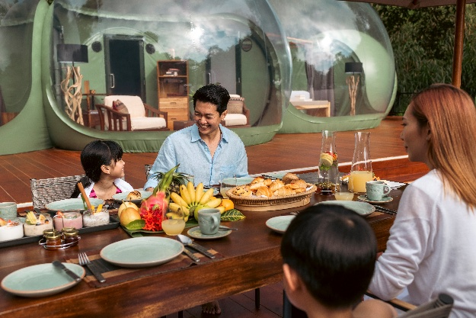

For families
Children are welcome, and under-4s stay free if they share parents' bedding. Extra beds for 4–11-year-olds cost $255 a night (including meal plan and activity per night stay), and $360 a night for over-11s. Babysitters can be booked on request, and a children’s menu can be found across all restaurants, as well as the spa.

Weddings, meetings and events

Meetings & events
Anantara’s personalised service and indulgent touches combined with the retreat’s stunning natural surroundings make Anantara Golden Triangle Elephant Camp & Resort an ideal venue for any business event or executive retreat. Tailor-made activities and superior standards of service make Anantara Golden Triangle an unforgettable setting for incentive groups. In addition to providing a perfect meeting venue, Anantara’s team can help craft an exclusive event curated for your group’s needs, from intimate executive gatherings to motivational team-building activities
Mae Khong Room: 216 sqm-144 guests
Rim Khong Room: 96 sqm- 64 guests

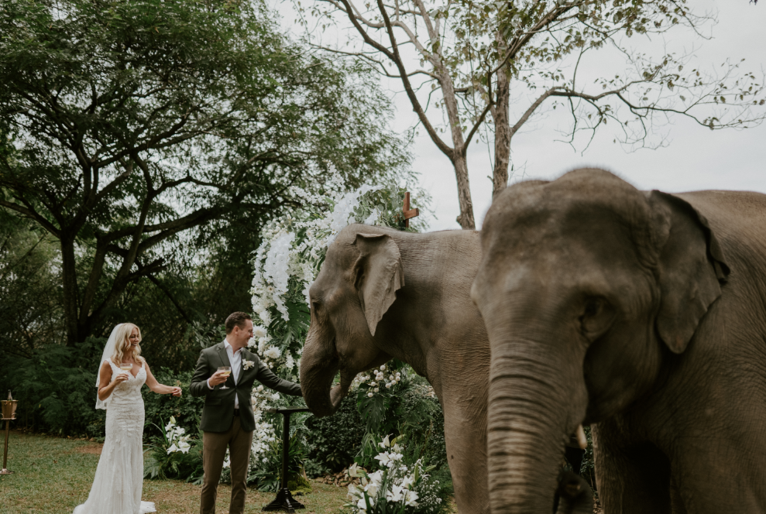

Weddings
Starting from $3,000
The Golden Triangle’s enchanting landscapes and rich local culture provide abundant inspiration for fairytale weddings, which are tailored to each couple’s dreams and needs. For instance, the wedding ceremony can incorporate meaningful Thai rituals. Rings can be exchanged on a secluded hilltop overlooking the Mekong River or amidst verdant rice paddies. Distinctive evening dining celebrations include a Khantoke sunset dinner on a private hilltop, with traditional local delicacies served for guests to share as they recline on Thai triangular pillows in a Lanna decorated sala.

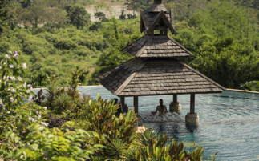

Guests with disabilities

Anantara Golden Triangle offers the flexibility to adapt Deluxe Rooms to meet accessibility needs. Upon request, these rooms can be equipped with:
- Rails for support in the shower, bathtub, and toilet areas.
- Portable ramps to ensure smooth wheelchair access to different parts of the resort.
- Wheelchairs available for guest use during their stay.
- Handheld showerheads.
- A special chair for the shower, ensuring a safe and more comfortable bathing experience.

Awards and recognitions
2026
- #37, Top 100 Best Hotels, World's Best Award 2026, Travel + Leisure
- #13, Best Resorts in Asia, World's Best Award 2026, Travel + Leisure
- #2, Best Resorts in Thailand, World's Best Award 2026, Travel + Leisure
- #2, Best Upcountry Hotels in Thailand, Travel + Leisure Luxury Awards Asia Pacific 2026
- #6, Best Hotel Pools in Thailand, Travel + Leisure Luxury Awards Asia Pacific 2026
- Top 15 One-of-a-Kind Hotels in the World, Travelers’ Choice Awards Best of the Best 2026, TripAdvisor
- Green Growth 2050 Platinum Certification
- Best Spotlight 2026, Tatler Thailand

-----

Media contact
Ms. Supa-arpha Itthikaiwan (Mandy)
Cluster Director of Marketing & Communications
Anantara Chiang Mai Resort | Anantara Golden Triangle Elephant Camp & Resort
E: supaarpha_it@anantara.com T: +66 (0) 53 333 337

