LEADERSHIP BIO
Mr. Jean Marc Pougnet - General Manager
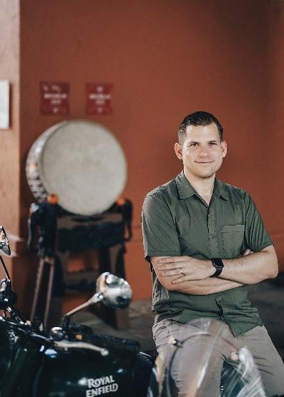
Chiang Rai, Thailand – Jean-Marc Pougnet is General Manager of Anantara Golden Triangle Elephant Camp & Resort, an award-winning luxury retreat overlooking the meeting point of Thailand, Laos and Myanmar. A Mauritian national, Jean-Marc returned to the resort in his first General Manager role after previously serving as Food & Beverage Manager and Director of Food & Beverage before leading operations as Resort Manager at Avani+ Khao Lak Resort. With more than a decade of hospitality experience across Europe, Africa and Asia, he has built a reputation for operational excellence, innovative dining concepts and creating memorable guest experiences. Passionate about meaningful luxury, Jean-Marc believes the most unforgettable journeys are shaped by authentic connections with local culture, nature and people—an approach that perfectly reflects Anantara Golden Triangle's immersive experiences, ethical elephant encounters and extraordinary destination-led hospitality. He holds degrees in International Hotel and Tourism Management from Ulster University in Northern Ireland and HTMi Hotel and Tourism Management Institute Switzerland. For media enquiries, please contact jpougnet@anantara.com.
---Ends---

About Anantara Golden Triangle Elephant Camp & Resort
Anantara Golden Triangle Elephant Camp & Resort is an award-winning 63-key luxury retreat perched on a lush hillside overlooking the meeting point of Thailand, Laos and Myanmar. Set within 160 acres of bamboo forest, just one hour from Chiang Rai International Airport, the resort is home to the Golden Triangle Asian Elephant Foundation and offers unforgettable experiences including ethical elephant encounters, Jungle Bubbles, treetop dining at Canopy, immersive wellness and destination-inspired adventures. Favoured by couples, honeymooners, families and luxury travellers seeking meaningful experiences in nature, the resort combines authentic local culture with world-class hospitality in one of Southeast Asia's most extraordinary destinations. Discover more at anantara.com/golden-triangle-chiang-rai and follow the resort on Facebook and Instagram.

About Anantara Hotels & Resorts
A luxury hospitality brand for modern travellers, Anantara Hotels & Resorts connects guests to genuine places, people and stories in some of the world’s most extraordinary destinations. Each Anantara embraces the surroundings and culture of its destination, creating unforgettable memories for every guest since 2001. From city to sea and desert to jungle, Anantara delivers heartfelt, Thai-inspired hospitality at its over 50 hotels and resorts across Asia, Europe, Africa, the Middle East and the Indian Ocean.

Anantara Hotels & Resorts is a Minor Hotels brand and recognises its guests through one unified loyalty programme, Minor DISCOVERY, part of GHA DISCOVERY.

Visit anantara.com for more information, and connect with Anantara on Facebook, Instagram, TikTok, X and YouTube.

About Minor Hotels
Minor Hotels is a global leader in the hospitality industry with more than 640 hotels, resorts and branded residences in operation and committed development across 66 countries. The group crafts innovative and insightful experiences through its hotel brands including Anantara, Elewana Collection, The Wolseley Hotels, Tivoli, Minor Reserve Collection, NH Collection, nhow, Avani, Colbert Collection, NH, Oaks, and iStay, as well as a diverse portfolio of restaurants and bars, travel experiences, and spa and wellness brands. With over four decades of expertise, Minor Hotels builds stronger brands, fosters lasting partnerships, and drives business success by always focusing on what matters most to our guests, team members and partners.

Minor Hotels is a proud member of the Global Hotel Alliance (GHA) and recognises its guests through one unified loyalty programme, Minor DISCOVERY, part of GHA DISCOVERY.

Discover our world at minorhotels.com and connect with Minor Hotels on Facebook, Instagram, LinkedIn, TikTok and YouTube.

For media enquiries, please contact:

Ms. Supa-arpha Itthikaiwan (Mandy)
Cluster Director of Marketing & Communications
Anantara Chiang Mai Resort | Anantara Golden Triangle Elephant Camp & Resort
T: +66 53 253 337
E: supaarpha_it@anantara.com

