PRESS RELEASE

HOLISTIC HARMONY

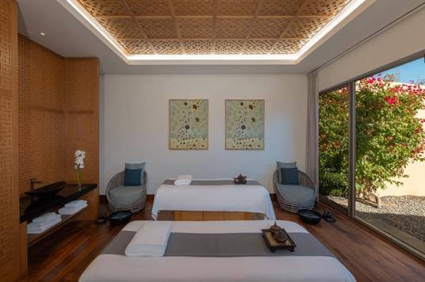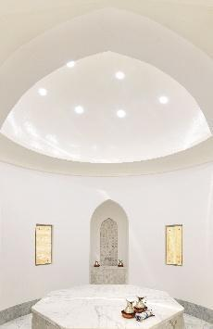

Anantara Al Jabal Al Akhdar Resort Introduces Elevated Wellness Rituals and Bespoke Mountain Retreats

Perched 2,000 metres above sea level on the curving rim of a massive canyon, Anantara Al Jabal Al Akhdar Resort introduces a high-altitude sanctuary for intrepid and discerning global travellers seeking cultural immersion and natural luxury. Blending fortified Omani architecture with contemporary style, the award-winning Anantara Spa acts as a serene mountaintop oasis within Oman’s rugged Al Hajar mountain range. The dedicated wellness facility delivers deeply restorative therapies tailored for wellness seekers, couples and luxury explorers looking to realign body and mind against the dramatic backdrop of the Saiq Plateau.

The spa infrastructure encompasses five beautifully appointed private luxury treatment suites alongside separate male and female indoor hydrothermal circuits. Guests have access to aroma saunas, herbal steam rooms, experience showers and private indoor relaxation chambers that open out into tranquil garden viewing areas. The treatment menu integrates indigenous mountain botanicals, utilizing locally harvested damask rose, pomegranate and Omani frankincense to ground therapies in the region's rich heritage. Signature journeys include the 90-minute Revitalising Pomegranate Journey, which uses a locally sourced fruit and salt body scrub to polish the skin before executing a deeply invigorating Arabian massage.

Beyond single therapies, the resort offers structured wellness programmes ranging from one to three days, developed under the guidance of Resident Wellness Practitioner Khem Raj. Each programme initiates with a personal wellness consultation to establish specific health goals, mapping out daily schedules of mountain meditation, yoga and guided wadi hiking. These multi-day retreats include full access to the property's fitness facilities, tennis court, jacuzzi and heated indoor swimming pool. For traditional thermal cleansing, the spa features a classic hammam ritual where guests experience an exhilarating salt scrub, a purifying body wrap and a traditional olive foam soaping on heated marble plinths.

"Our spa and wellness philosophy represents a profound architectural and experiential homage to the authentic soul of Oman," says Abdullatif Al Farsi, General Manager of Anantara Al Jabal Al Akhdar Resort. "By anchoring our wellness rituals and hydrothermal suites directly into the rugged cliffs of the Saiq Plateau, we give guests an unrivaled vantage point to engage in high-altitude wadi treks, rose-distilling village immersions and cliffside wellness rituals that cannot be replicated anywhere else in the world."

-Ends-

About Anantara Al Jabal Al Akhdar Resort
Perched 2,000 metres above sea level on the curving rim of a massive canyon in Oman’s Al Hajar mountain range, Anantara Al Jabal Al Akhdar Resort is the highest five-star luxury resort in the Middle East. The secluded haven features 115 guest rooms and private pool villas blending fortified Omani architecture with contemporary style. Discerning travellers experience natural luxury across six signature restaurants and lounges, a cliff-edge infinity pool and the award-winning Anantara Spa offering indigenous wellness rituals. Located a scenic two-hour drive from Muscat International Airport, it serves as a prestigious gateway to ancient forts, rose-distilling mountain villages and dramatic canyon adventures.
Website: anantara.com/al-jabal-al-akhdar | Social Media: Facebook, Instagram, TikTok and YouTube.

About Anantara Hotels & Resorts
A luxury hospitality brand for modern travellers, Anantara Hotels & Resorts connects guests to genuine places, people and stories in some of the world’s most extraordinary destinations. Each Anantara embraces the surroundings and culture of its destination, creating unforgettable memories for every guest since 2001. From city to sea and desert to jungle, Anantara delivers heartfelt, Thai-inspired hospitality at its over 50 hotels and resorts across Asia, Europe, Africa, the Middle East and the Indian Ocean.

Anantara Hotels & Resorts is a Minor Hotels brand and recognises its guests through one unified loyalty programme, Minor DISCOVERY, part of GHA DISCOVERY.

Visit anantara.com for more information, and connect with Anantara on Facebook, Instagram, TikTok, X and YouTube.

About Minor Hotels
Minor Hotels is a global leader in the hospitality industry with more than 640 hotels, resorts and branded residences across 66 countries. The group crafts innovative and insightful experiences through its hotel brands including Anantara, Elewana Collection, The Wolseley Hotels, Tivoli, Minor Reserve Collection, NH Collection, nhow, Avani, Colbert Collection, NH, Oaks and iStay, as well as a diverse portfolio of restaurants and bars, travel experiences and spa and wellness brands. With over four decades of expertise, Minor Hotels builds stronger brands, fosters lasting partnerships and drives business success by always focusing on what matters most to our guests, team members and partners.

Minor Hotels is a proud member of the Global Hotel Alliance (GHA) and recognises its guests through one unified loyalty programme, Minor DISCOVERY, part of GHA DISCOVERY.

Discover our world at minorhotels.com and connect with Minor Hotels on Facebook, Instagram, LinkedIn, TikTok and YouTube.

For media enquiries, please contact:
Laurence Desiree Klett
Cluster Director of Marketing and Communications
Anantara Al Jabal Al Akhdar Resort | Tivoli LA VIE Muscat Hotel & Residences
E: lklett@minor.com

Mohamed Ali Ben Jemaa
Cluster Marketing Executive
Anantara Al Jabal Al Akhdar Resort | Tivoli LA VIE Muscat Hotel & Residences
E: mohamed.ali@minor.com

Camilla Coburn Davis
Director of Public Relations
Minor Hotels Middle East & Africa
E: cdavis@minor.com

