At the Pinnacle of Mindful Luxury and Conscious Sustainability in Oman

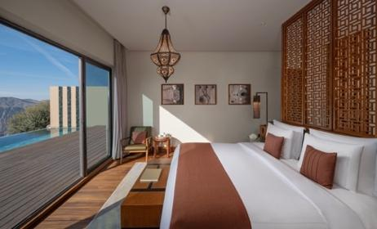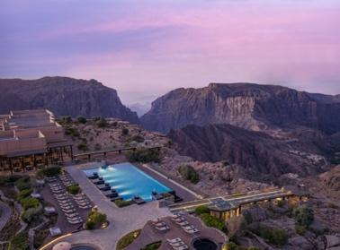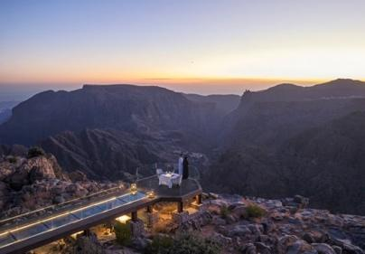

Anantara Al Jabal Al Akhdar Resort - Sustainability Overview

At Anantara Al Jabal Al Akhdar Resort, sustainability lies at the heart of the resort’s ethos. Perched 2,000 metres above sea level on the rim of a vast canyon, this gem of the Saiq Plateau on Oman’s Green Mountain blends dramatic natural beauty with authentic luxury. As the highest five-star resort in the Middle East, Anantara Al Jabal Al Akhdar elevates both setting and experience, with sustainability guiding every aspect of its operations.
Aligned with Minor Hotels’ sustainability strategy and global frameworks such as GSTC and Green Growth 2050 principles, the resort is committed to lasting positive impacts on the environment, local communities and cultural heritage. It is the first hotel in Oman to achieve Green Growth 2050 Platinum certification, reflecting leadership in sustainable luxury hospitality. This dedication is further recognised through its status as a UNESCO Sustainable Travel Pledge signatory and awards including Leading Green Resort at the World Travel Awards and the Condé Nast Traveller Readers’ Choice Awards 2025.
The resort actively supports initiatives that strengthen communities and protect the environment. Beyond hosting health and wellness programmes, it provides ongoing support to the Oman Cancer Association and the Environment Society of Oman through Minor Hotels’ Dollars for Deeds programme. Collaborating with local community offices, the resort hosts health education sessions, awareness campaigns and development initiatives. It also welcomes locals and dignitaries for cultural occasions such as Oman National Day and heritage-led events that strengthen social ties and cultural pride.
Animal welfare is a key pillar of sustainability. Partnerships with veterinary clinics in Muscat promote treatment and neutering programmes to manage the stray cat and dog population in and around Jebel Al Akhdar. Feeding stations across the resort support stray cats and wild donkeys, ensuring animal wellbeing while maintaining ecological balance.
Water conservation is a core focus. Efficient fixtures, mountain-adapted irrigation and reuse of treated water for landscaping and operations saved 39,199 cubic metres of water in 2025. Guests and team members are encouraged to adopt mindful water use, contributing to the collective protection of this vital resource.
Energy efficiency and carbon reduction are integral to operations. Ambient LED lighting, smart building systems and motion sensors reduce consumption, while solar energy and two electric vehicle charging stations lower the carbon footprint. In 2025, these initiatives cut 94,635 kilowatt hours compared with the previous year. Continuous monitoring ensures further reductions in energy use and emissions.
Waste management reflects a strong commitment to circularity. The resort’s on-site water bottling plant reduces single-use plastics, while segregation, recycling and repurposing minimise landfill impact. Used cooking oil is converted into 2,045 litres of biodiesel and 1,587 linens, towels and textiles are donated or repurposed to support community and animal welfare. Around 33 tonnes of waste were recycled in 2025.
The Housekeeping team also runs an internal “Anantara Souk,” selling pre-loved items donated by staff for a nominal fee. This prevents landfill waste, raises funds for Dollars for Deeds and fosters engagement and pride among the team.
Local sourcing is central to the resort’s philosophy. Seasonal fruits and vegetables from the gardens, along with olives and honey from on-site beehives, are transformed into jams, marmalades, olive oil and honey. Annually, around 3,500 kilograms of produce are harvested, including 2,600 kilograms of olives and 30–35 kilograms of honey.
Each September, the resort hosts the Olive Harvest Festival, inviting guests and locals to participate in traditional olive picking, pressing and farm-to-table experiences that celebrate Omani heritage and sustainable agriculture. Local sourcing reduces transport-related emissions, supports regional livelihoods and showcases authentic Omani flavours.
Anantara Al Jabal Al Akhdar is deeply woven into the social fabric of its region. Over a third of the resort’s team members are Omanis, reflecting a commitment to local talent. Development initiatives, training programmes and wellbeing-focused policies foster inclusion, professional growth and long-term career opportunities. Sustainability awareness is embedded into daily operations through regular team engagement and training.
The resort’s architecture and landscaped surroundings honour Al Jabal Al Akhdar’s dramatic beauty, drawing inspiration from traditional Omani villages and using local materials wherever possible. Thoughtful design preserves ecological balance while promoting responsible water and energy use. Through cultural experiences, collaborations with artisans and storytelling, Omani heritage is safeguarded and shared with guests.
Guests are invited to join the resort’s sustainability journey through simple actions, from reusing towels to choosing sustainably packaged amenities and participating in experiences that celebrate the natural environment and local culture. All guest amenities and products in the spa and boutique are cruelty-free, with many items supporting local businesses and artisans.
Sustainable dining extends beyond guest outlets to the team cafeteria. Smaller plates and active food-waste reduction initiatives are encouraged. Surplus ingredients and coffee grounds are repurposed as fertiliser, while fruit peels, skins and bread are reused responsibly, including as animal feed. Banquets, outlets and coffee breaks employ plastic-free setups and responsibly sourced materials.
At Anantara Al Jabal Al Akhdar Resort, sustainability is a continuous journey. Through innovation, meticulous monitoring and alignment with global standards, the resort continually enhances its environmental, social and cultural impact. It sets a benchmark for responsible luxury in Oman, where communities are empowered, heritage is preserved and every guest experience is enriched through conscious and meaningful hospitality.

This Earth Day, Anantara Al Jabal Al Akhdar, a member of the Global Hotel Alliance and part of the Green Collection Hotels, reaffirms its commitment to sustainable luxury, embracing eco-conscious practices while offering guests an exceptional, globally connected experience.

-Ends-

About Anantara Al Jabal Al Akhdar Resort
Perched 2,000 metres above sea level on the curving rim of a massive canyon in Oman’s Al Hajar mountain range, Anantara Al Jabal Al Akhdar Resort is the highest five-star luxury resort in the Middle East. The secluded haven features 115 guest rooms and private pool villas blending fortified Omani architecture with contemporary style. Discerning travellers experience natural luxury across six signature restaurants and lounges, a cliff-edge infinity pool and the award-winning Anantara Spa offering indigenous wellness rituals. Located a scenic two-hour drive from Muscat International Airport, it serves as a prestigious gateway to ancient forts, rose-distilling mountain villages and dramatic canyon adventures.
Website: anantara.com/al-jabal-al-akhdar | Social Media: Facebook, Instagram, TikTok and YouTube.

About Anantara Hotels & Resorts
A luxury hospitality brand for modern travellers, Anantara Hotels & Resorts connects guests to genuine places, people and stories in some of the world’s most extraordinary destinations. Each Anantara embraces the surroundings and culture of its destination, creating unforgettable memories for every guest since 2001. From city to sea and desert to jungle, Anantara delivers heartfelt, Thai-inspired hospitality at its over 50 hotels and resorts across Asia, Europe, Africa, the Middle East and the Indian Ocean.

Anantara Hotels & Resorts is a Minor Hotels brand and recognises its guests through one unified loyalty programme, Minor DISCOVERY, part of GHA DISCOVERY.

Visit anantara.com for more information, and connect with Anantara on Facebook, Instagram, TikTok, X and YouTube.

About Minor Hotels
Minor Hotels is a global leader in the hospitality industry with more than 640 hotels, resorts and branded residences across 66 countries. The group crafts innovative and insightful experiences through its hotel brands including Anantara, Elewana Collection, The Wolseley Hotels, Tivoli, Minor Reserve Collection, NH Collection, nhow, Avani, Colbert Collection, NH, Oaks and iStay, as well as a diverse portfolio of restaurants and bars, travel experiences and spa and wellness brands. With over four decades of expertise, Minor Hotels builds stronger brands, fosters lasting partnerships and drives business success by always focusing on what matters most to our guests, team members and partners.

Minor Hotels is a proud member of the Global Hotel Alliance (GHA) and recognises its guests through one unified loyalty programme, Minor DISCOVERY, part of GHA DISCOVERY.

Discover our world at minorhotels.com and connect with Minor Hotels on Facebook, Instagram, LinkedIn, TikTok and YouTube.

For media enquiries, please contact:
Laurence Desiree Klett
Cluster Director of Marketing and Communications
Anantara Al Jabal Al Akhdar Resort | Tivoli LA VIE Muscat Hotel & Residences
E: lklett@minor.com

Mohamed Ali Ben Jemaa
Cluster Marketing Executive
Anantara Al Jabal Al Akhdar Resort | Tivoli LA VIE Muscat Hotel & Residences
E: mohamed.ali@minor.com

Camilla Coburn Davis
Director of Public Relations
Minor Hotels Middle East & Africa
E: cdavis@minor.com

