Property Awards
Anantara Al Jabal Al Akhdar Resort
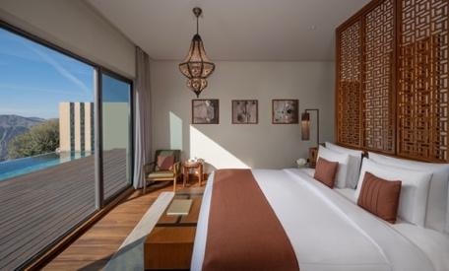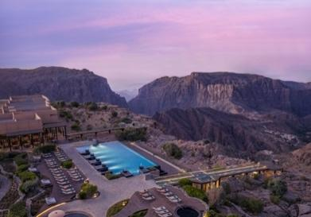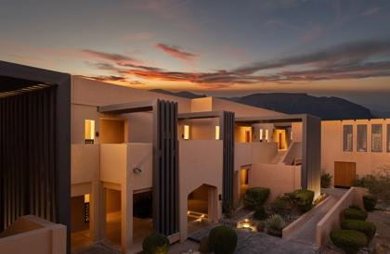
2026
- People's Choice Award by Layaline (MENA) – Winner
- Condé Nast Traveller (Global) – Triple Crown Recognition
- Tripadvisor Travellers' Choice Awards (Global) – Travellers' Choice Winner
- LA LISTE (Global) – Top 1,000 Hotels in the World
2025
- Tripadvisor Best of the Best (Global) – Top Luxury Hotels in the Middle East (Ranked #24)
- World Spa Awards (UK) – Oman's Best Resort Spa; Oman's Best Wellness Retreat
- Luxury Lifestyle Awards (USA) – Best Luxury Mountain Resort in Oman
- Travel + Leisure India – India's Best Awards (India) – Best Leisure Hotel (International Hotels)
- Hotelier Middle East Awards (MENA) – Spa & Wellness Person of the Year
2024
- Elite Traveler Top 100 Suites (UK) – Three Bedroom Royal Mountain Villa
- World Travel Awards (UK) – Middle East's Leading Honeymoon Resort; Middle East's Leading Wedding Resort; Oman's Leading Luxury Resort; Oman's Leading Villa Resort; Oman's Leading Luxury Hotel Villa
- World Travel Awards (UK) – World's Leading Green Resort; World's Leading Honeymoon Resort
- World Spa Awards (UK) – Oman's Best Resort Spa; Oman's Best Wellness Retreat
- Travel + Leisure World's Best Awards (USA) – Best Hotels in Oman
- Travel + Leisure India – India's Best Awards (India) – Best Leisure Hotel (International Hotels)
- World Culinary Awards (UK) – Oman's Best Hotel Restaurant (Bella Vista)
- LuxLife Resorts & Retreats Awards (UK) – Most Picturesque Luxury Mountain Resort – Oman
- BBC Good Food Middle East Awards (Middle East) – Staycation Experience; Best Casual Restaurant (Al Maisan); Best Fine Dining Restaurant – GCC (Bella Vista & Al Qalaa)
- Hotelier Middle East Awards (UAE) – Housekeeping Manager of the Year (Kuldeep); Unsung Hero of the Year (Hasan)
- Green Growth 2050 (Global) – Sustainability Certification
2023
- Elite Traveler Top 100 Suites (UK) – Three Bedroom Royal Mountain Villa
- World Travel Awards (UK) – Middle East's Leading Honeymoon Resort; Middle East's Leading Wedding Resort; Oman's Leading Luxury Resort; Oman's Leading Villa Resort; Oman's Leading Luxury Hotel Villa
- World Travel Awards (UK) – World's Leading Green Resort
- Travel + Leisure World's Best Awards (USA) – Best Hotels in Oman
- Booking.com Traveller Review Awards (Global) – Traveller Review Award
- Leaders in Hospitality Awards (UAE) – Hotel with the Best View; Hotel Chef of the Year
- Luxury Travel Advisor (USA) – Most Instagrammable Hotel in the World
- World Spa Awards (UK) – Oman's Best Resort Spa; Oman's Best Wellness Retreat
- LuxLife Resorts & Retreats Awards (UK) – Luxury Mountain Resort of the Year – Oman
- Tripadvisor Travellers' Choice Awards (Global) – Travellers' Choice Winner
- World Culinary Awards (UK) – Oman's Best Hotel Restaurant
- BBC Good Food Middle East Awards (Middle East) – Staycation Experience; Best Casual Restaurant (Al Maisan); Best Fine Dining Restaurant – Oman (Bella Vista)
2022
- World Travel Awards (UK) – Middle East's Leading Honeymoon Resort; Oman's Leading Luxury Resort; Oman's Leading Villa Resort; Oman's Leading Luxury Hotel Villa
- World Travel Awards (UK) – World's Leading Green Resort
- World Spa Awards (UK) – Oman's Best Resort Spa; Oman's Best Wellness Retreat
- Tripadvisor Travellers' Choice Awards (Global) – Travellers' Choice Winner
- BBC Good Food Middle East Awards (Middle East) – Staycation Experience; Best Casual Restaurant (Al Maisan); Best Fine Dining Restaurant (Bella Vista)
- Condé Nast Traveler Readers' Choice Awards (USA) – Top 10 Resorts in the Middle East
- Green Growth 2050 (Global) – Sustainability Certification
- LIV Hospitality Design Awards (Global) – Architectural Design – Luxury Resort; Architectural Design – Middle East
- Minor Hotels Awards (Thailand) – Best Sustainability Award
2021
- Luxury Lifestyle Awards (UAE) – Best Luxury Hotels in Oman
- Leaders in Hospitality Awards (UAE) – Leading Hospitality Heavyweight (Rami Farhat); CSR Initiative of the Year
- Travel + Leisure (USA) – Best Hotel in Oman
- World Travel Awards (UK) – Middle East's Leading Honeymoon Resort; Oman's Leading Luxury Resort; Oman's Leading Villa Resort; Oman's Leading Luxury Hotel Villa (Three Bedroom Royal Mountain Villa)
- World Travel Awards (UK) – World's Leading Green Resort
- World Spa Awards (UK) – Oman's Best Resort Spa; Oman's Best Wellness Retreat
- World Spa & Wellness Awards (UK) – Spa of the Year – Middle East & Africa
- Tripadvisor Travellers' Choice Awards (Global) – Travellers' Choice Winner
- Tripadvisor Travellers' Choice Restaurants (Global) – Top 10% of Restaurants Worldwide
- BBC Good Food Middle East Awards (Middle East) – Staycation Experience (AAJA); Best Casual Restaurant – GCC (Al Maisan); Best Fine Dining Restaurant – GCC (Bella Vista)
- Condé Nast Traveller Middle East Readers' Choice Awards (Middle East) – Favourite Hotel in Oman
- Condé Nast Traveler Readers' Choice Awards (USA) – Top 10 Resorts in the Middle East
- Hotelier Middle East Awards (UAE) – Hotel Team of the Year; Unsung Hero of the Year (Omar Al Daghari)
- NHI Awards (Oman) – Recognition of Omar Al Daghari, Abdullah Al Zakwani, Omran Al Balushi, Humaid Al Fahdi and Nassr Al Zakwani

2020
- BBC Good Food Middle East Awards (Middle East) – Staycation Experience – GCC

-Ends-

About Anantara Al Jabal Al Akhdar Resort
Perched 2,000 metres above sea level on the curving rim of a massive canyon in Oman’s Al Hajar mountain range, Anantara Al Jabal Al Akhdar Resort is the highest five-star luxury resort in the Middle East. The secluded haven features 115 guest rooms and private pool villas blending fortified Omani architecture with contemporary style. Discerning travellers experience natural luxury across six signature restaurants and lounges, a cliff-edge infinity pool and the award-winning Anantara Spa offering indigenous wellness rituals. Located a scenic two-hour drive from Muscat International Airport, it serves as a prestigious gateway to ancient forts, rose-distilling mountain villages and dramatic canyon adventures.
Website: anantara.com/al-jabal-al-akhdar | Social Media: Facebook, Instagram, TikTok and YouTube.

About Anantara Hotels & Resorts
A luxury hospitality brand for modern travellers, Anantara Hotels & Resorts connects guests to genuine places, people and stories in some of the world’s most extraordinary destinations. Each Anantara embraces the surroundings and culture of its destination, creating unforgettable memories for every guest since 2001. From city to sea and desert to jungle, Anantara delivers heartfelt, Thai-inspired hospitality at its over 50 hotels and resorts across Asia, Europe, Africa, the Middle East and the Indian Ocean.

Anantara Hotels & Resorts is a Minor Hotels brand and recognises its guests through one unified loyalty programme, Minor DISCOVERY, part of GHA DISCOVERY.

Visit anantara.com for more information, and connect with Anantara on Facebook, Instagram, TikTok, X and YouTube.

About Minor Hotels
Minor Hotels is a global leader in the hospitality industry with more than 640 hotels, resorts and branded residences across 66 countries. The group crafts innovative and insightful experiences through its hotel brands including Anantara, Elewana Collection, The Wolseley Hotels, Tivoli, Minor Reserve Collection, NH Collection, nhow, Avani, Colbert Collection, NH, Oaks and iStay, as well as a diverse portfolio of restaurants and bars, travel experiences and spa and wellness brands. With over four decades of expertise, Minor Hotels builds stronger brands, fosters lasting partnerships and drives business success by always focusing on what matters most to our guests, team members and partners.

Minor Hotels is a proud member of the Global Hotel Alliance (GHA) and recognises its guests through one unified loyalty programme, Minor DISCOVERY, part of GHA DISCOVERY.

Discover our world at minorhotels.com and connect with Minor Hotels on Facebook, Instagram, LinkedIn, TikTok and YouTube.

For media enquiries, please contact:

Laurence Desiree Klett
Cluster Director of Marketing and Communications
Anantara Al Jabal Al Akhdar Resort | Tivoli LA VIE Muscat Hotel & Residences
E: lklett@minor.com

Mohamed Ali Ben Jemaa
Cluster Marketing Executive
Anantara Al Jabal Al Akhdar Resort | Tivoli LA VIE Muscat Hotel & Residences
E: mohamed.ali@minor.com

Camilla Coburn Davis
Director of Public Relations
Minor Hotels Middle East & Africa
E: cdavis@minor.com

