PRESS RELEASE
Exhilarating Mountain Experiences

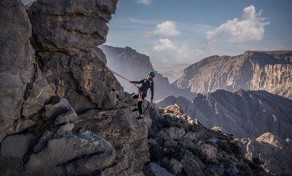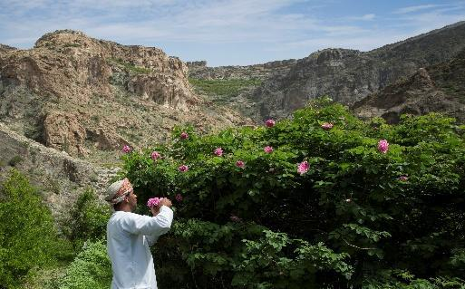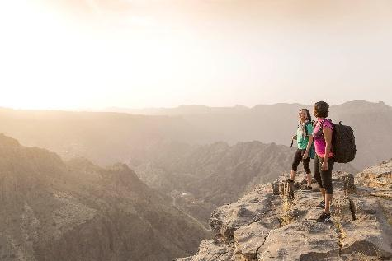

Anantara Al Jabal Al Akhdar Resort Launches High-Altitude Cultural Immersions and Mountain Adventure Expeditions
Perched 2,000 metres above sea level on the curving rim of a massive canyon, Anantara Al Jabal Al Akhdar Resort introduces a curated portfolio of outdoor expeditions for intrepid and discerning global travellers seeking cultural immersion and natural luxury. The five-star resort beautifully blends fortified Omani architecture with contemporary style, serving as an active mountain base within Oman’s rugged Al Hajar mountain range. These signature guest experiences are designed for luxury explorers, active couples and heritage enthusiasts looking to engage directly with the dramatic landscape and living traditions of the Saiq Plateau.
The resort's adventure programming features a custom-built cliffside Via Ferrata route where seasoned instructors guide thrill-seekers along steel cables, abseiling points, and vertical rock faces directly over the canyon rim. Mountaineering activities leverage the area's year-round temperate alpine climate, offering guided wadi hiking trails through ancient ruins, juniper forests, and hidden caves, alongside dedicated mountain biking routes. Between mid-March and mid-April, the property conducts exclusive agricultural excursions allowing guests to witness the annual bloom of damask roses cascading down the mountain slopes and visit traditional local distilleries to observe the extraction of smoked rosewater.
Cultural itineraries extend into the surrounding Ad Dakhiliyah Governorate, featuring guided excursions to the historic city of Nizwa to explore its ancient fort, traditional silver souks, and historic Friday cattle auction. Guests can also tour Birkat Al Mouz, a UNESCO World Heritage site showcasing the ancient al falaj irrigation system that represents a central component of Omani heritage. On-property leisure experiences include mountaintop yoga sessions, archery, astronomy stargazing, and an interactive kids' and teens' club providing educational fossil discovery walks and nature storytelling sessions across the resort grounds.
"Our guest experience philosophy represents a profound architectural and experiential homage to the authentic soul of Oman," says Abdullatif Al Farsi, General Manager of Anantara Al Jabal Al Akhdar Resort. "By anchoring our adventure trails and cultural excursions directly into the rugged cliffs of the Saiq Plateau, we give guests an unrivaled vantage point to engage in high-altitude wadi treks, rose-distilling village immersions, and cliffside wellness rituals that cannot be replicated anywhere else in the world."

-Ends-

About Anantara Al Jabal Al Akhdar Resort
Perched 2,000 metres above sea level on the curving rim of a massive canyon in Oman’s Al Hajar mountain range, Anantara Al Jabal Al Akhdar Resort is the highest five-star luxury resort in the Middle East. The secluded haven features 115 guest rooms and private pool villas blending fortified Omani architecture with contemporary style. Discerning travellers experience natural luxury across six signature restaurants and lounges, a cliff-edge infinity pool and the award-winning Anantara Spa offering indigenous wellness rituals. Located a scenic two-hour drive from Muscat International Airport, it serves as a prestigious gateway to ancient forts, rose-distilling mountain villages and dramatic canyon adventures.
Website: anantara.com/al-jabal-al-akhdar | Social Media: Facebook, Instagram, TikTok and YouTube.

About Anantara Hotels & Resorts
A luxury hospitality brand for modern travellers, Anantara Hotels & Resorts connects guests to genuine places, people and stories in some of the world’s most extraordinary destinations. Each Anantara embraces the surroundings and culture of its destination, creating unforgettable memories for every guest since 2001. From city to sea and desert to jungle, Anantara delivers heartfelt, Thai-inspired hospitality at its over 50 hotels and resorts across Asia, Europe, Africa, the Middle East and the Indian Ocean.

Anantara Hotels & Resorts is a Minor Hotels brand and recognises its guests through one unified loyalty programme, Minor DISCOVERY, part of GHA DISCOVERY.

Visit anantara.com for more information, and connect with Anantara on Facebook, Instagram, TikTok, X and YouTube.

About Minor Hotels
Minor Hotels is a global leader in the hospitality industry with more than 640 hotels, resorts and branded residences across 66 countries. The group crafts innovative and insightful experiences through its hotel brands including Anantara, Elewana Collection, The Wolseley Hotels, Tivoli, Minor Reserve Collection, NH Collection, nhow, Avani, Colbert Collection, NH, Oaks and iStay, as well as a diverse portfolio of restaurants and bars, travel experiences and spa and wellness brands. With over four decades of expertise, Minor Hotels builds stronger brands, fosters lasting partnerships and drives business success by always focusing on what matters most to our guests, team members and partners.

Minor Hotels is a proud member of the Global Hotel Alliance (GHA) and recognises its guests through one unified loyalty programme, Minor DISCOVERY, part of GHA DISCOVERY.

Discover our world at minorhotels.com and connect with Minor Hotels on Facebook, Instagram, LinkedIn, TikTok and YouTube.
For media enquiries, please contact:
Laurence Desiree Klett
Cluster Director of Marketing and Communications
Anantara Al Jabal Al Akhdar Resort | Tivoli LA VIE Muscat Hotel & Residences
E: lklett@minor.com

Mohamed Ali Ben Jemaa
Cluster Marketing Executive
Anantara Al Jabal Al Akhdar Resort | Tivoli LA VIE Muscat Hotel & Residences
E: mohamed.ali@minor.com

Camilla Coburn Davis
Director of Public Relations
Minor Hotels Middle East & Africa
E: cdavis@minor.com

