PRESS RELEASE
Gastronomic Journeys

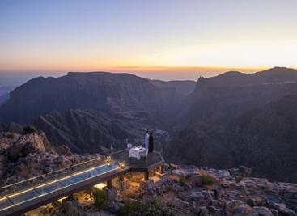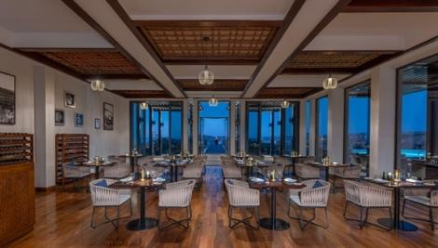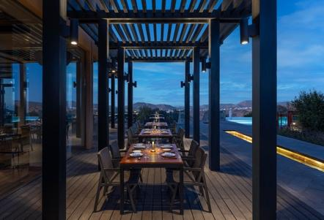

Anantara Al Jabal Al Akhdar Resort Showcases High-Altitude Culinary Innovation and Authentic Omani Flavours

Perched 2,000 metres above sea level on the curving rim of a massive canyon, Anantara Al Jabal Al Akhdar Resort introduces a sophisticated mountain dining destination for epicureans and luxury travellers seeking cultural immersion and natural luxury. The five-star resort hosts a collection of six distinct restaurants and lounges that merge fortified Omani architecture with contemporary style. The culinary portfolio delivers elevated dining experiences tailored for food connoisseurs, couples and heritage enthusiasts who wish to experience indigenous ingredients and year-round alfresco dining high above the Saiq Plateau.

The resort's dining ecosystem features diverse culinary concepts, including Al Qalaa, a fine-dining Middle Eastern restaurant housed in a central fort tower inspired by Khasab Castle in Northern Oman. Al Qalaa serves inventive Omani cuisine crafted from produce harvested from local farms and the Gulf, set beneath a dramatic constellation of hanging lanterns. For international fare, Al Maisan provides live cooking stations featuring Middle Eastern, contemporary Thai, fresh sushi, and fiery Indian dishes, complete with a spacious outdoor terrace overlooking the canyon. Poolside dining is anchored by Bella Vista, a contemporary restaurant serving seasonal Italian cuisine and fresh salads alongside a cliff-edge infinity pool.

For lighter refreshments, Al Baha café and deli offers traditional English and Omani afternoon tea within the central courtyard, while Al Shourfa and Al Burj provide rooftop lounge experiences featuring shisha, tapas and signature cocktails under the stars. The pinnacle of the resort’s culinary offering is delivered through bespoke private dining programs. Guests can experience Designer Dining By Anantara at Diana’s Point, the historic cliffside location visited by the late Diana, Princess of Wales in 1986, or ascend to the glass-floored Royal Edge platform. Additionally, the property hosts interactive Spice Spoons cooking classes, where guests tour the resort garden with Chef Henrico to master authentic Middle Eastern and Thai culinary techniques.

"Our culinary philosophy represents a profound architectural and experiential homage to the authentic soul of Oman," says Abdullatif Al Farsi, General Manager of Anantara Al Jabal Al Akhdar Resort. "By anchoring our six signature restaurants directly into the rugged cliffs of the Saiq Plateau, we give guests an unrivaled vantage point to engage in high-altitude wadi treks, rose-distilling village immersions, and cliffside wellness rituals that cannot be replicated anywhere else in the world."

-Ends-

About Anantara Al Jabal Al Akhdar Resort
Perched 2,000 metres above sea level on the curving rim of a massive canyon in Oman’s Al Hajar mountain range, Anantara Al Jabal Al Akhdar Resort is the highest five-star luxury resort in the Middle East. The secluded haven features 115 guest rooms and private pool villas blending fortified Omani architecture with contemporary style. Discerning travellers experience natural luxury across six signature restaurants and lounges, a cliff-edge infinity pool and the award-winning Anantara Spa offering indigenous wellness rituals. Located a scenic two-hour drive from Muscat International Airport, it serves as a prestigious gateway to ancient forts, rose-distilling mountain villages and dramatic canyon adventures.
Website: anantara.com/al-jabal-al-akhdar | Social Media: Facebook, Instagram, TikTok and YouTube.

About Anantara Hotels & Resorts
A luxury hospitality brand for modern travellers, Anantara Hotels & Resorts connects guests to genuine places, people and stories in some of the world’s most extraordinary destinations. Each Anantara embraces the surroundings and culture of its destination, creating unforgettable memories for every guest since 2001. From city to sea and desert to jungle, Anantara delivers heartfelt, Thai-inspired hospitality at its over 50 hotels and resorts across Asia, Europe, Africa, the Middle East and the Indian Ocean.

Anantara Hotels & Resorts is a Minor Hotels brand and recognises its guests through one unified loyalty programme, Minor DISCOVERY, part of GHA DISCOVERY.

Visit anantara.com for more information, and connect with Anantara on Facebook, Instagram, TikTok, X and YouTube.

About Minor Hotels
Minor Hotels is a global leader in the hospitality industry with more than 640 hotels, resorts and branded residences across 66 countries. The group crafts innovative and insightful experiences through its hotel brands including Anantara, Elewana Collection, The Wolseley Hotels, Tivoli, Minor Reserve Collection, NH Collection, nhow, Avani, Colbert Collection, NH, Oaks and iStay, as well as a diverse portfolio of restaurants and bars, travel experiences and spa and wellness brands. With over four decades of expertise, Minor Hotels builds stronger brands, fosters lasting partnerships and drives business success by always focusing on what matters most to our guests, team members and partners.

Minor Hotels is a proud member of the Global Hotel Alliance (GHA) and recognises its guests through one unified loyalty programme, Minor DISCOVERY, part of GHA DISCOVERY.

Discover our world at minorhotels.com and connect with Minor Hotels on Facebook, Instagram, LinkedIn, TikTok and YouTube.

For media enquiries, please contact:
Laurence Desiree Klett
Cluster Director of Marketing and Communications
Anantara Al Jabal Al Akhdar Resort | Tivoli LA VIE Muscat Hotel & Residences
E: lklett@minor.com

Mohamed Ali Ben Jemaa
Cluster Marketing Executive
Anantara Al Jabal Al Akhdar Resort | Tivoli LA VIE Muscat Hotel & Residences
E: mohamed.ali@minor.com

Camilla Coburn Davis
Director of Public Relations
Minor Hotels Middle East & Africa
E: cdavis@minor.com

