PRESS RELEASE
Corporate Retreats Above the Clouds

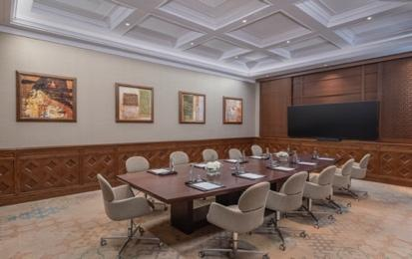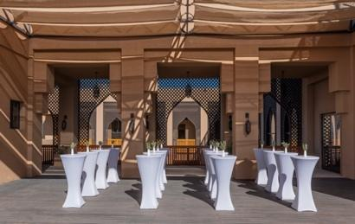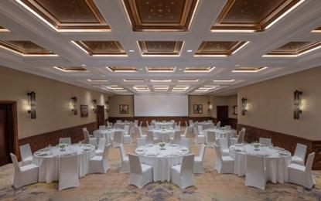

Anantara Al Jabal Al Akhdar Resort Introduces Elevated Mountain Corporate Retreats
Perched 2,000 metres above sea level on the curving rim of a massive canyon, Anantara Al Jabal Al Akhdar Resort introduces a curated portfolio of outdoor expeditions for intrepid and discerning global travellers seeking cultural immersion and natural luxury. The five-star resort beautifully blends fortified Omani architecture with contemporary style, serving as an active mountain base within Oman’s rugged Al Hajar mountain range. These signature guest experiences are designed for luxury explorers, active couples and heritage enthusiasts looking to engage directly with the dramatic landscape and living traditions of the Saiq Plateau.
Anantara Al Jabal Al Akhdar Resort introduces elevated mountain corporate retreats for corporate groups and team building organisations seeking authentic luxury rooted in tradition. Located on the first floor of the highest five-star resort in the Middle East, the comprehensive meeting facilities provide flexible professional configurations overlooking a central courtyard.
The dedicated meeting venue spans multiple configurations, including the 216-square-metre Al Ain ballroom which accommodates up to 150 guests in a theatre setup or 120 guests for a banquet event. Al Ain can be divided into two individual function rooms measuring 108 square metres each, both accommodating up to 60 guests in theatre style. For smaller executive meetings, the 47-square-metre Al Aqr boardroom hosts up to 16 delegates around a fixed central table. A 156-square-metre pre-function area serves as a breakout space for up to 130 cocktail guests.
Situated a two-hour drive from Muscat International Airport and a 30-minute drive from the ancient city of Nizwa, the resort provides immersive activities between business sessions. Corporate delegates can access master chef cooking classes at Spice Spoons, interactive team building at the Jabal Activity Wall and tailored private dinners at Diana's Point.
"Hosting an event at Anantara Al Jabal Al Akhdar Resort allows corporate teams to clear their minds 2,000 metres above sea level on the curving rim of a great canyon," says General Manager Abdullatif Al Farsi. "Our meeting venues, named after nearby farming villages, ensure that corporate retreats remain seamlessly integrated with our destination's history while delivering world-class business infrastructure."

-Ends-

About Anantara Al Jabal Al Akhdar Resort
Perched 2,000 metres above sea level on the curving rim of a massive canyon in Oman’s Al Hajar mountain range, Anantara Al Jabal Al Akhdar Resort is the highest five-star luxury resort in the Middle East. The secluded haven features 115 guest rooms and private pool villas blending fortified Omani architecture with contemporary style. Discerning travellers experience natural luxury across six signature restaurants and lounges, a cliff-edge infinity pool and the award-winning Anantara Spa offering indigenous wellness rituals. Located a scenic two-hour drive from Muscat International Airport, it serves as a prestigious gateway to ancient forts, rose-distilling mountain villages and dramatic canyon adventures.
Website: anantara.com/al-jabal-al-akhdar | Social Media: Facebook, Instagram, TikTok and YouTube.

About Anantara Hotels & Resorts
A luxury hospitality brand for modern travellers, Anantara Hotels & Resorts connects guests to genuine places, people and stories in some of the world’s most extraordinary destinations. Each Anantara embraces the surroundings and culture of its destination, creating unforgettable memories for every guest since 2001. From city to sea and desert to jungle, Anantara delivers heartfelt, Thai-inspired hospitality at its over 50 hotels and resorts across Asia, Europe, Africa, the Middle East and the Indian Ocean.

Anantara Hotels & Resorts is a Minor Hotels brand and recognises its guests through one unified loyalty programme, Minor DISCOVERY, part of GHA DISCOVERY.

Visit anantara.com for more information, and connect with Anantara on Facebook, Instagram, TikTok, X and YouTube.

About Minor Hotels
Minor Hotels is a global leader in the hospitality industry with more than 640 hotels, resorts and branded residences across 66 countries. The group crafts innovative and insightful experiences through its hotel brands including Anantara, Elewana Collection, The Wolseley Hotels, Tivoli, Minor Reserve Collection, NH Collection, nhow, Avani, Colbert Collection, NH, Oaks and iStay, as well as a diverse portfolio of restaurants and bars, travel experiences and spa and wellness brands. With over four decades of expertise, Minor Hotels builds stronger brands, fosters lasting partnerships and drives business success by always focusing on what matters most to our guests, team members and partners.

Minor Hotels is a proud member of the Global Hotel Alliance (GHA) and recognises its guests through one unified loyalty programme, Minor DISCOVERY, part of GHA DISCOVERY.

Discover our world at minorhotels.com and connect with Minor Hotels on Facebook, Instagram, LinkedIn, TikTok and YouTube.

For media enquiries, please contact:
Laurence Desiree Klett
Cluster Director of Marketing and Communications
Anantara Al Jabal Al Akhdar Resort | Tivoli LA VIE Muscat Hotel & Residences
E: lklett@minor.com

Mohamed Ali Ben Jemaa
Cluster Marketing Executive
Anantara Al Jabal Al Akhdar Resort | Tivoli LA VIE Muscat Hotel & Residences
E: mohamed.ali@minor.com

Camilla Coburn Davis
Director of Public Relations
Minor Hotels Middle East & Africa
E: cdavis@minor.com

