PRESS RELEASE

Introducing Anantara Al Jabal Al Akhdar Resort

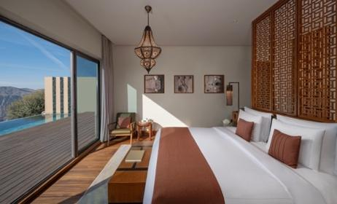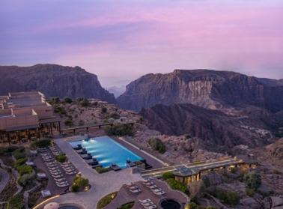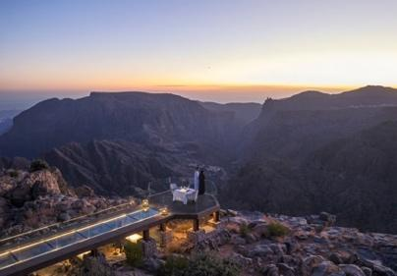

Anantara Al Jabal Al Akhdar Resort Establishes High-Altitude Luxury Sanctuary in Oman
Perched 2,000 metres above sea level on the curving rim of a massive canyon, Anantara Al Jabal Al Akhdar Resort introduces a secluded haven for intrepid and discerning global travellers seeking cultural immersion and natural luxury. Blending fortified Omani architecture with contemporary style, this five-star resort acts as a luxurious mountaintop base within Oman’s rugged Al Hajar mountain range. The property offers high-altitude sanctuary experiences tailored for luxury explorers, couples and heritage enthusiasts looking to connect deeply with the rich history and dramatic landscape of the Saiq Plateau.

The resort features 115 luxuriously appointed guest keys, comprising 82 Premier and Deluxe Canyon View Rooms and 33 private pool villas. The 60-square-metre canyon rooms are among the largest in the Sultanate, featuring balconies and spa-like bathrooms carved out of sustainable local stone. The standalone villa collection includes temperature-controlled infinity pools, dedicated villa host services, and configurations ranging from one-bedroom sanctuaries to the ultra-exclusive, 700-square-metre Three Bedroom Royal Mountain Villa. Guests are positioned a scenic two-hour drive from Muscat International Airport and a four and a half hour drive from Dubai, offering a dramatic arrival past wadis and historic desert forts.

Culinary and recreational assets leverage the mountain's year-round temperate climate, which remains significantly cooler than the surrounding lowlands. The resort hosts six signature restaurants and lounges, including Al Qalaa, a fine-dining Middle Eastern tower concept, and Bella Vista, a contemporary poolside Italian restaurant. Private dining is delivered via Dining by Design at Diana’s Point, the exact cliffside location visited by the late Diana, Princess of Wales in 1986, and the glass-floored Royal Edge platform. Wellness facilities span a cliff-edge infinity pool, a 24-hour fitness centre, and the award-winning Anantara Spa, which houses five private luxury treatment suites and separate male and female indoor hydrothermal circuits.

"Our resort represents a profound architectural and experiential homage to the authentic soul of Oman," says Abdullatif Al Farsi, General Manager of Anantara Al Jabal Al Akhdar Resort. "By anchoring 115 luxury keys directly into the rugged cliffs of the Saiq Plateau, we give guests an unrivaled vantage point to engage in high-altitude wadi treks, rose-distilling village immersions, and cliffside wellness rituals that cannot be replicated anywhere else in the world.

-Ends-

About Anantara Al Jabal Al Akhdar Resort
Perched 2,000 metres above sea level on the curving rim of a massive canyon in Oman’s Al Hajar mountain range, Anantara Al Jabal Al Akhdar Resort is the highest five-star luxury resort in the Middle East. The secluded haven features 115 guest rooms and private pool villas blending fortified Omani architecture with contemporary style. Discerning travellers experience natural luxury across six signature restaurants and lounges, a cliff-edge infinity pool and the award-winning Anantara Spa offering indigenous wellness rituals. Located a scenic two-hour drive from Muscat International Airport, it serves as a prestigious gateway to ancient forts, rose-distilling mountain villages and dramatic canyon adventures.
Website: anantara.com/al-jabal-al-akhdar | Social Media: Facebook, Instagram, TikTok and YouTube.

About Anantara Hotels & Resorts
A luxury hospitality brand for modern travellers, Anantara Hotels & Resorts connects guests to genuine places, people and stories in some of the world’s most extraordinary destinations. Each Anantara embraces the surroundings and culture of its destination, creating unforgettable memories for every guest since 2001. From city to sea and desert to jungle, Anantara delivers heartfelt, Thai-inspired hospitality at its over 50 hotels and resorts across Asia, Europe, Africa, the Middle East and the Indian Ocean.

Anantara Hotels & Resorts is a Minor Hotels brand and recognises its guests through one unified loyalty programme, Minor DISCOVERY, part of GHA DISCOVERY.

Visit anantara.com for more information, and connect with Anantara on Facebook, Instagram, TikTok, X and YouTube.

About Minor Hotels
Minor Hotels is a global leader in the hospitality industry with more than 640 hotels, resorts and branded residences across 66 countries. The group crafts innovative and insightful experiences through its hotel brands including Anantara, Elewana Collection, The Wolseley Hotels, Tivoli, Minor Reserve Collection, NH Collection, nhow, Avani, Colbert Collection, NH, Oaks and iStay, as well as a diverse portfolio of restaurants and bars, travel experiences and spa and wellness brands. With over four decades of expertise, Minor Hotels builds stronger brands, fosters lasting partnerships and drives business success by always focusing on what matters most to our guests, team members and partners.

Minor Hotels is a proud member of the Global Hotel Alliance (GHA) and recognises its guests through one unified loyalty programme, Minor DISCOVERY, part of GHA DISCOVERY.

Discover our world at minorhotels.com and connect with Minor Hotels on Facebook, Instagram, LinkedIn, TikTok and YouTube.

For media enquiries, please contact:
Laurence Desiree Klett
Cluster Director of Marketing and Communications
Anantara Al Jabal Al Akhdar Resort | Tivoli LA VIE Muscat Hotel & Residences
E: lklett@minor.com

Mohamed Ali Ben Jemaa
Cluster Marketing Executive
Anantara Al Jabal Al Akhdar Resort | Tivoli LA VIE Muscat Hotel & Residences
E: mohamed.ali@minor.com

Camilla Coburn Davis
Director of Public Relations
Minor Hotels Middle East & Africa
E: cdavis@minor.com

