Leadership Bios
Anantara Al Jabal Al Akhdar Resort

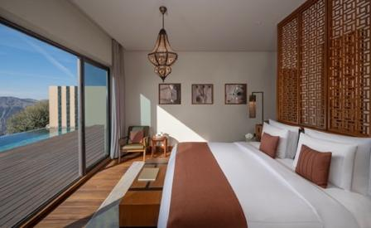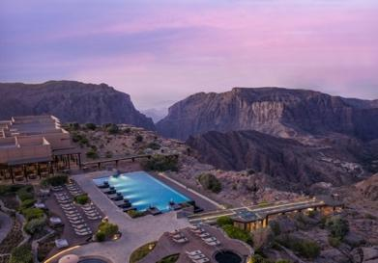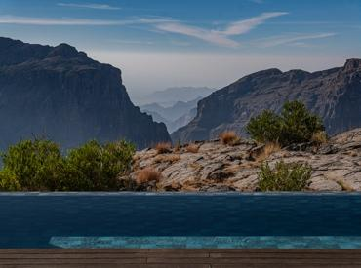

Abdullatif Al Farsi – General Manager
Abdullatif Al Farsi is General Manager of Anantara Al Jabal Al Akhdar Resort, a luxury hotel perched 2,000 metres above sea level on the curving rim of a great canyon. With over two decades of distinguished international hospitality leadership, his background focuses on scaling ultraluxury operations and delivering culturally immersive hospitality that respects local ecosystems. Al Farsi’s operational philosophy centers on elevating authentic luxury through the deep integration of local Omani culture and world-class standard execution, ensuring every guest experiences a rare jewel of mountain hospitality. For media and interview requests regarding Anantara Al Jabal Al Akhdar Resort, contact him directly at aalfarsi@anantara.com.

Geo George – Resident Manager
Geo George is Resident Manager of Anantara Al Jabal Al Akhdar Resort, a luxury hotel perched 2,000 metres above sea level on the curving rim of a great canyon. Since joining Minor Hotels in 2013, his international career highlights critical strategic and asset management roles across luxury properties in Mauritius, Doha, Tunisia, and the UAE. George focuses on driving day-to-day operational excellence, long-term commercial performance, and safeguarding the premium infrastructure required of an elite clifftop destination. For all operational and executive corporate inquiries regarding Anantara Al Jabal Al Akhdar Resort, please email ggeorge@anantara.com.

Laurence Desiree Klett – Cluster Director of Marketing
Laurence Desiree Klett is Cluster Director of Marketing of Anantara Al Jabal Al Akhdar Resort, a luxury hotel perched 2,000 metres above sea level on the curving rim of a great canyon. Directing the marketing footprint for both Anantara Al Jabal Al Akhdar Resort and Tivoli Al Hajar Vie Muscat, her background focuses on executing cross-brand luxury storytelling and positioning ultra-luxury hospitality assets to affluent international audiences. Klett's creative strategy centers on showcasing the natural beauty, cultural heritage, and authentic experiences of the Saiq Plateau through premium storytelling and impactful digital engagement. For marketing partnerships or media inquiries regarding Anantara Al Jabal Al Akhdar Resort, please contact lklett@anantara.com.

Aidai Ismailova – Cluster Director of Sales
Aidai Ismailova is Cluster Director of Sales of Anantara Al Jabal Al Akhdar Resort, a luxury hotel uniquely situated on a great canyon edge in the Al Hajar Mountains. Managing a strategic portfolio across Anantara Al Jabal Al Akhdar Resort, Anantara Al Baleed Resort Salalah, and Tivoli Al Hajar Vie Muscat, her extensive background features elite commercial leadership and high-value government relations across the Gulf region. Ismailova’s commercial strategy centers on driving multi-property revenue growth and building high-value partnerships that position the resort portfolio as the premier regional destination for travelers seeking luxury above the clouds. For interview requests regarding the resort’s market positioning or sales strategies, please contact aismailova@anantara.com.

Chef Henrico – Executive Chef
Chef Henrico is Executive Chef of Anantara Al Jabal Al Akhdar Resort, a luxury hotel uniquely situated on a great canyon edge in the Al Hajar Mountains. His celebrated global culinary career spans prestigious fine-dining kitchens across Europe and the Middle East, bringing a masterful perspective to clifftop gastronomy. Chef Henrico specializes in blending signature Middle Eastern flavors with contemporary international techniques, utilizing ingredients freshly harvested from local farming villages to anchor his menus in true authentic luxury. For culinary media inquiries and interview requests regarding Anantara Al Jabal Al Akhdar Resort, please email hgrobbelaar@anantara.com.

Gretchen Arenas – Director of Rooms
Gretchen Arenas is Director of Rooms of Anantara Al Jabal Al Akhdar Resort, a luxury hotel perched 2,000 metres above sea level on the curving rim of a great canyon. Possessing a comprehensive background in premium room operations and front office management for major international hospitality groups, she oversees the resort's diverse accommodation portfolio from luxury canyon view rooms to elite private villas. Arenas’s management philosophy targets the flawless delivery of authentic mountain hospitality and highly personalized guest service at every touchpoint. For operations inquiries or media requests regarding guest services at Anantara Al Jabal Al Akhdar Resort, contact garenas@anantara.com.
-Ends-

About Anantara Al Jabal Al Akhdar Resort
Perched 2,000 metres above sea level on the curving rim of a massive canyon in Oman’s Al Hajar mountain range, Anantara Al Jabal Al Akhdar Resort is the highest five-star luxury resort in the Middle East. The secluded haven features 115 guest rooms and private pool villas blending fortified Omani architecture with contemporary style. Discerning travellers experience natural luxury across six signature restaurants and lounges, a cliff-edge infinity pool and the award-winning Anantara Spa offering indigenous wellness rituals. Located a scenic two-hour drive from Muscat International Airport, it serves as a prestigious gateway to ancient forts, rose-distilling mountain villages and dramatic canyon adventures.
Website: anantara.com/al-jabal-al-akhdar | Social Media: Facebook, Instagram, TikTok and YouTube.

About Anantara Hotels & Resorts
A luxury hospitality brand for modern travellers, Anantara Hotels & Resorts connects guests to genuine places, people and stories in some of the world’s most extraordinary destinations. Each Anantara embraces the surroundings and culture of its destination, creating unforgettable memories for every guest since 2001. From city to sea and desert to jungle, Anantara delivers heartfelt, Thai-inspired hospitality at its over 50 hotels and resorts across Asia, Europe, Africa, the Middle East and the Indian Ocean.

Anantara Hotels & Resorts is a Minor Hotels brand and recognises its guests through one unified loyalty programme, Minor DISCOVERY, part of GHA DISCOVERY.

Visit anantara.com for more information, and connect with Anantara on Facebook, Instagram, TikTok, X and YouTube.

About Minor Hotels
Minor Hotels is a global leader in the hospitality industry with more than 640 hotels, resorts and branded residences across 66 countries. The group crafts innovative and insightful experiences through its hotel brands including Anantara, Elewana Collection, The Wolseley Hotels, Tivoli, Minor Reserve Collection, NH Collection, nhow, Avani, Colbert Collection, NH, Oaks and iStay, as well as a diverse portfolio of restaurants and bars, travel experiences and spa and wellness brands. With over four decades of expertise, Minor Hotels builds stronger brands, fosters lasting partnerships and drives business success by always focusing on what matters most to our guests, team members and partners.

Minor Hotels is a proud member of the Global Hotel Alliance (GHA) and recognises its guests through one unified loyalty programme, Minor DISCOVERY, part of GHA DISCOVERY.

Discover our world at minorhotels.com and connect with Minor Hotels on Facebook, Instagram, LinkedIn, TikTok and YouTube.

For media enquiries, please contact:
Laurence Desiree Klett
Cluster Director of Marketing and Communications
Anantara Al Jabal Al Akhdar Resort | Tivoli LA VIE Muscat Hotel & Residences
E: lklett@minor.com

Mohamed Ali Ben Jemaa
Cluster Marketing Executive
Anantara Al Jabal Al Akhdar Resort | Tivoli LA VIE Muscat Hotel & Residences
E: mohamed.ali@minor.com

Camilla Coburn Davis
Director of Public Relations
Minor Hotels Middle East & Africa
E: cdavis@minor.com

