PRESS RELEASE
Minor Hotels Debuts Anantara Tented Camp Kafue River

Anantara’s landmark safari camp in Zambia opens for reservations

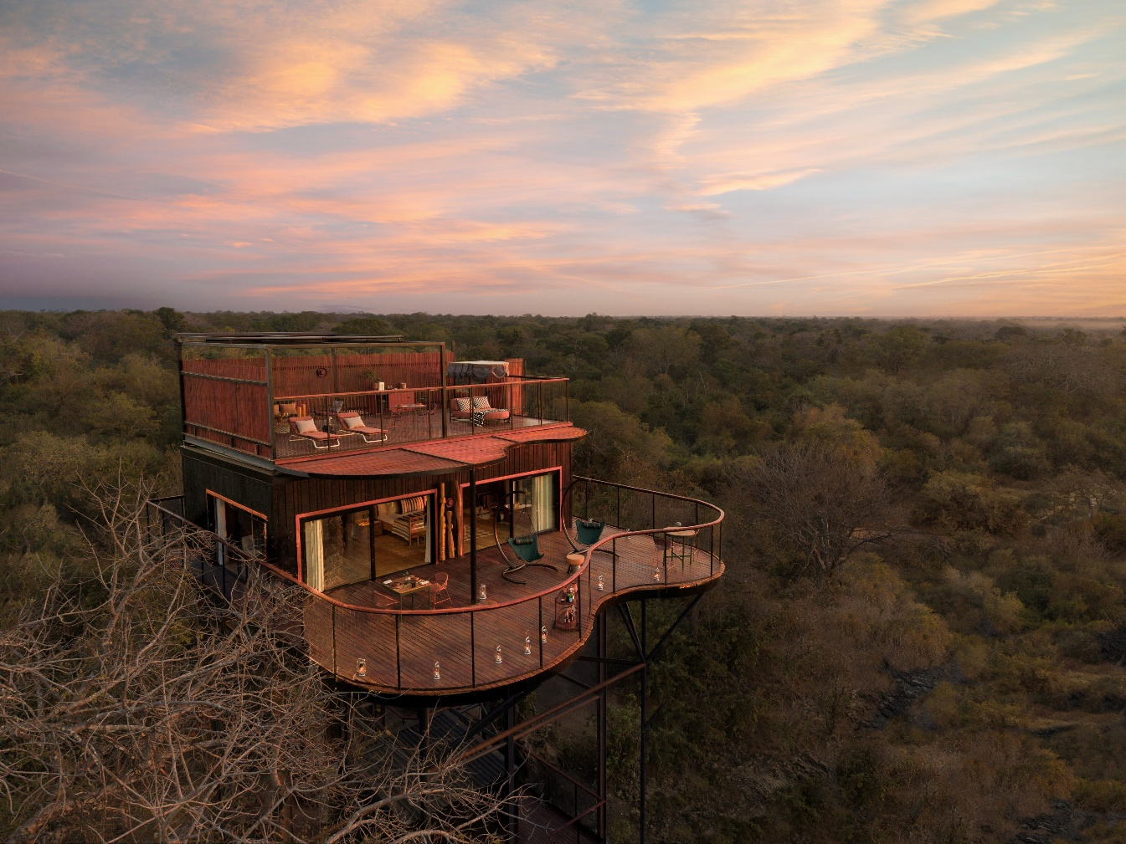

Bangkok, 13 July 2026 – Minor Hotels welcomes the arrival of Anantara Tented Camp Kafue River, the brand’s first tented safari camp and a key milestone in Anantara’s 25th anniversary year. The new 13-key camp is located within Kafue National Park, one of Africa’s largest protected areas, supporting the Government and African Parks’ long-term ecological restoration in Zambia.
With access to almost seven metres of river frontage shared only with the resident wildlife, Anantara Kafue is Zambia’s only lodge elevated at least 3.5 metres above the ground, raised on timber platforms to maintain wildlife movement providing uninterrupted views of the Kafue River. Its opening coincides with wildlife restoration initiatives and a steadily recovering wilderness where hippos, elephants, large predators, antelope and over 500 bird species flourish. Guests will experience this transformation through land and water activities such as game drives, river safaris, guided walks, bush picnics and catch-and-release fishing.
Designed by Meg Ralph Spaces and recognised with LIV Hospitality Design Awards, the camp follows a low-impact, contemporary approach, operating entirely on solar power, using on-site water purification bottling and treatment, and eliminating single-use plastics from the start. The use of prefabricated structures preserves all existing trees, and soft red lighting is employed at night to minimise disturbance to nocturnal wildlife.
Anantara Kafue’s signature accommodation, the three Horizon Terrace Suites, are the highest suites in Zambia, each suspended 14.3 metres above the ground and accessed by a glass elevator, with upper-level star beds and expansive decks. Guests staying in one of the nine Pool and Bush Villas enjoy private plunge pools and dedicated indoor spa rooms, while the 400-square-metre Presidential Villa is designed to offer elevated river views, exclusive boat access and a private spa zone. All villas are supported by dedicated hosts for dining, activities and wellness arrangements.
Dining is integrated into the stay, with travellers enjoying unlimited flexibility. The camp’s signature floating pontoon on the river hosts dawn breakfasts, afternoon tea and sunset dinners above the water, while Luzuba Harvestry and Twalumba Bar & Lounge offer modern Zambian cuisine, afternoon tea, cocktails and fireside gatherings. Spice Spoons provides hands-on Zambian cooking classes for further immersion.
In-nature wellness is key to the experience, with the full range of Anantara Spa treatments available in-room, complemented by steam sessions in the privacy of one’s suite or villa, a distinction unique in Zambia. A fully equipped floating Technogym fitness platform anchored in the river offers private training, yoga and open-air relaxation, alongside nature-based activities such as birdwatching and stargazing.
“Three years in the making, Anantara Tented Camp Kafue River is a significant step in our expansion across Africa and reflects the shared vision of the Government of Zambia, African Parks and Anantara,” said Nico Vivier, Regional Director of Operations and Development for Minor Hotels in Africa. “Its location within a major conservation landscape allows us to introduce a new standard of low-impact luxury in Zambia while contributing to the long-term restoration of Kafue National Park.”
Anantara Kafue is located within Kafue National Park, with private charter flights available from Livingstone or Lusaka to Chunga airstrip. The camp can also be reached by short domestic flight from Livingstone. Lusaka International Airport is a four-hour drive from the property. For more information, please visit the official website, call on +27 10 003 8979 or email at cro.jnb@minorhotels.com.
- Ends –

Editor’s Notes:
About Minor Hotels
Minor Hotels is a global leader in the hospitality industry with over 640* hotels, resorts and branded residences across 59 countries. The group crafts innovative and insightful experiences through its hotel brands including Anantara, Elewana Collection, The Wolseley Hotels, Tivoli, Minor Reserve Collection, NH Collection, nhow, Avani, Colbert Collection, NH, Oaks, and iStay, as well as a diverse portfolio of restaurants and bars, travel experiences, and spa and wellness brands. With over four decades of expertise, Minor Hotels builds stronger brands, fosters lasting partnerships, and drives business success by always focusing on what matters most to our guests, team members and partners.
Minor Hotels is a proud member of the Global Hotel Alliance (GHA) and recognises its guests through one unified loyalty programme, Minor DISCOVERY, part of GHA DISCOVERY.
Discover our world at minorhotels.com and connect with Minor Hotels on Facebook, Instagram, LinkedIn, TikTok and YouTube.
*Property count includes operating properties as well as committed developments through ownership, joint ventures, signed leases and management agreements.
For media inquiries, please contact:
Lisa Carey
Cluster PR Manager – Anantara Zimbabwe & Zambia
E: lcarey@minor.com

Camilla Coburn Davis
Regional PR Director - Minor Hotels Middle East & Africa
E: cdavis@minor.com

