PRESS RELEASE
Minor Hotels Breaks Ground on First Avani Hotel
in Singapore
The new 200-key lifestyle property in the historical district of Tanjong Pagar is set to open in 2027 in partnership with Kajima Development and Al Wathba Investment.
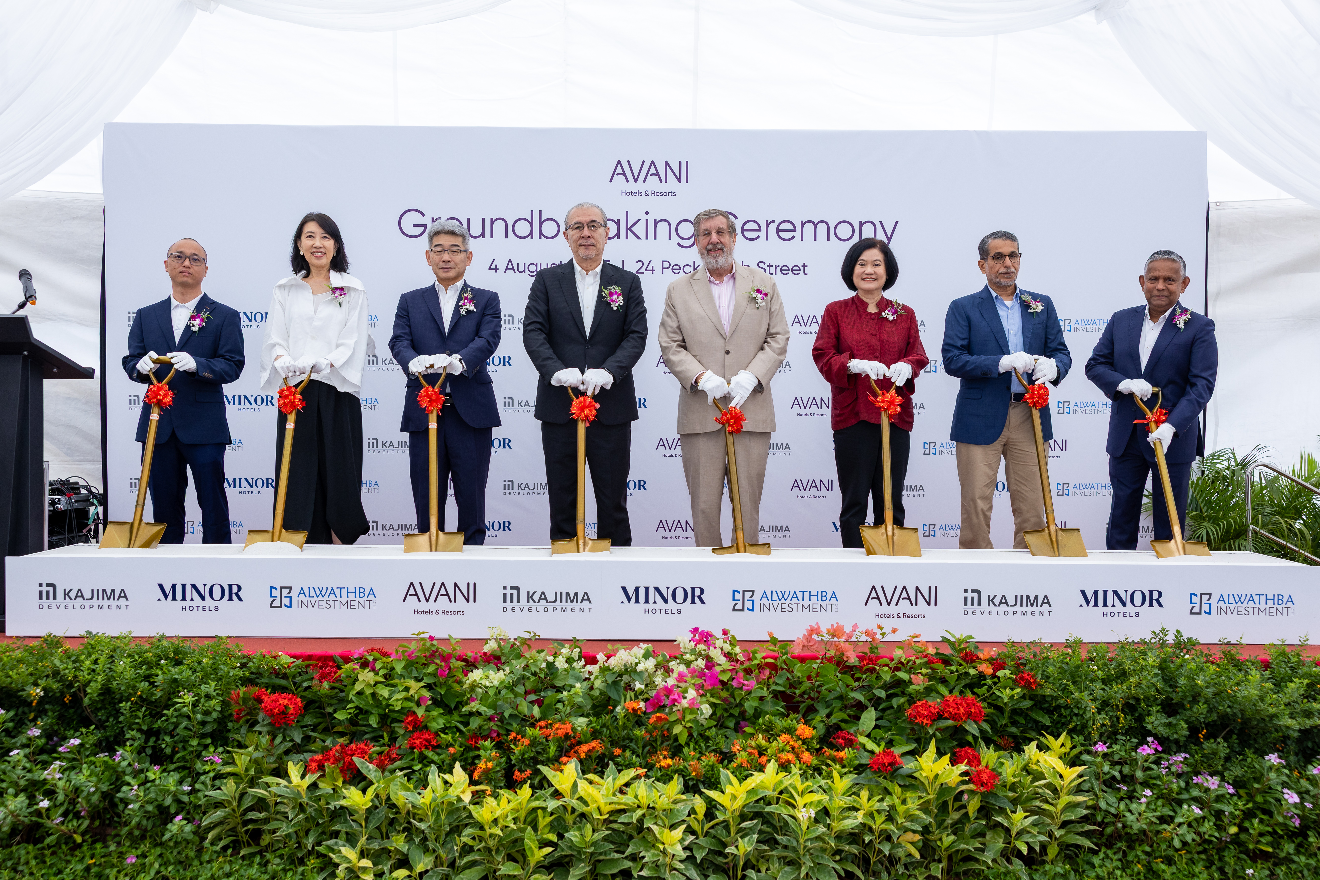
Left to right: Mr. Winston Zhu Wenting, Managing Director of Kim Hua Construction Pte. Ltd.; Ms. Angelene Chan, Chairman of DP Architects; H.E. Hiroshi Ishikawa, Ambassador of Japan to Singapore; Mr. Shuichi Oishi, CEO of Kajima Development; Mr. William E. Heinecke, Chairman and Founder of Minor International; H.E. Mrs. Ureerat Chareontoh, Ambassador of Thailand to Singapore; H.E. Mohamed Saif Al Suwaidi, Managing Director of Al Wathba Investment; and Mr. Dillip Rajakarier, CEO of Minor Hotels and Group CEO of Minor International.
Bangkok, 4th August 2025 – Minor Hotels, a global hospitality group with over 640 hotels, resorts and branded residences across 57 countries, celebrates a key milestone with the groundbreaking ceremony of its first Avani property in Singapore. Taking place at 24 Peck Seah Street in the vibrant Tanjong Pagar district, the event marked the beginning of construction of the 14-storey lifestyle hotel, set to welcome guests in Q2 2027. The project is being developed through a strategic partnership between Minor Hotels, Singapore-based Kajima Development, and Abu Dhabi-based Al Wathba Investment, reinforcing continued international confidence in Singapore’s tourism market.

With over 50 distinguished guests in attendance, the ceremony was officiated by key executives and project partners including Mr. William E. Heinecke, Chairman and Founder of Minor International, the parent company of Minor Hotels; Mr. Dillip Rajakarier, CEO of Minor Hotels and Group CEO of Minor International; H.E. Mohamed Saif Al Suwaidi, Managing Director of Al Wathba Investment; Mr. Shuichi Oishi, CEO of Kajima Development; Mr. Winston Zhu Wenting, Managing Director of Kim Hua Construction Pte. Ltd.; and Ms. Angelene Chan, Chairman of DP Architects. Guests of Honour included H.E. Hiroshi Ishikawa, Ambassador of Japan to Singapore, and H.E. Mrs. Ureerat Chareontoh, Ambassador of Thailand to Singapore.
The event began with a welcome address by Mr. Heinecke, who highlighted the strategic significance of the project and its role in expanding Avani’s presence in key global cities. This was followed by a project overview presented by representatives from the development team, offering insights into the vision behind the new hotel. Guests then gathered for the ceremonial turning of the soil, marking the official start of this exciting new chapter for Avani Hotels & Resorts in one of Asia’s most dynamic cities.
Speaking at the event, Mr. Heinecke commented:
“Today’s groundbreaking is a proud moment for Minor Hotels as we introduce the Avani brand to Singapore. With our trusted partners Kajima and Al Wathba, we are bringing to life a project that not only reflects our shared commitment to innovation and excellence, but also celebrates the city’s unique blend of culture and modernity.”
Mr. Mohamed Saif Al Suwaidi, Managing Director of Al Wathba Investment, added:
“We are honoured to be part of this milestone occasion. This groundbreaking marks more than just the start of the construction – it represents a shared vision of creating a distinctive hospitality experience that embodies the spirit of Singapore and the strength of our collaboration.”
Mr. Shuichi Oishi, CEO of Kajima Development, commented in a statement:
“This groundbreaking reflects our continued commitment to Singapore and our confidence in the long-term growth of its hospitality scene. Together with our partners, we are proud to embark on a project that contributes to the city’s future as a world-class destination.”
Located in the heart of Tanjong Pagar, the upcoming 200-key Avani Singapore will offer an elevated urban escape blending the heritage of Singapore’s historic shophouse precinct with Avani’s signature contemporary style. Facilities will include a pool deck, AvaniFit gym, vibrant dining concepts and a pedestrian link between Peck Seah and Tras Street. The property’s location, less than 200 metres from the Tanjong Pagar MRT Station and 350 metres from Maxwell MRT Station, will provide seamless access to the Downtown Core, Marina Bay and other key districts for both local and international visitors.
-Ends-

Editor’s Notes:

About Avani Hotels & Resorts
Designed for today’s traveller, Avani Hotels & Resorts offers stylish rooms, connected social spaces and relaxed and on-the-go dining that is locally inspired. Balance is central to everything Avani does, providing guests with the right measure of service, fun and privacy. Launched in 2011, Avani’s over 40 properties across five continents offer premium city hotels, tropical resorts and retreats in nature with a focus on smart design, upbeat service and good value.
Avani Hotels & Resorts is a Minor Hotels brand and recognises its guests through one unified loyalty programme, Minor DISCOVERY, part of GHA DISCOVERY.
Visit avanihotels.com for more information, and connect with Avani on Facebook, Instagram, TikTok, X and YouTube.

About Minor Hotels
Minor Hotels is a global leader in the hospitality industry with over 640* hotels, resorts and branded residences across 57 countries. The group crafts innovative and insightful experiences through its hotel brands including Anantara, Elewana Collection, The Wolseley Hotels, Tivoli, Minor Reserve Collection, NH Collection, nhow, Avani, Colbert Collection, NH, Oaks, and iStay, as well as a diverse portfolio of restaurants and bars, travel experiences, and spa and wellness brands. With over four decades of expertise, Minor Hotels builds stronger brands, fosters lasting partnerships, and drives business success by always focusing on what matters most to our guests, team members and partners.
Minor Hotels is a proud member of the Global Hotel Alliance (GHA) and recognises its guests through one unified loyalty programme, Minor DISCOVERY, part of GHA DISCOVERY.
Discover our world at minorhotels.com and connect with Minor Hotels on Facebook, Instagram, LinkedIn, TikTok and YouTube.
*Property count includes operating properties as well as committed developments through ownership, joint ventures, signed leases and management agreements.

For media enquiries, please contact:
Marion Walsh-Hedouin
Global Head of Public Relations & Communications, Minor Hotels
mwalsh@minor.com

Elisa Grimaldi
Director of Public Relations & Communications, Avani Hotels & Resorts
egrimaldi@minor.com

