PRESS RELEASE

Anantara Chiang Mai Resort Launches Unforgettable Culinary Journeys With New Spice Spoons Cooking Class Cruises

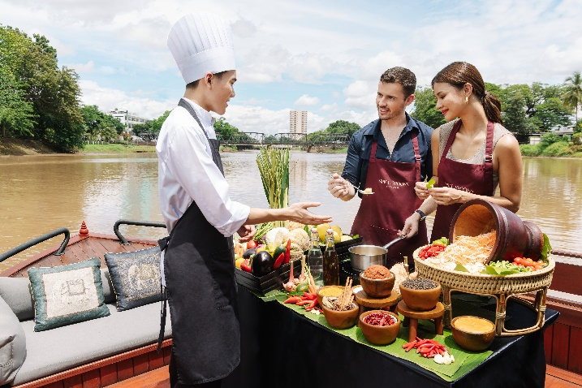

Anantara Chiang Mai Resort’s new cooking classes aboard the Nam Jit launch on 1 October 2025, combining the spice of the north with the stunning scenery found along the banks of the Mae Ping River.

Chiang Mai, 1 October 2025 – Anantara Chiang Mai Resort unveils a new culinary journey aboard the Nam Jit, combining two of its most popular experiences – the Spice Spoons cooking class and the JAO Ping River Cruise. Guests can now master Thai favourites and northern specialties while cruising the Mae Ping River in signature Anantara style.

Anantara Hotels & Resorts has long immersed its guests in each destination with authentic experiences that showcase the landscape, culture, and people. At Anantara Chiang Mai, this ethos is brought to life through a cooking adventure that begins with a guided tuk-tuk ride to the vibrant local market. Here, chefs introduce guests to staple Thai ingredients, recommend home-friendly substitutions, and encourage tastings of fresh local snacks still hot from the pan.

Back at the resort, guests board the Nam Jit, a 21-metre hand-carved teak pontoon in traditional Lanna style. Low on the water and open on all sides, the vessel offers refreshing breezes and panoramic river views. Under expert guidance, participants prepare classic Thai dishes, such as spicy tom yum goong soup and aromatic green curry, as well as northern delights like khao soi noodles, hung lay curry, and nam prik ong relish. Guests will enjoy their creations for lunch as they continue their sail, complemented by the city’s iconic views. Each guest departs with a Spice Spoons certificate and recipe set to recreate the experience at home.

“The Spice Spoons cooking experience abroad Nam Jit is a truly unique way to discover the soul of Chiang Mai,” said Arnaud Béril, Cluster General Manager of Anantara Chiang Mai Resort and Anantara Golden Triangle Elephant Camp & Resort. “It reflects Anantara’s promise to connect travellers with the authentic essence of each destination – in this case, through food, community, and the beauty of the river.”

The Spice Spoons cruise experience is priced at THB 4,800++ per person, inclusive of the market tour, or THB 3,800++ for the cruise and class only. Market tours begin at 10:00 am, with the cruise departing daily at 11:00 am. Reservations are required 24 hours in advance. Alternatively, guests can opt for the on-land Spice Spoons cooking class at the resort’s show kitchen at Bodhi Terrace.

Part of the JAO Ping River Cruise fleet, the Nam Jit joins other distinctive journeys, from morning cultural visits to Wat Ket Karam and afternoon tea sailings, to sunset cruises and Michelin-starred chef dinners aboard Dibba Yana Chitta, a floating artwork by renowned Thai artist Chalermchai Kositpipat.

For more information or reservations, please call +66 53 253 333 or email chiangmai@anantara.com.

-Ends-

Editor’s Notes:

About Anantara Chiang Mai Resort
As the capital of the ancient Lanna kingdom, Chiang Mai overflows with cultural discoveries, from traditional Buddhist temples and handicraft collectives to a decidedly contemporary art and cafe scene. Surrounding the city, adventure awaits, whether trekking through the mountains to elephant sanctuaries and hilltribe villages or soaring over them in a hot-air balloon.

Anantara Chiang Mai Resort offers boutique contemporary luxury on the banks of the Mae Ping River, just five minutes from the Night Bazaar and 15 minutes from the airport. Eighty-four rooms and suites are located on the main grounds, with 25 serviced suites designed for long stays and families just across the road. The central 100-year-old heritage house, formerly the British consulate, plays host to elegant evenings of wining and dining. Leisure facilities include the award-winning Anantara Spa, a 34 m swimming pool by the river, and a fitness centre offering yoga, tai chi and muay Thai classes.

About Anantara Hotels & Resorts
A luxury hospitality brand for modern travellers, Anantara Hotels & Resorts connects guests to genuine places, people and stories in some of the world’s most extraordinary destinations. Each Anantara embraces the surroundings and culture of its destination, creating unforgettable memories for every guest since 2001. From city to sea and desert to jungle, Anantara delivers heartfelt, Thai-inspired hospitality at its over 50 hotels and resorts across Asia, Europe, Africa, the Middle East, and the Indian Ocean.

Anantara Hotels & Resorts is a Minor Hotels brand and recognises its guests through one unified loyalty programme, Minor DISCOVERY, part of GHA DISCOVERY.

Visit anantara.com for more information, and connect with Anantara on Facebook, Instagram, TikTok, X, and YouTube.

About Minor Hotels
Minor Hotels is a global leader in the hospitality industry with over 640* hotels, resorts and branded residences across 59 countries. The group crafts innovative and insightful experiences through its hotel brands including Anantara, Elewana Collection, The Wolseley Hotels, Tivoli, Minor Reserve Collection, NH Collection, nhow, Avani, Colbert Collection, NH, Oaks, and iStay, as well as a diverse portfolio of restaurants and bars, travel experiences, and spa and wellness brands. With over four decades of expertise, Minor Hotels builds stronger brands, fosters lasting partnerships, and drives business success by always focusing on what matters most to our guests, team members and partners.

Minor Hotels is a proud member of the Global Hotel Alliance (GHA) and recognises its guests through one unified loyalty programme, Minor DISCOVERY, part of GHA DISCOVERY.

Discover our world at minorhotels.com and connect with Minor Hotels on Facebook, Instagram, LinkedIn, TikTok, and YouTube.

*Property count includes operating properties as well as committed developments through ownership, joint ventures, signed leases, and management agreements.

For media enquiries, please contact:

Supa-arpha Itthikaiwan (Mandy)
Director of Marketing & Communications
Anantara Chiang Mai Resort
T: + 66 (0) 53 253 333
E: supaarpha_it@anantara.com

