

How art becomes the protagonist of every stay at Anantara Villa Padierna Palace Benahavís Marbella Resort

Anantara Villa Padierna Palace Benahavís Marbella Resort is an oasis of luxury and elegance located in an idyllic setting on the Costa del Sol. This five-star Grand Luxury resort, a member of The Leading Hotels of the World, is a museum hotel that houses a collection of more than 1,200 works of art, with a particular emphasis on sculpture and painting.
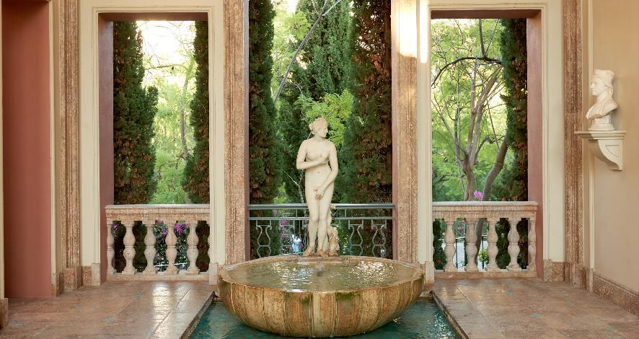

Highlights include pieces of Greco-Roman sculpture, works from the Iberian period, shields from noble houses and a period-spanning selection of canvases signed by prominent artists. An impressive Roman amphitheatre sets the scene for unique cultural experiences, and, unlike at conventional museums, visitors to Anantara Villa Padierna can enjoy art from dawn to dusk.

Marble and sculpture
Selected collections of statues, shields, curbstones and decorative elements in marble adorn the hotel. This collection of heraldry in stone and marble covers all periods, from noble shields eroded by time to perfectly preserved episcopal shields. The diversity and splendour of this collection are incomparable, and its beauty pays daily tribute to the anonymous master stonemasons.

Among the marbles, both complete and fragmented, those from the late Roman period and Tuscan style stand out for their unique charm and personality.

A parade of sculptures populates the hotel’s halls like characterful protagonists. The Three Graces, located in the hallway on the first floor, are carved in marble and represented as adolescents. An 18th-century Marble Oval with a virgin carved in profile adorns the façade of La Loggia’s terrace, topped below with a cherub. A Marble Torso (mutilated) from the 18th century evokes Greek art from the Hellenistic or Praxitelian period with its robustness and musculature; undoubtedly a theme of gods and heroes of antiquity, it stands in the lobby gallery.

The balanced and beautiful Episcopal Shield, executed in medium-to-high relief marble from the 16th to 18th centuries, is a history lesson located on the resort's north façade. This work has a kind of Castilian anointing and a certain nobility that evokes those secondaries of the time who were destined, due to their lesser degree of nobility, to episcopal dignities.

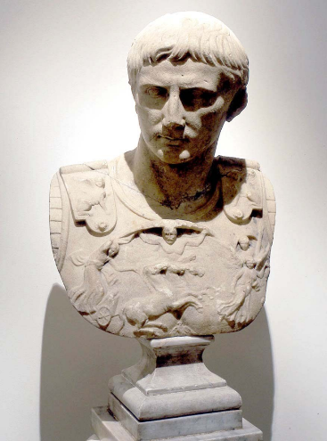
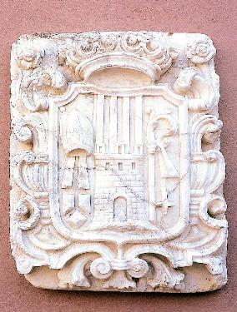
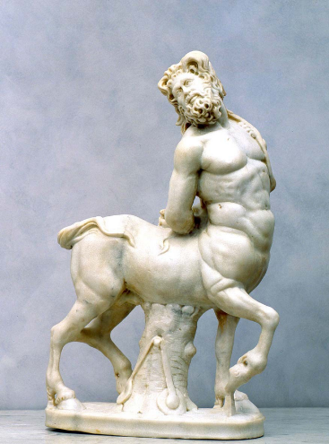
The Centaur in the lobby gallery is a sculpture full of vigour with a certain baroque contortion that distances it from the balanced models of Phidias and Lysippus and brings us closer to the style of Praxìteles. The sculpture of Caesar Augustus, also in the lobby gallery, is a magnificently executed portrait with strong expression and great realism; its bas-relief cuirass is exquisitely decorated with mythological motifs.

Fachada norte
Galería del lobby
Galería del lobby
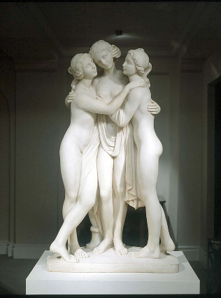
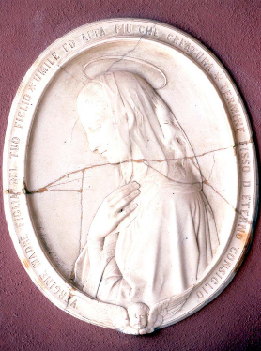
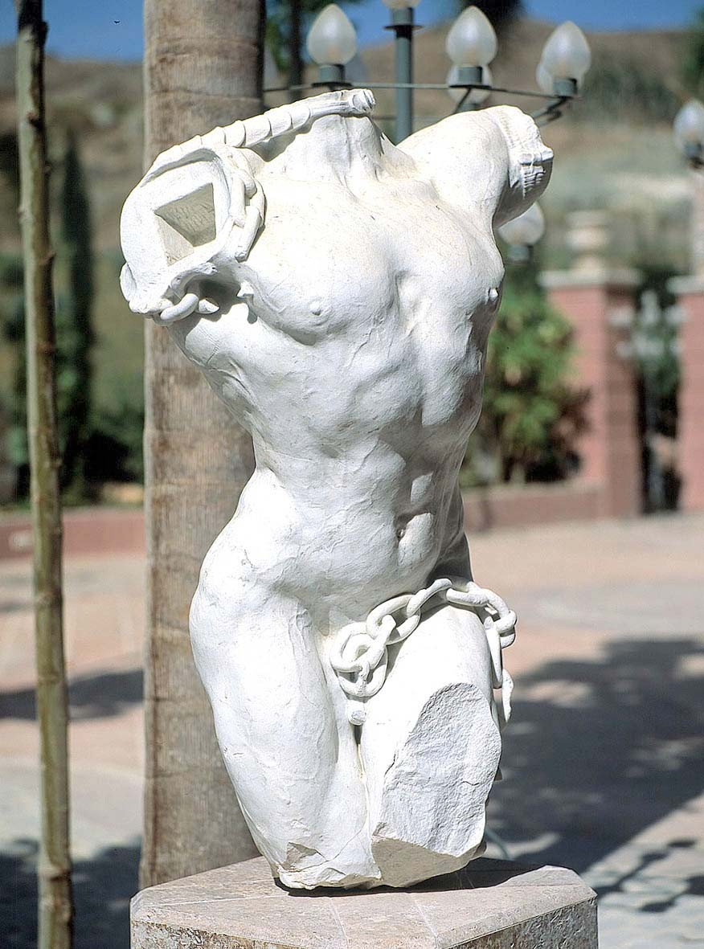

Pasillo de la primera planta
Fachada de la terraza de La Loggia
Galería del lobby

Portraits and canvases
Sala Venus
Eddy's Bar
Galería del lobby
The hotel houses a notable collection of European portraits, mainly from the 17th, 18th and 19th centuries, with a notable presence of Spanish paintings, characterised by their excellent quality and aesthetics. These portraits offer a broad panorama of the styles, composures, clothing colours and customs of the time, as well as a detailed study of the adornments, environment and psychology of the characters represented.
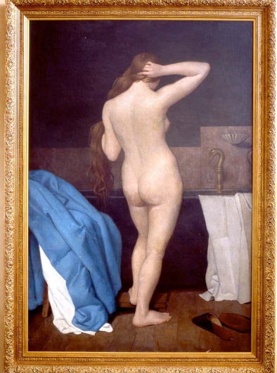
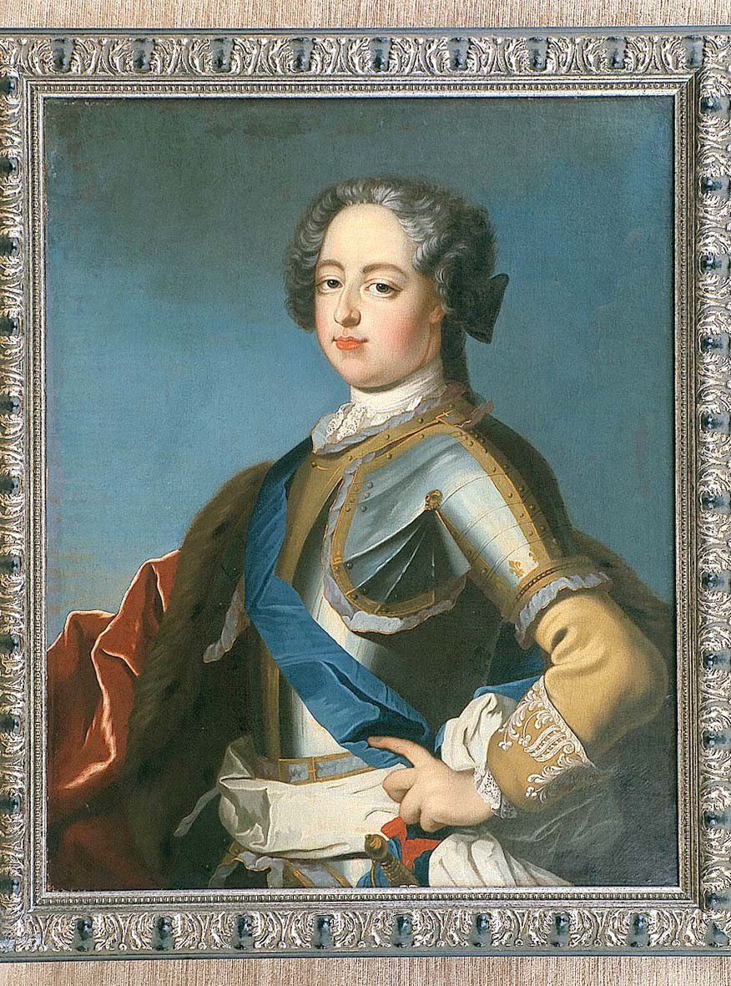


Female Nude in the Bathroom, located in the Venus Room of the hotel, is an oil canvas from the 19th century that evokes intimacy and, with its back turned, a modesty reminiscent of Eduardo Rosales. The French portrait of the Gentleman in Eddy's Bar, an oil-on-canvas featuring a studious pose, is rich in colour with strong strong visual appeal. In terms of placing it in a time and attributing it to an artist, we are drawn to the likes of Boucher, Mengs, Nattier, van Loo and Rigaud.

The beautiful 17th-century oil painting located in the lobby gallery is Escape to Egypt, by Juan de las Roelas of the Sevillian School. The work demonstrates the artist’s mastery of composition, drawing and colour. While the upper section is conceived in baroque terms, the lower part reveals classical tastes with an almost mathematical balance of masses, accentuated by the two saint donors.

Anantara Villa Padierna is more than a destination for luxurious getaways. With hundreds of works adorning elegant spaces from the lobby and terraces to the spa and gym, it becomes a living museum where art and hospitality merge into a unique experience.

Art Gardens

The resort's gardens combine flora and classical art. The sculptures, inspired by the Greco-Roman world, adorn the landscape with their serene presence, while the fountains add a sonorous melody to the environment.

The marble historical-mythological reproductions, as well as the multicoloured busts and sculptures, stand out. Additionally, the collection of marble finials, present in every corner of the hotel, adds a note of elegance, with shapes ranging from cups to flames and a variety of geometric designs that underscore this artistic symphony.

Anantara Villa Padierna is the finest place on the Costa del Sol to enjoy art. Each sculpture, fountain and architectural detail is carefully selected to create an experience that goes beyond a simple stay, turning each moment into an opportunity for inspiration.

Contacts:
María Nájera / mnajera@idoneacomunicacion.com / 654 79 33 24
Andrea Alonso / aalonso@idoneacomunicacion.com / 606 90 76 56

