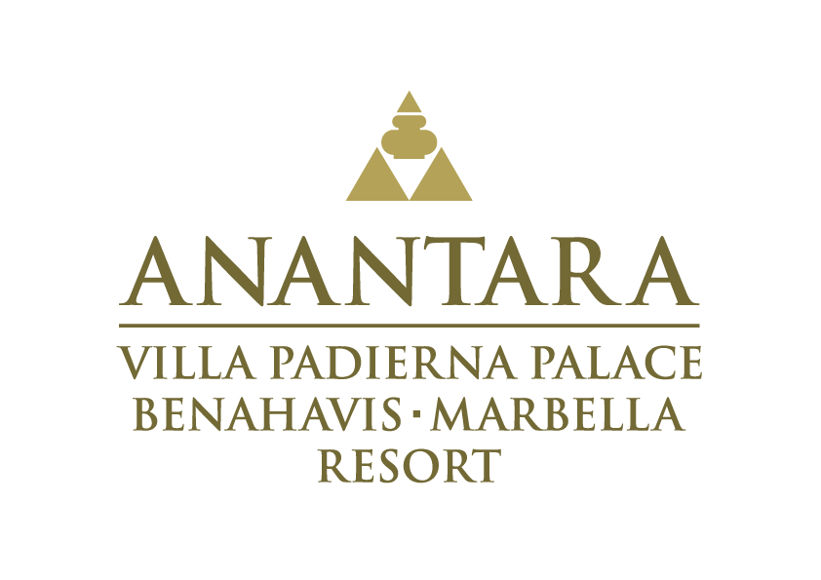

Anantara Villa Padierna Palace
Benahavís Marbella Resort

• An oasis of well-being and comfort in Marbella
• Ten restaurants with irresistible gastronomic offerings
• Healing remedies and high-performance skincare at Anantara Spa
• Three golf courses with views of the Mediterranean
• Commitment to sustainability and local producers



Anantara Villa Padierna Palace
Benahavís Marbella Resort

• An oasis of well-being and comfort in Marbella

Anantara Villa Padierna Palace Benahavis Marbella Resort is a five-star oasis of luxury and elegance located in an idyllic setting of Costa del Sol. A member of The Leading Hotels of the World, the resort has 125 rooms and suites, including 9 villas with private pools that stand out for their uniqueness and sophistication, inviting you to immerse yourself in the true tranquillity that the Mediterranean offers.

Surrounded by three impressive golf courses, this iconic "museum hotel" shelters a collection of more than 1,200 pieces of art, focused on sculptures and paintings, including pieces of Greco-Latin, works from the Iberian period, noble coats of arms and a selection of extraordinary canvases signed by prominent artists, as well as an impressive Roman amphitheatre.

An oasis of well-being and comfort in Marbella

A stay at Anantara Villa Padierna Palace is synonymous of rest and luxury. Its 125 pet-friendly rooms overlook beautiful gardens and rolling green golf courses, all designed for maximum comfort and relaxation. Guests can choose from three types of Deluxe rooms, some with lake views and private terraces; three types of suites ranging from lake view and terrace accommodations to connecting family rooms; and four types of Grand Suites that come with such premium amenities as Jacuzzi and an extra bedroom. For those looking for greater privacy, nine private pool villas offer spectacular luxury amidst the tranquillity of the resort’s expansive grounds.

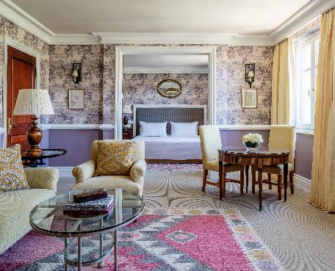
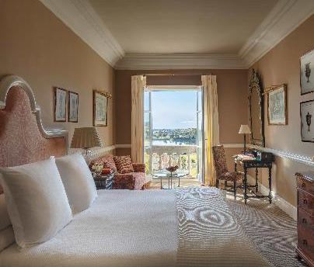
Each room, suite and villa blends the palatial sophistication of Anantara Villa Padierna Palace with exclusive pieces of art to create a sense of unique distinction. With elegant accommodation and world-class service in a privileged location on the Costa del Sol, Anantara Villa Padierna Palace welcomes guests to an oasis of comfort.

Irresistible gastronomic offerings

Anantara Villa Padierna Palace delights gourmets with ten exceptional restaurants, each with its own personality.

La Veranda: The resort’s iconic destination dining venue presents a combination of heritage local dishes and favourites from the last 20 years, including Bluefin tuna tartare and crêpes Suzette flamed tableside. Head Chef Santiago Altuna creates classic recipes with a modern touch for a memorable culinary experience.

La Loggia: With its stunning terrace views across the lake to the Rock of Gibraltar, La Loggia is the perfect place to savour classic Malagan dishes from the lunch menu, including Andalusian gazpacho with tiger prawns and Malagueño orange soup with mackerel. At night the focus shifts to elegant Italian fare, such as spaghetti carbonara and an antipasto buffet.

La Pérgola: Nestled in the pool garden, this casual restaurant serves light lunches and snacks, accompanied by a good wine or cocktail. La Pérgola specialises in healthy dishes with a wide range of vegan recipes and natural juices.

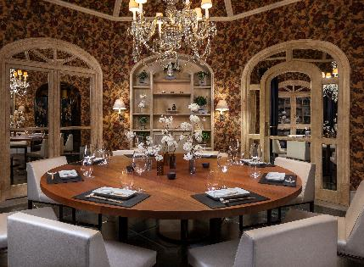
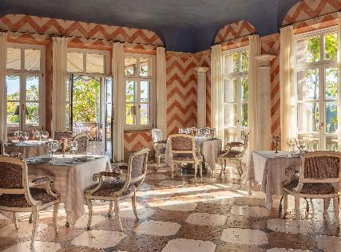
99 Sushi Bar & Restaurant: Authentic flavours of fine Japanese fusion cuisine in a tranquil lakeside setting. 99 Sushi offers a contemporary, fresh and original experience where diners can choose both classic dishes from traditional Japanese cuisine and more avant-garde and innovative creations.

Eddy's Bar: An elegant English bar decorated with a wide collection of works of art that becomes the perfect setting for a snack or aperitif. In addition, its lounge invites you to relax thanks to its cozy atmosphere, where visitors can enjoy an exquisite cocktail prepared by an expert mixologist.

Hole 55: From hearty breakfast to healthy salads, baguettes, homemade desserts and typical Andalusian snacks paired with excellent regional wine, the wide selection of dishes at this casual restaurant overlooking the golf course makes it the ideal spot to refresh and re-energise.

Olà Beirut: Recently added to the hotel's restaurant portfolio, this Middle Eastern destination dining venue serves authentic Lebanese dishes such as baked cauliflower with Tahini sauce (Arnabeet meshwe), grilled minced lamb and beef skewers (Kafta Mashwi) alongside creative drinks and shisha.

Beach Club – By the Sea: With impressive views of the Mediterranean, the Beach Club is a mandatory stop during the summer months for seafood, white prawns from Huelva or Malaga white garlic garnished with red tuna, among other typical dishes.

Irene’s Health Kitchen: Chef Irene Hernández serves a menu of healthy and detoxifying dishes, including red fruit gazpacho, salads with beets, brown rice, protein-bread sandwiches and delicious açai bowls. The kitchen’s setting within Anantara Spa makes it
the ideal stop before or after an indulgent treatment.

Healing remedies and high-performance skincare at Anantara Spa

With a passionate commitment to the health and well-being of its guests, Anantara Villa Padierna Palace immerses visitors in the tranquillity of its lush surroundings, inviting them to unwind at Anantara Spa, named Best Spa at the Condé Nast Johansens Awards for Excellence 2022.

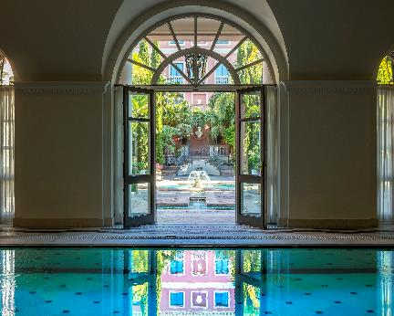
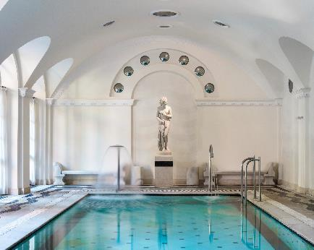
Surrounded by impressive gardens, it’s one of the largest spas in Europe with more than 2,000 square metres of Roman and Turkish baths, an aromatic circuit – the only facility of this kind on Costa del Sol, 13 treatment rooms and a beauty salon. The decor is inspired by legendary Roman baths, with classical statues dotted around the poolside garden and natural light streaming through large windows and stained-glass skylights.

This elegant sanctuary offers a wide variety of wellness programmes and personalised plans in partnership with exclusive brands such as Valmont, Biologique, Esthederm, Comfort Zone, Piroche and Oribe.

In addition, Anantara Spa offers a selection of treatments based on ancient therapies, including traditional Thai massage, world-renowned for its ability to boost energy and increase flexibility through the use of Thai herbal creams that soothe muscle tension; and Detox By Piroche – a therapy based on traditional cupping techniques with 10 different essential oils.

Anantara Spa's expert team is composed of physiotherapists, masseuses, aestheticians and personal trainer who provide a personalised, rejuvenating and relaxing journey for each guest.

Three golf courses with views of the Mediterranean

In a peerless setting on Costa del Sol, Anantara Villa Padierna Palace is a particularly favoured destination for golfers thanks to its proximity to three impressive golf courses.


FLAMINGOS: With views of the Mediterranean that stretch from Gibraltar to Africa, the resort's original course is one of the most picturesque on Costa del Sol. Flamingos has 18 holes and has hosted events including the European Senior Tour in 2002, 2003, 2004 and the Spanish Women's Open in 2010.
ALFERINI: Designed by Spanish architect Antonio García Garrido and located in a spectacular green valley surrounded by mountains, Alferini is one of the few par 73 courses on Costa del Sol. The course, which hosted the Women's Spanish Open in 2022, has 18 holes and is considered quite technical with long fairways and large greens.

TRAMORES: This course also has 18 holes and is perfect for beginners and those looking to perfect their technique with support from the prestigious Michael Campbell Golf Academy, which operates at the club. Located in a serene setting, it is framed by two valleys and provides stunning views of the Mediterranean.

Commitment to sustainability and local sourcing

Anantara Villa Padierna Palace commits to sustainability with the implementation of a range of responsible practices, including reduced use of plastics and introduction of recyclable containers for bathroom amenities.

The resort has partnered with Ecovidrio to promote glass recycling, and has registered its recycling practices with the Junta of Andalucia, which enables responsible management of various types of waste, such as alkaline batteries, ink cartridges and fluorescent tubes.

To promote sustainable mobility, electric vehicle chargers have been installed, and to improve ​​energy efficiency, LED lights have replaced halogen bulbs.

In addition, the resort prioritises collaboration with local suppliers to support the community and ensure the quality and freshness of the products used in all its restaurants and services. Products that come directly from local producers include beer, extra virgin olive oil, freshly baked bread, homemade jams, chips, vinegar and artisanal chocolate.

A commitment to the community and desire to make a positive impact is reflected in the resort’s support of local charities, including the Fundatul Foundation, which helps integrate students into working life, and Dreamland in Mijas, Málaga – a foundation dedicated to the care of sick donkeys.

An oasis of luxury and wellbeing, Anantara Villa Padierna Palace Benahavís Marbella Resort is the ideal destination for those seeking a tranquil getaway, far from the hubbub of Marbella and Puerto Banús, in the heart of the Mediterranean.

Idónea Comunicación
María Nájera / mnajera@idoneacomunicacion.com / 654 79 33 24
Andrea Alonso / aalonso@idoneacomunicacion.com / 606 90 76 56
Paula Mediano / pmediano@idoneacomunicacion.com / 665 16 20 74

