PRESS KIT
iNDIGENOUS DESIGN
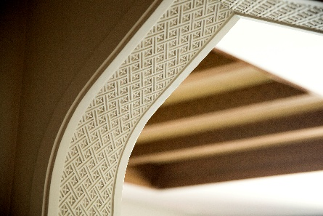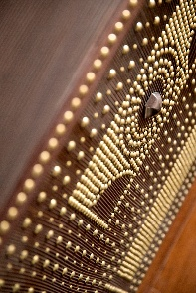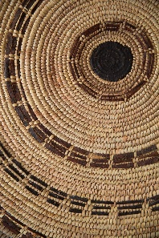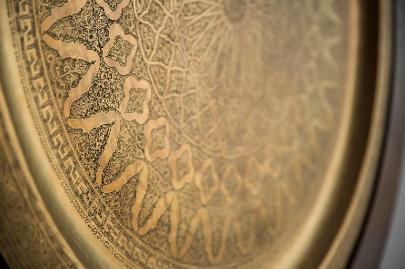

Carved into the mountain’s rugged landscape, Anantara Al Jabal Al Akhdar Resort is a uniquely compelling space set amidst juniper shrubs, rose bushes and scattered, ageless rock. Inspired by surrounding ancient forts, mud-brick villages and castles, the design pays homage to the mountain, with striking views of the gorge and Hajar mountain range providing a dramatic backdrop.

Designed by award-winning French-Moroccan architect Lotfi Sidirahal from ‘Atelier Pod’, celebrated for creating harmony between architecture, interior and landscape, the resort reflects its culturally rich and diversely vibrant background. Prior to the design, Lotfi and his team spent considerable time exploring the surrounding area, meeting with inhabitants of the mountains and visiting abandoned villages to immerse themselves into the culture and ensure the resort stays true to the charm and intrigue of its locale.

Inspiration has been drawn from the layout of the local villages to create a peaceful landscape filled with fragrant rose bushes, indigenous fruit trees, lush green terraces and al falaj water features, which mirror Oman’s typical system of irrigation channels. Constructed using traditional building techniques and local building materials, including stone taken from the mountain, the resort is an alluring blend that reflects Omani history and culture, with contemporary flair. Sanded earthy coloured façades blend seamlessly with the rugged mountainscape, with signature touches such as fort-like doors carved from solid wood, gently curving archways and decorative latticework resulting in a unique setting that is respectful of its surroundings and enhances the magnificent views.

From the moment guests step through the commanding entrance, they are enveloped in an air of restful, sophisticated style. The sense of arrival is heighted with a welcoming ceremony, allowing them to enjoy the mountain-fresh breeze whilst listening the melodic beat of traditional Omani music. As they make their way through to the central courtyard, guests can catch their first glimpse of the magnificent view, stretching over the garden terraces and beyond to the dramatic gorge. With a large open fireplace providing a central focal point, the courtyard shapes the heart of the resort. The six restaurants and lounges continue the superb design, with the signature restaurant, Al Qalaa, housed in a free-standing tower that takes inspiration from the iconic architecture of Khasab Castle in Musandam, northern Oman. Other unique design features include the spa which features the falaj-inspired waterways that gurgle quietly throughout the resort and the infinity pool, which stretches along the curve of the plateau.

Stone pathways lined with shrubbery and rose bushes gently lead off to the resort’s 115 rooms and villas. Designed to incorporate authentic luxury, the elegant interiors echo the surrounding culture, exuding a minimalist style infused with warm, rich colours alongside traditional additions such as local artwork, Arabesque lanterns and handmade pottery. Indigenous mountain icons such as roses, pomegranates, butterflies, juniper trees and marine fossils permeate design choices and are reflected through choices in the décor and artwork. The 82 Premier and Deluxe Rooms are positioned to offer a view that encompasses ancient villages clinging to the side of the vast canyon, allowing guests to marvel at the mountainscape while lounging in a bath, relaxing in their private balcony or reclining from the comfort of their bed. Meanwhile, the eleven Cliff Pool Villas and Royal Mountain Villa overlook deep canyons forged by ancient rivers that plunge into the valleys below.

-Ends-

Editor’s Notes:
Anantara is a luxury hospitality brand for modern travellers, connecting them to genuine places, people and stories through personal experiences, and providing heartfelt hospitality in the world’s most exciting destinations. The collection of distinct, thoughtfully designed luxury hotels and resorts provides a window through which to journey into invigorating new territory, curating personal travel experiences.

From cosmopolitan cities to desert sands to lush islands, Anantara connects travellers to the indigenous, grounds them in authentic luxury, and hosts them with passionate expertise. The portfolio currently boasts over 40 stunning hotels and resorts located in Thailand, Indonesia, China, Vietnam, Cambodia, Malaysia, Maldives, Sri Lanka, Mauritius, Seychelles, Mozambique, Zambia, Tunisia, UAE, Qatar, Oman, Portugal, Spain, Hungary and Italy, with a pipeline of future properties across Asia, the Middle East and Europe.

The brand’s premier vacation ownership programme, Anantara Vacation Club, extends the opportunity to own a share in the Anantara experience with a portfolio of eight luxurious Club Resorts as well as travel privileges at partner resorts and hotels worldwide.

For more information on Anantara Hotels, Resorts & Spas, please visit www.anantara.com. Follow us on Facebook: www.facebook.com/anantara; Twitter and Instagram: @anantara_hotels and @anantaraspawellness

Anantara is part of the DISCOVERY loyalty programme.

For international media enquiries, please contact:

Marwan Al Zadjali
Director of Marketing
E: malzadjali@anantara.com

Natasha Rhymes
Group Director PR & Communications, Minor Hotels
E: nrhymes@minor.com

