PRESS KIT

EXHILARATING MOUNTAIN EXPERIENCES

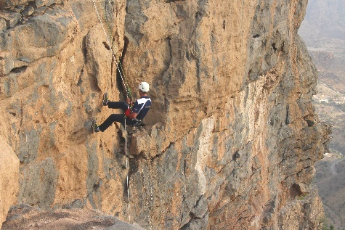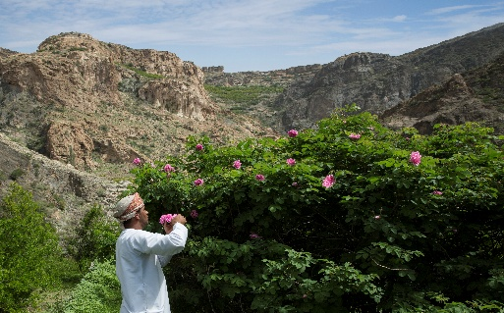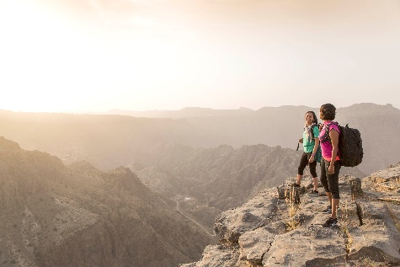

Located in the spectacular Al Hajar mountain range, Anantara Al Jabal Al Akhdar Resort beckons the inquisitive traveller with an array of inspirational experiences, immersing them in the rich culture, history and adventure on offer in a landscape of rugged beauty.

Cradled by soaring mountains and dramatic canyons freckled with wild fig and olive trees, the resort’s true spirit lies outdoors. Enjoying a perfectly chilled clime – a respite from the heat faced by the Gulf region for much of the year – it is a hiker’s paradise of trails meandering through gnarled juniper trees, ancient ruins, sleepy villages and dusty riverbeds. Accompanied by a local guide, guests can discover underground lakes in hidden caves, spot exotic flora and fauna, or rappel down sheer drop-offs for a falcon’s-eye view surging with adrenaline. Much of the terrain can also be enjoyed by mountain bike. From mid-March to mid-April, guests can witness the full bloom and heady aroma of the damask roses cascading down the mountain slopes, and visit a traditional distillery to discover the indigenous way smoked rosewater is extracted from the colourful petals.

With an intriguing heritage dating back thousands of years, culture lovers can pay a visit to the plethora of nearby heritage sites. They can climb to the top of the ancient city of Nizwa for a bird’s-eye view of the crenelated roofs of what was once a centre for trade and Islamic studies. They can delve into the local way of life by visiting the souk, renowned for its Friday cattle auction, intricately hand-carved khanjars (daggers) and ornamental silver jewellery. And they can marvel at old-world engineering in the deserted village of Birkat Al-Mouz, a UNECSO World Heritage Site that boasts the al falaj irrigation system, a central component of Omani history which has allowed life to flourish in the otherwise arid desert environment.

Back at the resort, those with a taste for adventure and of any ability can take to the cliff face under the guidance of seasoned instructors. Climbing the Via Ferrata, a steel cable that runs along the cliff edge, provides the perfect photo opportunity. Furthermore, the cable allows thrill-seekers to abseil down the rockface for a once-in-a-lifetime thrill.

Other experiences in the great outdoors include the ancient art of archery, mountaintop morning and sunset yoga sessions, picnicking on a deserted peak Bedouin style, stargazing beneath a blanket of night sky, and classic movies under the stars complete with gourmet popcorn.

Catering for even the youngest travellers, a dedicated kids’ and teens’ club offers a host of engaging and educational activities such as arts and crafts, painting, nature walks, fossil discovery sessions and storytelling, as well as an interactive treasure map allowing children to discover the wonders of the resort under the watchful eye of one of the resort’s guardians.

-Ends-

Editor’s Notes:
Anantara is a luxury hospitality brand for modern travellers, connecting them to genuine places, people and stories through personal experiences, and providing heartfelt hospitality in the world’s most exciting destinations. The collection of distinct, thoughtfully designed luxury hotels and resorts provides a window through which to journey into invigorating new territory, curating personal travel experiences.

From cosmopolitan cities to desert sands to lush islands, Anantara connects travellers to the indigenous, grounds them in authentic luxury, and hosts them with passionate expertise. The portfolio currently boasts over 40 stunning hotels and resorts located in Asia, the Indian Ocean, the Middle East, Africa and Europe, with a pipeline of future properties.

The brand’s premier vacation ownership programme, Anantara Vacation Club, extends the opportunity to own a share in the Anantara experience with a portfolio of eight luxurious club resorts as well as travel privileges at partner resorts and hotels worldwide.

For more information on Anantara Hotels, Resorts & Spas, please visit www.anantara.com. Follow us on Facebook: www.facebook.com/anantara; Twitter and Instagram: @anantara_hotels and @anantaraspawellness

Anantara is part of the DISCOVERY loyalty programme.

For international media enquiries, please contact:

Marwan Al Zadjali
Director of Marketing
E: malzadjali@anantara.com

Natasha Rhymes
Group Director PR & Communications, Minor Hotels
E: nrhymes@minor.com

