PRESS KIT

GASTRONOMIC JOURNEYS

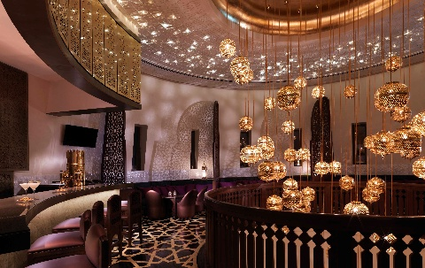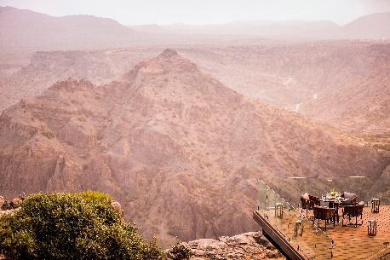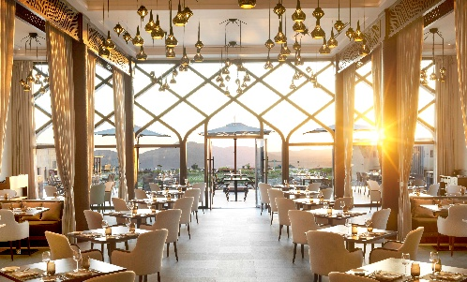
Culinary desires are well catered for at Anantara Al Jabal Al Akhdar Resort, with a collection of six restaurants and lounges offering exotic style, flawless service and authentic flavours. Guests are invited to enjoy rooftop shisha and tapas, indulge in fine dining at the Arabian grill located in the central fort tower, and sample traditional Italian cuisine complete with breathtaking canyon views.

Al Maisan, otherwise known as ‘The Rising Star’, is elevated above the central courtyard, with an elegant indoor dining area and a spacious outdoor terrace, the perfect setting to soak in the views of the vast canyon surrounding. Satisfying guests’ culinary cravings from breakfast through to dinner, chefs display their skills and flair at live cooking stations. There are flavours and aromas from all corners of the globe, from authentic Middle Eastern and contemporary Thai to fresh sushi and fiery Indian, plus an assortment of freshly made breads, sweets and pastries.

Situated in the heart of the resort, Al Qalaa, translated as ‘The Fort’, features the iconic architecture of Khasab Castle in Musandam, Northern Oman. The chic dining room is dressed in distinctive Omani details and softened by a constellation of lanterns hanging overhead. Inventive Omani cuisine crafted to perfection using time-honoured recipes and produce harvested from the Gulf and nearby farms capture the true essence of the destination.

With panoramic views stretching across the canyon, Bella Vista, meaning ‘Beautiful View’, is a worthy name for one of the most unique and inspiring poolside restaurants in the world. With the sky reflected in the water, guests can feast their eyes on the mountain horizon as they dine on seasonal Mediterranean cuisine. The ambience is relaxed during the day, with fresh salads and light dishes served by the pool. And as the sunset sets, it magically transforms to evening elegance.

Those looking for something lighter can choose the charming courtyard, Al Baha, or ‘The Courtyard’. With a central view overlooking the resort, the relaxed café and deli is the perfect spot to meet over traditional English or Omani afternoon tea. As the sun sets behind the mountains, guests can gather around the open fireplace as they soak in the mesmerising ambience.

To experience the time-honoured tradition of Omani hospitality, guests are invited to visit Al Shourfa and Al Burj, translated as ‘The Balcony’ and ‘The Tower’ in Arabic. Rooftop lounge Al Shourfa beckons with shisha and a choice of cigars under a blanket of stars, whilst Al Burj offers an array of light tapas, a selection of exotic cocktails, and fine wines in an ambient setting complete with shimmering lanterns and colourful accents.

The ultimate gastronomic experience, Anantara’s Dining by Design, gives guests the chance to dine at the spectacular cliff-edge platform, Diana’s Point, named after Diana, Princess of Wales, who visited the exact spot in November 1986. Alternatively, they can take their experience to another level at The Royal Edge, a glass platform positioned overlooking the canyon. Surrounded by nothing but flickering candles, guests enjoy an unparalleled dinner courtesy of their very own chef and butler as they revel in the soothing sounds of the great outdoors.

Another of Anantara’s signature concepts, Spice Spoons, allows guests to admire the array of fresh produce available locally by accompanying the chef to the resort’s garden. They will then be guided in the secrets of Thai or Middle Eastern cuisine with an interactive cooking class. Upon departure, each guest is provided with a certificate and recipe cards, allowing them to recreate their dishes at home.

-Ends-

Editor’s Notes:
Anantara is a luxury hospitality brand for modern travellers, connecting them to genuine places, people and stories through personal experiences, and providing heartfelt hospitality in the world’s most exciting destinations. The collection of distinct, thoughtfully designed luxury hotels and resorts provides a window through which to journey into invigorating new territory, curating personal travel experiences.

From cosmopolitan cities to desert sands to lush islands, Anantara connects travellers to the indigenous, grounds them in authentic luxury, and hosts them with passionate expertise. The portfolio currently boasts over 40 stunning hotels and resorts located in Asia, the Indian Ocean, the Middle East, Africa and Europe, with a pipeline of future properties.

The brand’s premier vacation ownership programme, Anantara Vacation Club, extends the opportunity to own a share in the Anantara experience with a portfolio of eight luxurious club resorts as well as travel privileges at partner resorts and hotels worldwide.

For more information on Anantara Hotels, Resorts & Spas, please visit www.anantara.com. Follow us on Facebook: www.facebook.com/anantara; Twitter and Instagram: @anantara_hotels and @anantaraspawellness

Anantara is part of the DISCOVERY loyalty programme.

For international media enquiries, please contact:

Marwan Al Zadjali
Director of Marketing
E: malzadjali@anantara.com

Natasha Rhymes
Group Director PR & Communications, Minor Hotels
E: nrhymes@minor.com

