PRESS KIT

Introducing Anantara Al Jabal Al Akhdar Resort

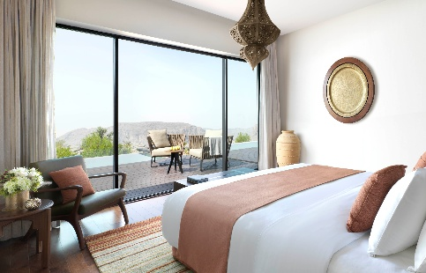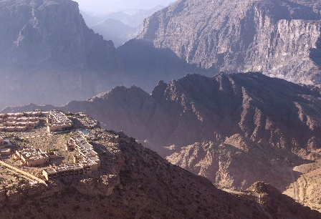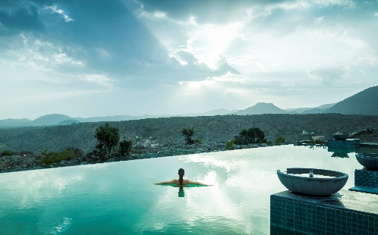

Perched 2,000 metres above sea level on the curving rim of a great canyon, Anantara Al Jabal Al Akhdar Resort is a secluded haven for the intrepid and discerning. Guests hover over an extreme landscape of rugged beauty while they discover a cultured treasury of authentic indulgences and immersions in the destination’s rich heritage. The highest luxury resort in the Middle East and amongst the highest in the world, Anantara Al Jabal Al Akhdar Resort is a luxurious base from which to explore this extraordinary corner of Oman.

Long inaccessible, Al Jabal Al Akhdar (Arabic for “The Green Mountain”) is a towering massif on the Sultanate of Oman’s vast Saiq Plateau. Dramatic peaks ring the setting. Prince Charles and the late Diana, Princess of Wales once sought out its breathtaking heights and scenic views in November 1986. Today, the arrival experience takes guests on an adventurous drive – two hours from Muscat International Airport or four and half hours from Dubai – past date plantations, dry riverbeds known locally as wadis, and historical forts. The resort echoes this fortified architecture, placing guests in modern ramparts inspired by the commanding indigenous citadels and re-imagined with sophisticated contemporary interiors.

A total of 115 luxury rooms and villas overlook either the dramatic canyon or tranquil gardens. Each features its own indigenous luxuries from custom-made Omani furniture to Amouage bath products evoking the region’s indigenous fragrances. The resort’s 82 Premier and Deluxe Rooms boast a spacious bedroom, amongst the largest in the country, each with views of the dramatic canyon and a spa-like bathroom carved out of sustainable material from the local area, complete with a rain shower and separate bath alongside a balcony. Meanwhile, the 33 villas grant guests an intimate escape each with personal villa host services and a private infinity pool overlooking the cliffs or hidden in an exotic garden. Guests have the choice of either one or two bedrooms or the exclusive Three Bedroom Royal Mountain Villa. Each villa features state-of-the-art interactive LED IPTVs and spacious living area, all adding to a sense of sublime luxury.

With a selection of six restaurants and lounges to choose from, guests can indulge their senses with experiences ranging from a fine dining Arabian grill concept and poolside Roman inspired restaurant to an all-day international dining restaurant serving world classics and a rooftop shisha lounge, with the pleasant climate allowing for year-round alfresco dining. The ultimate experience occurs at The Royal Edge, a glass platform positioned overlooking the canyon, with a romantic meal prepared by a personal chef served by candlelight.

Other highlights at the resort include a cliff-edge infinity pool and a state-of-the-art Fitness Centre, tennis court and world-acclaimed Anantara Spa. Harnessing the essence of Arabia, the spa welcomes guests with ancient hammam rituals, five treatment suites, private outdoor relaxation areas and separate male and female indoor swimming pools. A separate kids’ and teens’ club offers fun-filled activities, whilst a lavish ballroom and extensive meeting facilities offer a range of memorable venues for events and weddings “on top of the world”.

Surrounded by majestic mountains and enjoying cool temperatures throughout the year, Anantara Al Jabal Akhdar Resort presents travellers with authentic experiences, allowing them to explore the nearby culture, history and landscape. Hike through valleys bursting with date palms and orchards of pomegranate, haggle over a silk scarf in the souks and wander through gardens of sweet scented roses. Rise early to practice sun salutations atop a mountain, gaze at the awe-inspiring night sky with an astrology session, or for the active, try abseiling or mountain climbing, archery and mountain biking. Those looking to immerse themselves in the captivating traditions of Oman can visit the mountainside ancient villages and nearby heritage sites or take part in Omani cookery lessons, part of Anantara’s signature Spice Spoons series.

-Ends-
Editor’s Notes:
Anantara is a luxury hospitality brand for modern travellers, connecting them to genuine places, people and stories through personal experiences, and providing heartfelt hospitality in the world’s most exciting destinations. The collection of distinct, thoughtfully designed luxury hotels and resorts provides a window through which to journey into invigorating new territory, curating personal travel experiences.

From cosmopolitan cities to desert sands to lush islands, Anantara connects travellers to the indigenous, grounds them in authentic luxury, and hosts them with passionate expertise. The portfolio currently boasts over 40 stunning hotels and resorts located in Thailand, Indonesia, China, Vietnam, Cambodia, Malaysia, Maldives, Sri Lanka, Mauritius, Seychelles, Mozambique, Zambia, Tunisia, UAE, Qatar, Oman, Portugal, Spain, Hungary and Italy, with a pipeline of future properties across Asia, the Middle East and Europe.

The brand’s premier vacation ownership programme, Anantara Vacation Club, extends the opportunity to own a share in the Anantara experience with a portfolio of eight luxurious Club Resorts as well as travel privileges at partner resorts and hotels worldwide.

For more information on Anantara Hotels, Resorts & Spas, please visit www.anantara.com. Follow us on Facebook: www.facebook.com/anantara; Twitter and Instagram: @anantara_hotels and @anantaraspawellness

Anantara is part of the DISCOVERY loyalty programme.

For international media enquiries, please contact:

Marwan Al Zadjali
Director of Marketing
E: malzadjali@anantara.com

Natasha Rhymes
Group Director PR & Communications, Minor Hotels
E: nrhymes@minor.com

