PRESS KIT

HOLISTIC HARMONY
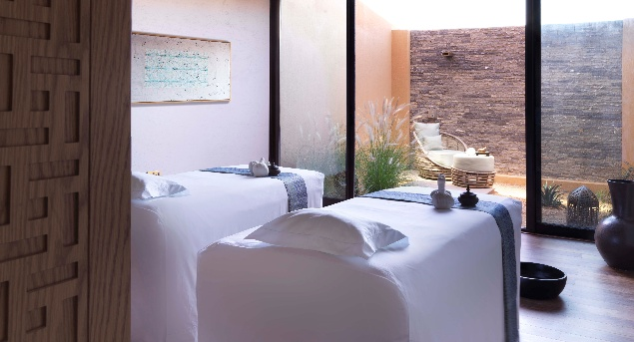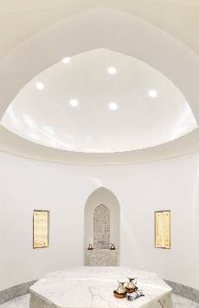

The award-winning Anantara Spa draws on the healing traditions of East and West to offer profound relaxation and rejuvenation. At Anantara Al Jabal Al Akhdar Resort, ancient hammam rituals and indigenous ingredients complement a rich collection of spa, wellness and beauty treatments that together result in a radiant sense of wellbeing.

Entering the oasis of tranquillity that is the spa, guests are enveloped by a soothing sense of peace in one of five beautifully appointed suites. Trained therapists offer an array of traditional Thai massages, Ayurvedic therapies and beautifying facials that incorporate the time-tested soothing of damask rose, pomegranate and frankincense all sourced from the mountain and wadi. The signature Revitalising Pomegranate Journey utilises the nourishing and regenerating properties of the fruit to polish, nourish and protect the skin, followed by a deeply invigorating Arabian massage.

A tradition that has evolved over thousands of years, spa visitors are invited to indulge in a traditional hammam ritual. Lying on heated marble, an exhilarating salt scrub is followed by a purifying body wrap and cleansing with olive foam soaping. The experience will leave them feeling refreshed and renewed as it has done since ancient times.

After their treatment, guests are invited to enjoy the use of the hydrothermal facilities, with male and female aroma saunas, steams and experience showers, and a relaxation area in which to slowly emerge from the cocoon of tranquillity.

Guests can boost their wellbeing further with personalised wellness programmes, which range from one to three days, and begins with a wellness consultation to understand their specific health needs and goals. Days of meditation, yoga, hiking in the fresh mountain air, eating well and sleeping deeply naturally rejuvenate. A series of recommended therapies rejuvenates the body and mind. The programmes also include full access to the heated swimming pool, jacuzzi, fitness centre and tennis court.

-Ends-

Editor’s Notes:
Anantara is a luxury hospitality brand for modern travellers, connecting them to genuine places, people and stories through personal experiences, and providing heartfelt hospitality in the world’s most exciting destinations. The collection of distinct, thoughtfully designed luxury hotels and resorts provides a window through which to journey into invigorating new territory, curating personal travel experiences.

From cosmopolitan cities to desert sands to lush islands, Anantara connects travellers to the indigenous, grounds them in authentic luxury, and hosts them with passionate expertise. The portfolio currently boasts over 40 stunning hotels and resorts located in Asia, the Indian Ocean, the Middle East, Africa and Europe, with a pipeline of future properties.

The brand’s premier vacation ownership programme, Anantara Vacation Club, extends the opportunity to own a share in the Anantara experience with a portfolio of eight luxurious club resorts as well as travel privileges at partner resorts and hotels worldwide.

For more information on Anantara Hotels, Resorts & Spas, please visit www.anantara.com. Follow us on Facebook: www.facebook.com/anantara; Twitter and Instagram: @anantara_hotels and @anantaraspawellness

Anantara is part of the DISCOVERY loyalty programme.

For international media enquiries, please contact:

Marwan Al Zadjali
Director of Marketing
E: malzadjali@anantara.com

Natasha Rhymes
Group Director PR & Communications, Minor Hotels
E: nrhymes@minor.com

