IMAGE CAPTIONS

National Museum of Photography - Santos warehouse

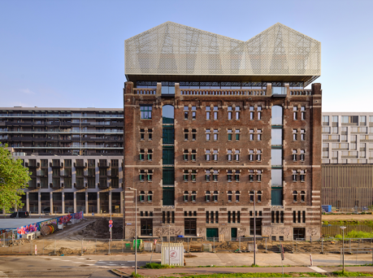 | National Museum of Photography – front view  © Photo Studio Hans Wilschut
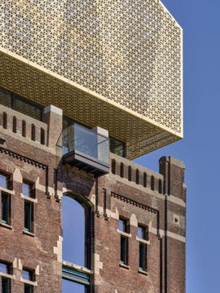 | National Museum of Photography – semi-transparent ‘crown’ façade  © Photo Studio Hans Wilschut
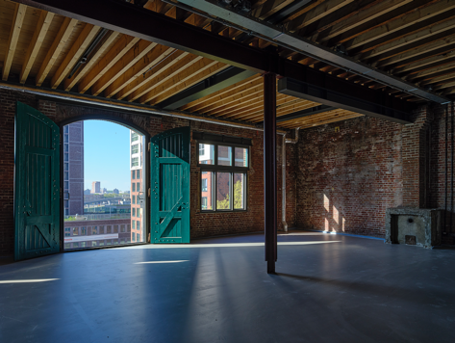 | National Museum of Photography – restored warehouse interior  © Photo Studio Hans Wilschut
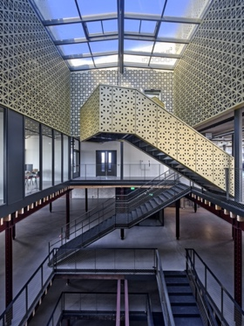 | National Museum of Photography – atrium and central stairwell  © Photo Studio Hans Wilschut
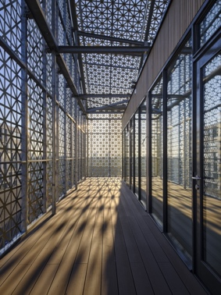 | National Museum of Photography  © Photo Studio Hans Wilschut
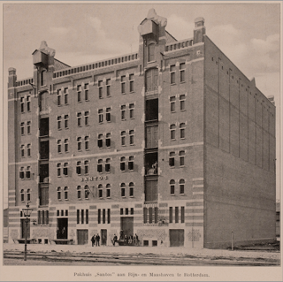 | Santos Warehouse, Rotterdam  Designed by Architects J.P. Stok & J.J. Kanters  Photo credit: Graafland, 1917

Gallery of Honour of Dutch Photography

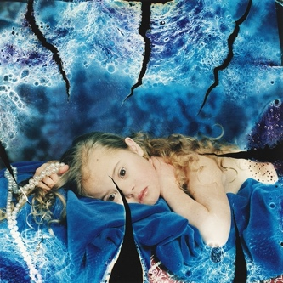 | Saskia (Aged 8), 1995  From Mind of their Own, 1995  © Erwin Olaf (1959-2023)
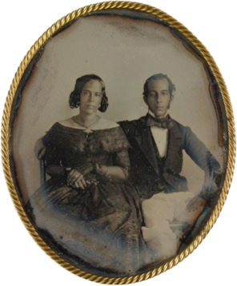 | Portrait of the Married Couple Johannes Ellis and Maria Louise de Hart, Paramaribo, Suriname, circa 1846  Attributed to J.L. Riker or Warren Thomson
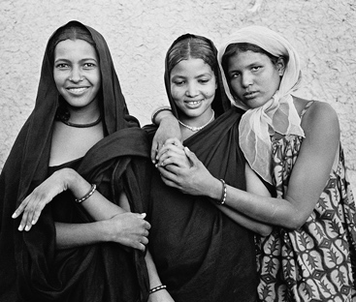 | Tuareg Women, Mali, 1964  © Violette Cornelius (1919-1998)
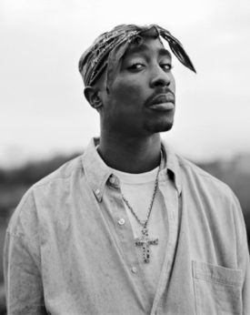 | Tupac Shakur, 1993  © Dana Lixenberg (1964)
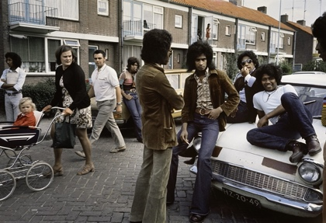 | South Moluccans, Tiel, 1970  © Ed van der Elsken (1925-1990)

