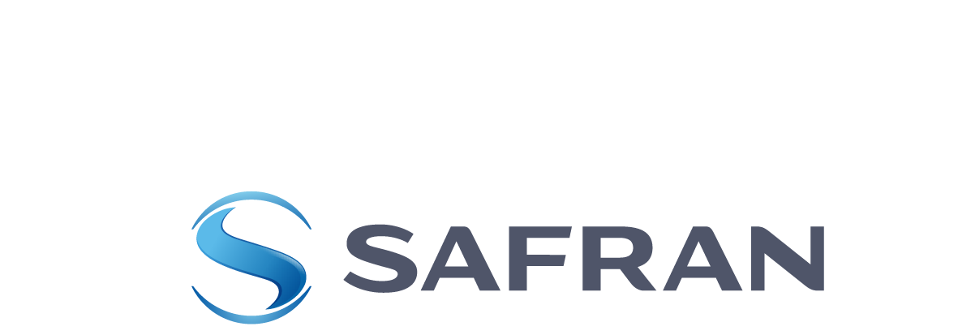
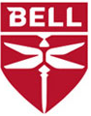

贝尔和赛峰集团承诺共享未来按需出行愿景

贝尔与赛峰集团将合作研发用于未来空中出租车和垂直起降飞行器的混合电力驱动系统

德国科隆（2018年6月19日） - 德事隆集团（纽约证券交易所代码：TXT）贝尔公司今日在未来运输世界大会（Future of Transportation World Conference）上宣布与赛峰集团（巴黎欧洲证券交易所代码：SAF）达成合作，后者将研发革新式的混合电力驱动系统解决方案，以支持贝尔的VTOL垂直起降飞机概念。

“贝尔正在引领未来个性化按需出行（On-demand Mobility）概念，这一概念将开创新的航空时代，未来，将会有更多的人群得以在更多的场景下享受航空出行的便利。” 贝尔创新业务部总监Scott Drennan在会议期间表示：“贝尔和赛峰集团的合作再次验证了我们致力于提供新颖，创新和高效的交通运输解决方案的承诺，该项合作是未来交通运输发展的历史性里程碑事件。“

多年来，赛峰集团创新团队始终积极探索新一代混合动力系统的发展潜力，贝尔和赛峰集团在电动及混合动力飞机的未来上享有共同的愿景，双方将携手推进贝尔空中出租车项目和其他全新的按需出行产品。

“得益于赛峰集团内部长期持续的技术发展战略，现在，我们有能力向贝尔的下一代产品提供我们的混合电力驱动系统解决方案；未来，新产品的性能将更加出众，并帮助客户创造更大的价值。” 赛峰集团研发与技术（R&T）和创新业务高级执行副总裁Stéphane Cueille说。

本次合作中，贝尔将负责VTOL垂直起降系统的设计，研发和生产；赛峰集团将利用其技术专长研发颠覆性的动力系统。

###

Press Contact
Bell
LINDSEY HUGHES
+1 817‐280‐3100
mediarelations@bh.com
Online Media Kit

Follow Us:
Facebook
Twitter
LinkedIn
Instagram
YouTube

Press Contact
Safran
CATHERINE MALEK
+33 1 40 60 80 28
catherine.malek@safrangroup.com

ABOUT SAFRAN
Safran is an international high-technology group, operating in the aircraft propulsion and equipment, space and defense markets. Safran has a global presence, with more than 58,000 employees and sales of 16.5 billion euros in 2017. Working alone or in partnership, Safran holds world or European leadership positions in its core markets. Safran undertakes Research & Development programs to meet fast-changing market requirements, with total R&D expenditures of around 1.4 billion euros in 2017. Safran is listed on the Euronext Paris stock exchange, and is part of the CAC 40 and Euro Stoxx 50 indices.
In February 2018, Safran took control of Zodiac Aerospace, significantly expanding its aircraft equipment activities. Zodiac Aerospace has 32,500 employees and generated sales of 5.1 billion euros for its fiscal year ended August 31, 2017.

ABOUT BELL
Thinking above and beyond is what we do. For more than 80 years, we’ve been reimagining the experience of flight – and where it can take us.
We are pioneers. We were the first to break the sound barrier and to certify a commercial helicopter. We were aboard NASA’s first lunar mission and brought advanced tiltrotor systems to market. Today, we’re defining the future of on-demand mobility.
Headquartered in Fort Worth, Texas – as a wholly-owned subsidiary of Textron Inc., – we have strategic locations around the globe. And with nearly one quarter of our workforce having served, helping our military achieve their missions is a passion of ours.
Above all, our breakthrough innovations deliver exceptional experiences to our customers. Efficiently. Reliably. And always, with safety at the forefront.

ABOUT TEXTRON INC.
Textron Inc. is a multi-industry company that leverages its global network of aircraft, defense, industrial and finance businesses to provide customers with innovative solutions and services. Textron is known around the world for its powerful brands such as Bell, Cessna, Beechcraft, Hawker, Jacobsen, Kautex, Lycoming, E-Z-GO, Greenlee, Textron Off Road, Arctic Cat, Textron Systems, and TRU Simulation + Training. For more information, visit: www.textron.com.
Certain statements in this press release are forward-looking statements which may project revenues or describe strategies, goals, outlook or other non-historical matters; these statements speak only as of the date on which they are made, and we undertake no obligation to update or revise any forward-looking statements.

These statements are subject to known and unknown risks, uncertainties, and other factors that may cause our actual results to differ materially from those expressed or implied by such forward-looking statements, including, but not limited to, the efficacy of research and development investments to develop new products or unanticipated expenses or delays in connection with the launching of significant new products or programs; the timing of our new product launches or certifications of our new aircraft products; and our ability to keep pace with our competitors in the introduction of new products and upgrades with features and technologies desired by our customers.

