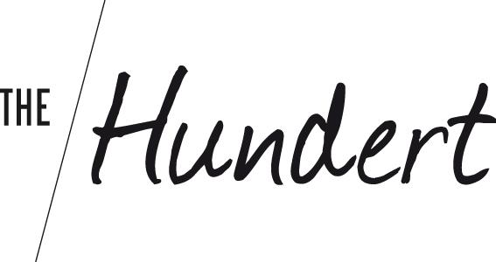
PRESS RELEASE

The 100 most exciting startups of Berlin
The startup magazine “The Hundert” publishes its 10. edition

Berlin, 30. October 2017. For its tenth edition the startup magazine The Hundert has returned to its hometown, choosing to portray the Top 100 startups of the capital in the newest edition. The result: an insightful and beautifully made coffee table book featuring one hundred startups from 43 different sectors of the local ecosystem. Selected from a pool of 860 nominated startups, the final 100 were chosen by a panel of 40 experts, including Philipp Justus (Google), Alexander Kudlich (Rocket Internet), Sonali De Rycker (Accel Partners), Daniel P. Glasner (Cherry Ventures), Mona Rübsamen (FluxFM) and Ansgar Oberholz (Sankt Oberholz). The selection criteria were that the startups had to be founded after 2013, had to be from Berlin or be headquartered here, and shouldn’t have been featured in a previous edition of the magazine.

Creating a multifaceted profile of the startup scene in Berlin

Startups from 43 different sectors are represented in the magazine, highlighting the enormous diversity present in the city. Although FinTech and E-Health startups take 21 of the 100 spots, the startups in the magazine showcase an astounding variety of ideas: AI technology helps build better service chatbots (Twyla) as well as predicting bestselling books (Inkitt); senior citizens can find human connections through activities (Trevivo) whilst skilled craftspeople can gain experience abroad (Journeyman); polling becomes transparent (Opinary) and freight forwarding goes digital (FreightHub). The founders were photographed in every corner of the city – from subway stations to parks, restaurants, cafés, coworking spaces, bridges and street scenes, the beautiful facades of Berlin as well as its rougher edges are represented in the images. Over a period of five weeks three photographers braced the capricious summer weather, which demanded a huge amount of flexibility from all involved.

The Big Reveal

This year the release party was celebrated on Friday night, October 27, 2017, at the heart of Berlin’s party district at Festsaal Kreuzberg. The startups, the jury members and all attending startup fans were the first to see the final product, not having been privy to the entire process beforehand. This time the magazine is done in the Berlin poster-style, which meant printing the original photos, pasting them all over the city, scratching and tearing them before photographing them again. To maintain the authenticity of the design and the flair of the city it was decided to only add the text digitally, which was done by the team at Operation Butterfly. A total of 550 guests were the first ones to page through the magazine, searching for their portraits and clinking a festive glass or two to the Berlin startup community.

The Hundert
The Hundert is a publication by NKF Media GmbH, with the first magazine being released in 2013. Each edition portrays the 100 most successful startups that represent an aspect of an ecosystem, be this the booming startup scene of New York (The Hundert 09), startups that are collaborating with corporates (The Hundert 05), or female founders from across Europe (The Hundert 08). The Hundert has a print run of 10.000 copies that are available at events, coworking spaces and with various partners across Germany, free of charge. Those that want to hold their own copy in their hands can order the edition directly from Amazon (within Europe) or on the-hundert.com for international shipment. The magazine is also available immediately as a free download on the-hundert.com.

The Hundert Vol. 10 was realised with the kind support from Berlin Partner, KPMG, lindenpartners, SAP and Weberbank.

Media Contact
Sabine Petzsch
Tel. +49-30-46-777-252
Email. sp@the-hundert.com
the-hundert.com

