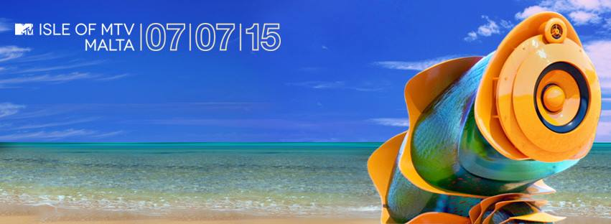
***BREAKING***

INTERNATIONAL HITMAKER
JASON DERULO
CONFIRMED FOR
ISLE OF MTV MALTA
Global chart sensation to perform explosive set to anticipated 50,000 + fans on 7 July 2015

Tweet this! GET READY TO BOUNCE! @jasonderulo is CONFIRMED to perform at #IOMTV on 07.07.15
London/ Milan – 21 May 2015: Multi-platinum selling, chart-topper JASON DERULO has today been announced as the latest act to take on the Isle of MTV Malta stage at this year’s summer bash. A partnership between MTV and the Malta Tourism Authority, the free live music event, now in its ninth consecutive year, will return to Il-Fosos Square, Malta on Tuesday 7 July 2015.
Derulo first made the world take notice when he broke onto the scene with his killer debut single ‘Whatcha Say’, which sold over five million digital downloads in the US alone. Boasting a total of 1.8 billion views on YouTube, 45 million worldwide record sales, 27 million social media followers, and three huge albums - Derulo continues to churn out hit singles. With his fourth studio album due for release next month, 2015 is already adding to his massive success story. It’s lead single ‘Want To Want Me’ has already amassed almost 23 million YouTube hits, became the biggest Top 40 radio launch ever in the United States and Derulo himself made headlines by being the first artist ever to launch a video on the dating app Tinder. Entitled ‘Everything is 4’, the album is available to preorder on iTunes now.
Bruce Gillmer, EVP, Music, Talent Programming and Events, MTV, commented: “We're very excited to have Jason join us in Malta this year. He brings along an ample string of hits and a musical style that's picture-perfect for this huge event.”
Derulo continues to break records and endorse his status as one of the world’s most successful artists having received countless awards and nominations, including five BMI Pop Music Awards.
Derulo commented: "MTV has always played an important role in my career, and the Isle of MTV Malta is a great continuation of our partnership."

Isle of MTV Malta will be filmed and edited into a 60-minute special that will broadcast across 20 MTV channels throughout Europe. As part of an extensive integrated marketing campaign, the Isle of MTV Malta Special concert will be supported by marketing initiatives, all of which will drive awareness of the event as well as leverage MTV’s world renowned brand and unique youth insight, to further cement and promote Malta’s position as a holiday destination for young people. Over the nine years that Isle of MTV has been held in Malta, the number of visitors to the island under the age of 24 has increased by 120.9% and now account for 19.9% of all tourists.
ENDS

Press Contacts:

Seema Alibhai  Communications  Viacom International Media Networks  Seema.Alibhai@vimn.com  0044 203 580 2106 | Sharlotte Ritchie  Communications  Viacom International Media Networks  Sharlotte.Ritchie@vimn.com  0044 203 580 2108

Notes to Editor
About Jason Derulo
Discovered at the age of 16 having already penned songs for the likes of Pitbull and Diddy, Jason ‘Derulo’ Desrouleaux was signed to Warner Bros. Records. In 2009 he topped the Billboard charts with his debut single ‘Whatcha Say’ – catching on internationally the track rose to Top Ten positions in multiple territories including Canada, Australia and the UK. His debut self-titled album followed in 2010, achieving international chart success.
Derulo’s second studio album, ‘Future History’ was released in 2011, followed by his third international album ‘Tattoos’ in 2013. All paved the way for what would be his most successful album to date - his third U.S album ‘Talk Dirty’ was released in Spring of 2014, spawning five platinum singles, collectively selling 16 million units worldwide, propelling Jason into an elite category of artists whom are able to boast such an accomplishment.
In five short years Jason has racked up 10 platinum singles, 1 billion plays on Spotify and a radio audience of 17 million. And it’s not just for his performance on the stage and screen that Derulo has received adoration and recognition. In 2011 he was awarded Songwriter of the Year at the BMI Pop Music Awards - Jason is as well known in the industry for his ability to write hit singles as he is for performing them.

About Isle of MTV

Now in its ninth year, the Isle of MTV franchise has seen past performers such as Nicole Sherzinger, Jessie J, Will.i.am, Rita Ora, Flo Rida, Snoop Dogg, Far East Movement, David Guetta, Kid Rock, Kelis, The Scissor Sisters, Lady Gaga, The Black Eyed Peas, Nelly Furtado, Maroon 5, The Chemical Brothers, Enrique Iglesias, N*E*R*D, Shaggy, Garbage, Jazzy Jeff, Gorillaz, OneRepublic and Morcheeba rock the Isle of MTV stage.

Previous Isle of MTV main event locations have included Torre de Belém, Lisbon, Portugal (2002), Ile du Gaou, Six-Fours Les Plages, France (2003), Tossa De Mar, Costa Brava, Spain (2004), Piazza dell Unita’ d’Italia, Trieste, Italy (2005). www.facebook.com/IsleofMTVMalta

About VIMN Advertising & Brand Solutions
VIMN Advertising & Brand Solutions is Viacom’s international in-house brand solutions sales business. It represents all the TV, digital and mobile channels of Viacom International Media Networks – including MTV, Nickelodeon, Comedy Central, BET, non-premium Paramount Pictures branded channels, VH1, VIVA, MTVHD, COLORS, and Spike. Viacom brands are seen globally in more than 3.2 billion households in approximately 170 territories and 40 languages via more than 200 locally programmed and operated TV channels and more than 550 digital media and mobile TV properties.

