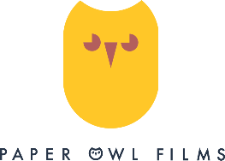
Sol – Cast Biographies
ZANA AKKOÇ is 12 years old, from Letterkenny in Ireland and is half-Turkish and half-Irish and loves his Donegal. He has been attending a performing arts academy for the past five years, during which time he has picked up a number of awards and accolades. He studies Musical Theatre, Singing and Piano and has undertaken examinations in Acting, Oral Communication and Musical Theatre performance. He has a musical ear and is a very expressive, bubbly and happy-go-lucky kid, much like Sol.

MYRA ZEPF is a children's author from County Down in Northern Ireland. She is the current winner of Ireland's Children's Book of the Year and has had her Irish-language books translated into eight languages, worldwide. She was the first ever Children's Writing Fellow for Northern Ireland (2017-2019), based at the Seamus Heaney Centre for Poetry at Queen’s University, Belfast. As well as writing picture books, chapter books and Young Adult fiction, she is now on a sworn mission to inspire younger minds to write and tell their own stories.

FIONNULA FLANAGAN is an internationally celebrated Irish actress, whose work on stage and screen has garnered her many distinctions, among which are two Tony Award Nominations, a Golden Saturn Award, an Emmy Award, numerous critics' awards, three IFTA Awards, including a Lifetime Achievement Award, and an Honorary Doctorate in the Arts from the National University of Ireland at Galway.

