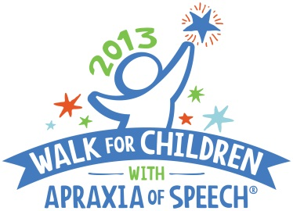
For Immediate Release: April 16, 2013
CASANA Contact: Sharon Gretz, M.Ed,
Executive Director/Founder
sharong@apraxia-kids.org
Phone: 412-343-7102
Website: www.apraxia-KIDS.org/
Local Contact: Katey Graf,
Finn’s Walk Coordinator
ktgraph@gmail.com
Phone: (916) 812-5522
http://secure.apraxia-kids.org/finnswalk

CENTRAL VALLEY FAMILY ORGANIZES FIRST ANNUAL WALK TO RAISE AWARENESS FOR CHILDREN WITH APRAXIA
Walk for Children with Apraxia of Speech–unlock our voices; open up our futures

(MODESTO, CALIFORNIA) – (April 16, 2013) –Chris and Peaches Brady will honor their 5-year-old son with apraxia, Finn Brady, at the first annual Finn’s Walk for Children with Apraxia of Speech event on Saturday, May 11, in East LaLoma Park. To date, the upcoming Walk has raised nearly $3,000 and counting; all proceeds raised benefit important programs and research of the Childhood Apraxia of Speech Association of North America (CASANA).

“At two and a half years old we finally received our diagnosis of Childhood Apraxia of Speech (CAS). I say ‘our’ because this is not just Finn’s diagnosis but our family's as well,” said Brady, who is helping coordinate this Walk for the first year in Modesto. Brady’s son was diagnosed with childhood apraxia of speech four years ago.

“We find hope in knowing that there are others out there who are dealing with this same adventure. We are thrilled to know that we can help raise awareness and funding to benefit important apraxia programs and research of the CASANA organization.”

The 2013 Finn’s Walk for Children with Apraxia of Speech is open to all adults and children. On-site registration and check-in begins at 8:00 AM, with the Walk starting promptly at 9:00 AM. Anyone interested in participating should contact Katey Graf at ktgraph@gmail.com OR visit the website at http://secure.apraxia-kids.org/finnswalk for more information, to register, or to make a donation.

Childhood Apraxia of Speech (CAS) is a very challenging and complicated neurological speech disorder in children. This little known disorder makes it difficult or impossible for children to accurately produce sounds, syllables, and/or words despite having a good understanding of language. The Walk for Children with Apraxia of Speech is held as a means to heighten awareness and to benefit important funding for CASANA programs and apraxia research.

About CASANA
The Childhood Apraxia of Speech Association of North America (CASANA), based in Pittsburgh, Pennsylvania and founded in 2000, is the only national 501(c)3 non-profit public charity exclusively dedicated to the needs and interests of children with apraxia of speech and their families. CASANA’s mission is to improve the systems of support in the lives of children with apraxia so that each child is afforded their best opportunity to develop speech. CASANA supports this mission by promoting awareness through Walks held all over North America; providing high quality information and support through the Apraxia-KIDS website and online communities; conducting multiple educational events; and funding apraxia research. For more information on CASANA and Childhood Apraxia of Speech, visit the Apraxia-KIDS website at http://www.apraxia-kids.org.
# # #

