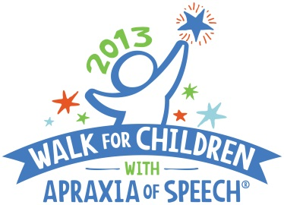
For Immediate Release: April 16, 2013
CASANA Contact: Sharon Gretz, M.Ed,
Executive Director/Founder
sharong@apraxia-kids.org
Phone: 412-343-7102
Website: www.apraxia-KIDS.org/
Local Contact: Natalie Britt,
Braylen’s Walk Coordinator
nbritt.randf@gmail.com
Phone: 251-753-3365
http://secure.apraxia-kids.org/mobilewalk

MOBILE MOTHER ORGANIZES FIRST ANNUAL WALK TO RAISE AWARENESS FOR CHILDREN WITH APRAXIA
Walk for Children with Apraxia of Speech–unlock our voices; open up our futures

(SPANISH FORT, ALABAMA) – (April 16, 2013) –Mobile mother, Natalie Britt, will honor her 3-year-old son with apraxia, Braylen Bradley, at the Braylen’s 1st Annual Walk for Children with Apraxia of Speech event on Saturday, May 11, in Five Rivers Delta Resource Center. To date, more than 60 participants have registered for the upcoming Walk that has raised over $3,000 and counting; all proceeds raised benefit important programs and research of the Childhood Apraxia of Speech Association of North America (CASANA).

“I am starting this Walk for Children with Apraxia of Speech in our community to raise awareness in honor of my son, Braylen. He was diagnosed a year ago and it has been a long road with intense speech therapy,” said Britt, who is coordinating this Walk for her first year in Spanish Fort.

“We hope you all can help make it successful with your support and donations to this great organization, CASANA, who helps families daily.”

The Braylen’s 1st Annual Walk for Children with Apraxia of Speech is open to all adults and children. On-site registration and check-in begins at 7:30 AM, with the Walk starting promptly at 9:00 AM. Anyone interested in participating should contact Britt at nbritt.randf@gmail.com OR visit the website at http://secure.apraxia-kids.org/mobilewalk for more information, to register, or to make a donation.

Childhood Apraxia of Speech (CAS) is a very challenging and complicated neurological speech disorder in children. This little known disorder makes it difficult or impossible for children to accurately produce sounds, syllables, and/or words despite having a good understanding of language. The Walk for Children with Apraxia of Speech is held as a means to heighten awareness and to benefit important funding for CASANA programs and apraxia research.

About CASANA
The Childhood Apraxia of Speech Association of North America (CASANA), based in Pittsburgh, Pennsylvania and founded in 2000, is the only national 501(c)3 non-profit public charity exclusively dedicated to the needs and interests of children with apraxia of speech and their families. CASANA’s mission is to improve the systems of support in the lives of children with apraxia so that each child is afforded their best opportunity to develop speech. CASANA supports this mission by promoting awareness through Walks held all over North America; providing high quality information and support through the Apraxia-KIDS website and online communities; conducting multiple educational events; and funding apraxia research. For more information on CASANA and Childhood Apraxia of Speech, visit the Apraxia-KIDS website at http://www.apraxia-kids.org.
# # #

