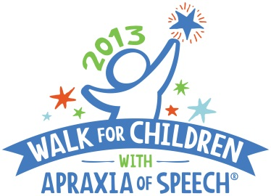
For Immediate Release: April 10, 2013
CASANA Contact: Sharon Gretz, M.Ed,
Executive Director/Founder
sharong@apraxia-kids.org
Phone: 412-343-7102
Website: www.apraxia-KIDS.org/
Local Contact: Lynn Carahaly,
Arizona Walk Coordinator
lynn@listening-ears.com
Phone: (480) 219-3953

CHANDLER SPEECH-LANGUAGE PATHOLOGIST ORGANIZES WALK TO RAISE AWARENESS FOR APRAXIA
Walk for Children with Apraxia of Speech–unlock our voices; open up our futures

(CHANDLER, ARIZONA) – (April 10, 2013) –Apraxia specialist, Lynn Carahaly, M.A., CCC-SLP, is on a mission to raise public awareness on behalf of Arizona families raising children with a rare speech disorder: Childhood Apraxia of Speech. Carahaly will honor local children with apraxia at the 2013 Arizona Walk for Children with Apraxia of Speech event to be held on Saturday, April 27, 2013 at Desert Breeze Park. To date, more than 200 participants have registered for the upcoming Walk that has raised over $10,000 and counting; all proceeds raised benefit important programs and research of the Childhood Apraxia of Speech Association of North America (CASANA).

“My goal is to bring families together, raise awareness, and strengthen the Arizona apraxia support network community, and fund raise for the amazing organization, CASANA,” said Carahaly, who is coordinating this Walk for her first year. Carahaly is the director and owner of Foundations Developmental House and Listening Ears located in Chandler, AZ.

“We invite everyone to come out and show support for children with apraxia and their families.”

The 2013 Arizona Walk for Children with Apraxia of Speech is open to all adults and children. On-site registration and check-in begins at 8:30 AM, with the Walk starting promptly at 10:00 AM. Anyone interested in participating should contact Carahaly at lynn@listening-ears.com OR visit the website at http://secure.apraxia-kids.org/arizonawalk for more information, to register, or to make a donation.

Childhood Apraxia of Speech (CAS) is a very challenging and complicated neurological speech disorder in children. This little known disorder makes it difficult or impossible for children to accurately produce sounds, syllables, and/or words despite having a good understanding of language. The Walk for Children with Apraxia of Speech is held as a means to heighten awareness and to benefit important funding for CASANA programs and apraxia research.

About CASANA
The Childhood Apraxia of Speech Association of North America (CASANA), based in Pittsburgh, Pennsylvania and founded in 2000, is the only national 501(c)3 non-profit public charity exclusively dedicated to the needs and interests of children with apraxia of speech and their families. CASANA’s mission is to improve the systems of support in the lives of children with apraxia so that each child is afforded their best opportunity to develop speech. CASANA supports this mission by promoting awareness through Walks held all over North America; providing high quality information and support through the Apraxia-KIDS website and online communities; conducting multiple educational events; and funding apraxia research. For more information on CASANA and Childhood Apraxia of Speech, visit the Apraxia-KIDS website at http://www.apraxia-kids.org.
###

