Stay a step ahead with KickStart Europe 2018
Conference on trends & investments in digital infrastructure

In 2017 alone, we generated more data than in the entire history of mankind. With our world transforming more and more towards a fully digital society, we rely heavily on the digital infrastructure to support double digit growth. To keep up with these ever growing market demands, insights are everything. On January 24, 2018, the KickStart Europe Conference on trends and investments in Connectivity, Data Centers and Cloud will take place in datahub Amsterdam.
From developers to investors and from designers to constructors: it’s time for the European digital industry to meet and learn from each other in RAI Amsterdam, to kick-off a great 2018.

Trends, technology, infrastructure & investments
Keynote speaker Gary Niederpruem, Vice President Global Marketing and Strategy at Vertiv, will kick-off the event. At Vertiv, he is responsible for leading the global marketing effort including devising strategic programs. Gary will share his vision on strategies, trends and latest developments in the digital infrastructure industry to keep up with the demand for data.
The event further focuses on the latest updates and expectations in the connectivity, cloud and data center market. Leading analysts (incl. CBRE) will talk about tech and digital infrastructure investments, regulatory and legal developments within the EU and the latest market acquisitions and consolidations. Several expert sessions focus on the ever-changing and mostly growing market demands, and how to keep up with them.
Meet the industry
At Kickstart Europe 2018, there is ample opportunity to meet, speak and get introduced to key players in the European digital industry. Meet new potential business partners, experts and relevant operators and investors, or catch up with existing contacts during the event and at the network drinks afterwards.
Stay a step ahead
Join us on January 24, 2018 in RAI Amsterdam to learn about the latest developments in trends, technology, infrastructure and investments in the EU and the Netherlands.

For more information and the detailed program, go to www.kickstartconf.eu

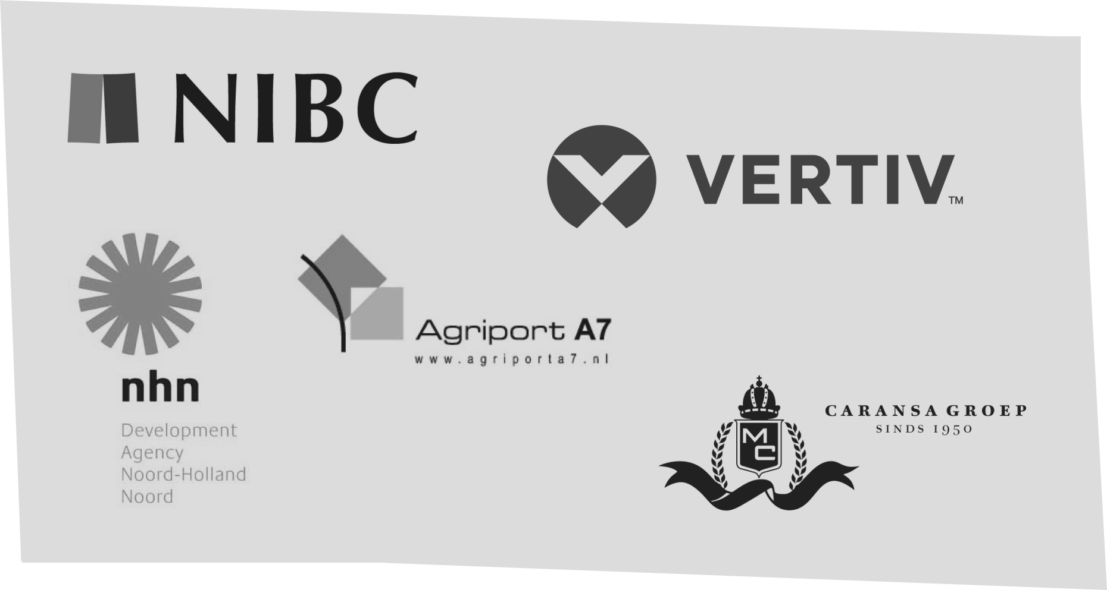

KickStart Europe 2018 is supported by
NIBC, Vertiv, NHN/Agriport & Caransa

About us
​Digital Gateway to Europe (DG) is the government and industry backed initiative to promote the Netherlands as international data hub. We help foreign companies in many ways to prepare launch or expansion in the Netherlands, by organizing events such as trade missions, launchpads and other meetups. Scale-ups, start-ups and enterprises who would like more in-depth information regarding the Dutch digital economy can consult our Digital Gateway to Europe knowledge database.
We are an independent organization created by the industry, for the industry. Supported by organizations and businesses from the digital infrastructure: datacenters, Internet Exchanges, Cloud providers and Connectivity providers.
Contact us
Digital Gateway to Europe
Abcouderstraatweg 46
1105 AA Amsterdam
The Netherlands
Find it on Google Maps

​e. info@digitalgateway.eu
t. 0031203037860 / 0031650439288
Twitter: @dgweu

