BETWEEN BORING AND BLING: OPPORTUNITIES IN THE US BRANDY MARKET

Marketers Should Borrow Halos of Wine & Whiskey to Fill Premium Brandy Vacuum

London – March 24, 2015 – In Rabobank’s new report on the U.S. brandy market, the bank identifies a clear market gap in what logically should be the strongest price segment – premium brands. Between the value, low growth end of the brandy spectrum – the “boring” – and the fast growing, super-premium cognac end – the “bling” – there is a potential opportunity for spirits companies to tap into the growing appetite for premium spirits among sophisticated, affluent U.S. consumers.

The premium brandy gap, in Rabobank’s view, stems from the U.S. view of cognac and brandy as separate categories, each with its own niche set of consumers. Domestic brandy (non-cognac) is a price sensitive segment with lacklustre sales, and consumers tend to be older, white and less affluent. Cognac, on the other end of the spectrum, holds a strong position in the African-American market, and price growth of super-premium cognacs is outpacing the market.

U.S. brandy sales echo this divergence; on the one hand, there are large volumes of domestic brands in the value price segment – around $12 or $13 a bottle, and on the other, smaller but fast-growing volumes (of mainly cognac) in the super-premium segment – which generally starts at $25 to $30 a bottle.

Stephen Rannekleiv, global wine and spirits analyst for Rabobank, says, “There is an enormous gap between domestic, value brandy and super-premium cognac: the premium segment. This is unusual because the premium segment is, generally, the strongest part of the U.S. spirits market overall. If brandy had a normal pricing curve, we estimate there would be approximately 4 million cases of premium brandy sold, at a retail value of nearly $1 billion.”

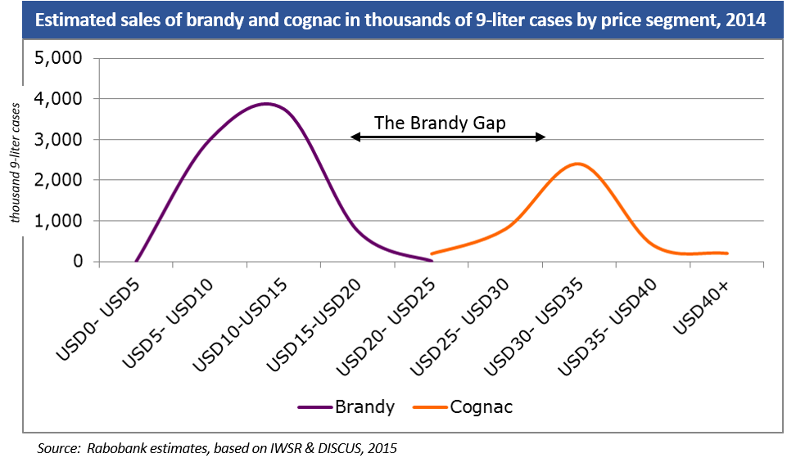

“If brandy had a normal pricing curve, the premium segment – where there is currently a vacuum – could be worth nearly $1 billion.”

Watch video clip of Stephen Rannekleiv on YouTube.

In Rabobank’s diagnosis, brandy’s image problem stems not only from stereotyped perceptions, but also from consumers’ lack of understanding about what brandy (including cognac) is – distilled wine often aged in bourbon barrels. For many, brandy is associated either with elderly, pipe-smoking gentlemen in club chairs, or with overly sweet fruit-flavored brandy liqueurs that taste like cough syrup. Neither of these appeals to affluent consumers taking part in the “cocktail culture.”

Rannekleiv continued, “Brandy (both domestic and cognac) has failed to gain relevance with the broader base of U.S. consumers – particularly affluent consumers who have driven recent premiumization trends in vodka, whiskey and wine. Increasing brandy consumption within this broader demographic represents an opportunity for foreign and domestic brandy suppliers to expand sales, improve profitability and grow the overall spirits category.”

Rabobank recognizes that overcoming some of brandy’s negative stereotypes will be an uphill battle.
“Building a premium brandy brand will require significant marketing resources – something that has been missing in the brandy category – but we believe the current context may create favorable conditions to do so,” said Rannekleiv. “Consumers today are more sophisticated and more open to new products and categories. Furthermore, the growing interest in premium wine and whiskey creates an ideal opening to reintroduce brandy to consumers using the halo from these categories, as brandy has characteristics of both (e.g., wine grape varietals used, whiskey barrel ageing, etc.)”

The full report is available to media upon request.
###

Rabobank Group is a global financial services leader providing wholesale and retail banking, leasing, real estate services, and renewable energy project financing. Founded over a century ago, Rabobank is one of the largest banks in the world, with nearly $1 trillion in assets and operations in more than 40 countries. In North America, Rabobank is a premier bank to the food, beverage and agribusiness industry. Rabobank’s Food & Agribusiness Research and Advisory team is comprised of more than 80 analysts around the world who provide expert analysis, insight and counsel to Rabobank clients about trends, issues and developments in all sectors of agriculture. www.rabobank.com/f&a

MEDIA CONTACTS:

Lynne Burns
Rabobank International
D: 212-808-2581
Lynne.Burns@rabobank.com

Sarah Kolell
Rabo AgriFinance
D: 816-516-7984
Sarah.Kolell@RaboAg.com

Jessup Wiley
Rabobank, N.A.
D: 559-447-7946
Jessup.Wiley@rabobank.com

Follow us on Twitter: @rabowholesale LinkedIn: Rabobank North America Wholesale

