PRESS RELEASE ENGLISH | 25/04/18

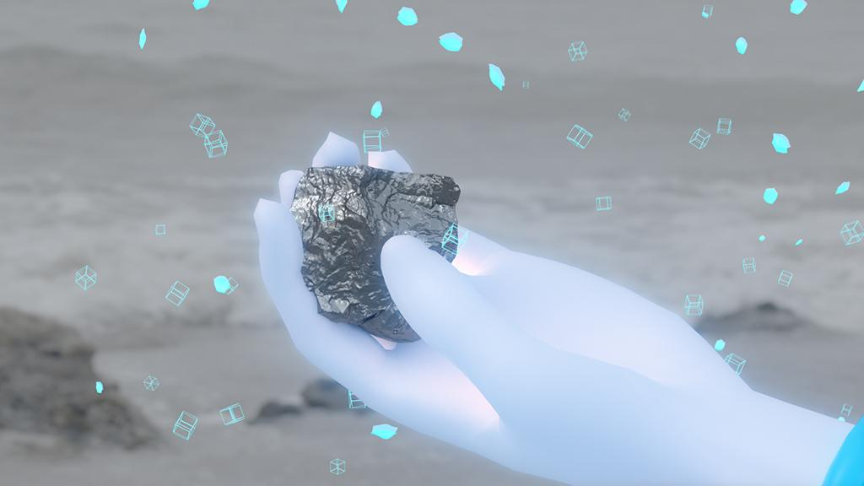
FIBER presents ‘Big Bias’: An Evening About The Hidden Prejudices In Smart Technologies | May 17
We are increasingly confronted by the dangers and faults of the tech-utopia promised by Silicon Valley. ‘'Smart' soap dispensers that can’t recognise the hands of people of colour. Accidents with self-driving cars. Cambridge Analytica’s illegal harvesting of over 50 million Facebook accounts. On Thursday evening May 17th, Amsterdam based FIBER, in collaboration with the Vlaams Cultuurhuis de Brakke Grond, presents a new season of Coded Matter(s), addressing the theme of ‘Worldbuilding’. FIBER reimagines the narrative technique of Worldbuilding to explore how art and design can envision a better world.

Coded Matter(s): Big Bias is the first edition of the Worldbuilding trilogy and gives the public an insight into the role that makers (artists, designers, thinkers) and companies play in tackling ethical problems surrounding practices such as big data and artificial intelligence, and also explores the role played by digital art and culture in developing more inclusive technological worlds and applications.
In his lecture-performance, artist and queer theorist Zach Blas explains how tech companies use magic and mysticism to conceptualise the application of data. The Flemish designer and researcher Femke Snelting is investigating how we can better understand the relationship between humans and digital infrastructures by considering how issues relating to race, gender, age and species are taken into account when collecting body data. The African American artist, coder and writer Mimi Onuoha unveils the bias of authorities by showing which data they refuse to collect or choose to exclude.
Since 2013, Coded Matter(s) has been a platform for artists, designers, startups and cultural practitioners to explore cutting-edge artistic production and new ways of understanding digital technologies and and their impact on our world. In 2018, Big Bias (May 17), Terra Fiction (September 27) and Engine Spaces (Nov/Dec), will explore the overarching theme of Worldbuilding though lectures and screenings. Worldbuilding is a narrative technique that originates from science fiction and transmedia storytelling and is used as an artistic method to reflect on complex subject such as climate change, terraformation, circularity and human-machine relationships.
For more information visit the website: https://www.codedmatters.nl/event/coded-matters-big-bias

// EVENT INFO

Date: 17th May
Time: 20:00-23:00 | Doors: 19:45
Location: Vlaams Cultuurhuis de Brakke Grond (Amsterdam)
Address: Nes 45, 1012 KD Amsterdam (NL)
Tickets: € 16 | Students: € 12 (no student card, no entry)
https://www.brakkegrond.nl/agenda/een-avond-over-de-verborgen-vooroordelen-in-slimme-technologie

Facebook event
https://www.facebook.com/events/2039164852991756/
Website Coded Matter(s)
https://www.brakkegrond.nl/agenda/een-avond-over-de-verborgen-vooroordelen-in-slimme-technologie
Website De Brakke Grond
https://www.brakkegrond.nl/agenda/een-avond-over-de-verborgen-vooroordelen-in-slimme-technologie

This event is made possible by the support of Creative Industries Fund NL, The New Institute, MU Art Space and the Amsterdam Fund for the Arts

// SUMMERY

Short (50 words)
On Thursday evening, May 17, FIBER presents in collaboration with de Brakke Grond a new season of Coded Matter(s). During the lecture program 'Big Bias' artists Zach Blas, Mimi Onuoha and Femke Snelting show the embedded prejudices in 'smart' technology and give a glimpse of alternative worlds with inclusive technology.
Medium (75 words)
On Thursday 17 May, the first edition of the new season Coded Matter (s) will take place in De Brakke Grond. The lecture program is based on the theme 'Big Bias' and uses three presentations by artists Zach Blas, Mimi Onuoha and Femke Snelting to show the embedded power structures and prejudices in 'smart' technology. Since 2013 FIBER has been exploring in the events series Coded Matter(s) how current issues concerning digital technology are dealt with within contemporary art, design and culture practices.

// ORGANISATIONS

About Coded Matter(s)
Coded Matter(s) is FIBER’s ongoing events series that explores various forms of digital culture, artistic and critical application of code and digital technologies and the role of interdisciplinary artists and thinkers. Started in 2013, FIBER has now organised over 13 editions. Now returning after a two year break to De Brakke Grond (Amsterdam), the new programme includes keynote presentations from leading artists, designers, architects, academic researchers and writers. These presentations are combined with short films, project demonstrations and masterclasses to stimulate new ways of thinking. Previous editions have explored the rise of the blockchain (Michel Bauwens & The Promise Of The Blockchain), algorithmic culture (Algorithmic Wildlife), live coding in club contexts (Algorave) and how the shape and depiction landscapes changes with technological developments and computer vision (Compiled Landscapes).
http://www.codedmatters.nl
About FIBER
FIBER is an Amsterdam based platform that supports and presents talented makers and thinkers who are operating at the intersection of audiovisual art, digital technology, music and societal issues. The platform functions as a platform for emerging young artists and connects them to urgent international developments, new public knowledge and work opportunities.
http://www.fiber-space.nl

About Flemish Arts Centre De Brakke Grond
Flemish Arts Centre De Brakke Grond offers the most significant contemporary art productions from Flanders, including visual art, literature, dance and theatre, music, performance, film, design, fashion, architecture and new media. The emphasis is on innovation, building bridges and artistic guts.
https://www.brakkegrond.nl/

END OF PRESS RELEASE

PRESS INFO

- Contact Information: press@fiber-space.nl (Thorsten Hertog / Jarl Schulp)
- Press Images & Digital Press Release ENG: http://fiber-festival.pr.co/165560-fiber-presents-big-bias-an-evening-about-the-hidden-prejudices-in-smart-technologies
- Press Images & Digital Press Release NL:
http://fiber-festival.pr.co/165712-big-bias-een-avond-over-verborgen-vooroordelen-in-slimme-technologie
- Credit Image: Zach Blas

FIBER
Tolhuisweg 2
1013 CL, Amsterdam (NL)
info@fiber-space.nl | press@fiber-space.nl
Interviews & press info: +31641235624

